Created in the cloud with Aspose.Words for Cloud. http://www.aspose.com/cloud/word-api.aspx

FROM THE DESK OF: Happy Thanksgiving, Mr. Williams
Published Date : November 21, 2011
Author : admin
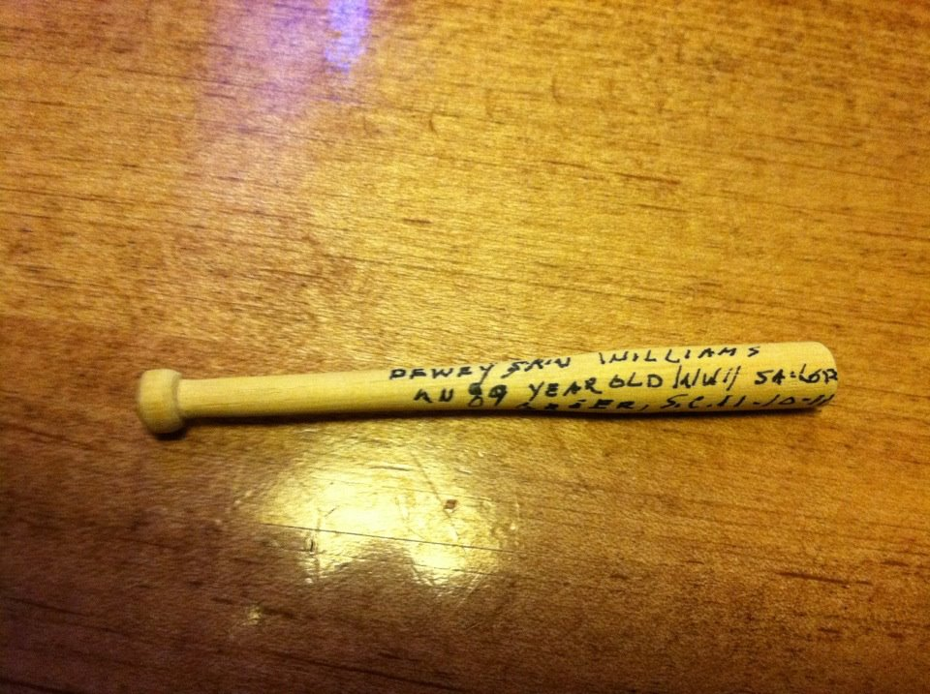
BY: Taft Matney
Preparing to celebrate Thanksgiving, people are getting their thoughts organized. As soon as Halloween 2011 went in to the record books, people began posting to social media what they were thankful for. For some it was friends or family. For others it was work – making it another day in a rough economy without being laid off.
Out to dinner with the family the other night, we were sitting at Como’s, a Greenville institution on Augusta Road, when an older gentleman walked up to the table. These days, you never know what someone’s motives might be, so I went on guard. He looked at me and smiled and said, “I want to give something to that boy,” motioning to my 8 year old son.
I know common sense would tell you we didn’t have anything to worry about. After all, we were in Pete’s. Nevertheless, I didn’t know what to think because in 2011 nobody comes up and says they want to give you something just for the heck of it.
“Um, okay,” I responded, even more alert than I was before.
He reached in the pocket of his old “Members Only” jacket and pulled out a small piece of wood. He leaned over my wife and gave it to our son.
I quit worrying.
He said, “I whittled it myself. I like to whittle ‘em and keep ‘em with me.”
It was a miniature baseball bat maybe three inches long, and on it he wrote, “Dewey ‘Skin’ Williams — An 89 year old WW II sailor. Greer, SC. 11-10-11.”
He smiled even more proudly than before pointing to the number written on the barrel of the bat. “7300. I’ve made 7300 of ‘em.”
He turned and walked away without another word as my son kept telling him, “Thank you.”
The 8 year old studied the bat all through supper. At least he did when he wasn’t inhaling his burger and picking off the excess bacon “for dessert.”
As we left, I went to the cash register to pay. The 8 year old hung back, and the wife stayed back even more to watch him.
He went up to the gentleman who had given him this 7300 bat and said, “Thank you again for the bat, Mr. Williams…and thank you for your service to our country.”
Mr. Williams looked back with a mix of surprise and appreciation and just said, “You’re welcome, young man. Now you have something to remember an old man by.”
So, as we celebrate another Thanksgiving, one that takes days to plan, hours to cook, and minutes to eat, let us remember the “Mr. Williams” of the world.
Let us remember not only the 89 year old WW II sailor, but the 25 year old soldier in the desert and everyone who has ever put on a uniform to keep us safe because it’s thanks to their sacrifices that we continue enjoying our freedoms.
Happy Thanksgiving, Mr. Williams.

Tweet

Comments

WHAT’S GOING ON: GOP Presidential Debate at Wofford Earns Solid Ratings
Published Date : November 16, 2011
Author : admin
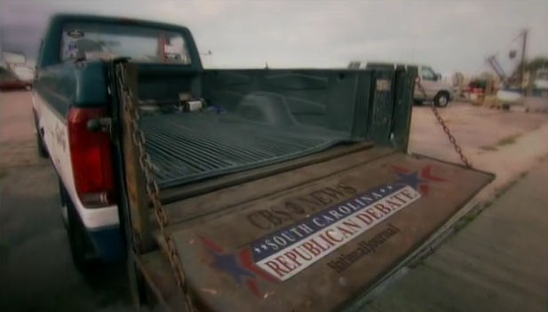
As the South Carolina Republican Party and Wofford College worked to showcase Spartanburg and the Upstate for this past Saturday night’s Republican presidential debate, ratings indicate that a substantial number watched their efforts.
According to the final numbers, from the 8-9 pm CBS broadcast (The remaining 30 minutes streamed live on the Internet and was recorded for future airing.), 5.48 million total viewers watched the debate. In the adult 25-54 demographic, 1.52 million viewers watched.

Saturday night’s debate from Spartanburg was the second most watched of the 10 GOP presidential debates so far.
South Carolina will get at least two more chances to appear on the national stage before its “First in the South” presidential preference primary on January 21, 2012.
The first will be a January 16, 2012 debate in Myrtle Beach aired by FOX News. The second will take place just days later on January 19 at a CNN aired “Town Hall” from the Southern Republican Leadership Conference in Charleston.
Tweet

Comments

CRESCENT Places: Dark Corner Distillery — Bringing Moonshine to the Sunshine (Part 3)
Published Date : November 14, 2011
Author : admin
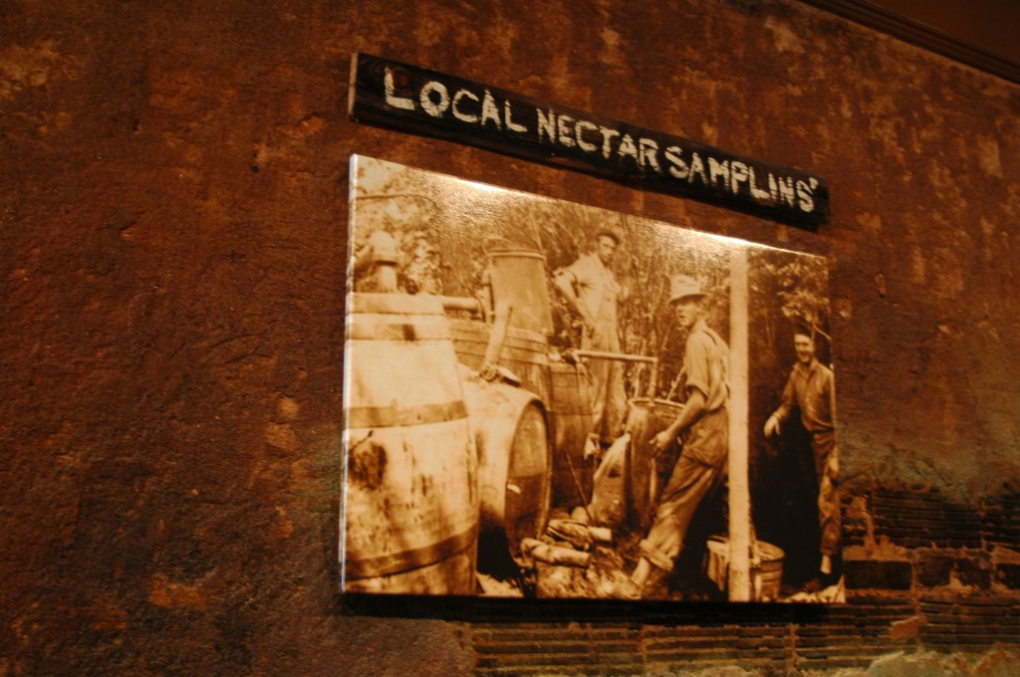
ESTIMATING THE COST OF STARTING A BUSINESS
The total cost is higher to date. The cost to manufacture is higher than we thought. Everything else is in line. We were pretty close. I’d say we were 90% on with our guess. One of our worst places we didn’t really expect to spend the money we did was the upfit on the building. Being in downtown really… it’s going to cost you a lot more capital because you’re dealing with so many…the permits and things like that. You’ve got a 1925 building that has original hardwood, original tin, so you just can’t come in here and throw things on the walls and throw things in the floor.
It’s a nice building and that was part of our deal. We could have gone out to West Greenville, got a 10,000 foot warehouse for half the price we’re paying on this. Upfitting for the building was our biggest unknown. We are engineers, not necessarily contractors who do contact projects so you get an estimate on it and you’re like “Wow, that’s twice as high as what we thought.” And when they’re done with the project, by the time you hit all the hiccups from doing it in an old building, you’re 50% over what they came up with. So that was the most, I guess, scary thing…watching the final bill come down the line for upfitting the building.
PACKAGING AND BRANDING DARK CORNER
I was doing a presentation a couple of weeks ago for an Upcountry Friends meeting and there is a pastor that’s in the group. When I got on the stage to present, he asked me the same question. I said “It’s kind of divine.” And it’s funny, he said, “It can’t be divine, you’re talking about moonshine and the word ‘divine.’” I said, “That’s the way it feels for me because a lot of things have just fallen into place.” I hate to use the word “passion” because it is so overused today, but when you’re passionate about something and your heart is truly in it, things sort of just come together. And that’s how a lot of this has been. It’s been sort of waking up one morning and having an idea “Oh, wow, if we did a Dark Corner Distillery, that would be a big hit.” One thing leads to another. Honestly, a lot of it for me is more like a dream than anything. I’ve got an idea when I wake up out of bed and I put it on paper and you see it out there in the store. It seems to be working pretty well.
One of the things, I knew I wanted it to be local, so I had to touch the hearts or the mouths of local people, some how. I wanted to be downtown because that’s easier to access the people. Wanted that foot traffic. I couldn’t necessarily compete with, say Mast (General Store). A lot of people say “How do you compete with Mast?” We don’t want to compete with Mast. We don’t have to.
NOT COMPETING WITH OTHER BUSINESSES
It’s local, everything in here is local. Nothing in here is from North Carolina. Everything we source from the arts to crafts to food panty goods, it’s all within pretty much a 20 mile radius. So it is all Upcountry goods and I guess we had a vision.
Growing up in the Dark Corner and going to Clemson, coming back to Greenville, I realized what my dad and I left in the Dark Corner, which would be our home and land, he sold it, we got rid of the best thing that’s ever happened to me – the Dark Corner. I visited it regularly for years. I’ve been out of Clemson now for 5 years. Every weekend, my wife and I ride up to Caesar’s Head, Saluda reservoir, Poinsett Bridge, Campbell’s Covered Bridge. We ride to these beautiful places and you just feel the history there. You have this magical cohesion to where my heart was in it and so, every today, I still today while we’re sitting here talking, I’m sitting here thinking “How can I make it better? How can I make it more authentic and truer to its depiction?”
The bottle label? I designed the bottle label. I could have source a local graphics company or artist to do it, but I had my heart in it and I went with it and ran with it and I feel like it sort of exemplifies our product.
The web site? I’m probably going to have a third job doing web site design because we get more compliments on the web site than we do on a lot of the other things we’re doing. I never did web sites before. I’m not a designer, but again, my heart is in it and it’s hard to mess up something if your heart is in it because you work hard enough and diligent enough to the point where it is perfect in your eyes. Hopefully, anyone that comes to visit us will see the flyers, which I designed, the bottle label, the web site. You’ll get a sense of the Dark Corner.
The logo? If you visit the Dark Corner, you listen to stories and you come into our store and you hear us tell stories. I hope you leave and feel like you’ve never left the Dark Corner. It’s all the same place. That’s kind of how all this has come together. Every day, we’re thinking of ways to make it more enjoyable because this is a fun experience.
Keep in mind that when we did the Dark Corner Distillery, the first week the idea was conceived, I went to Dean Campbell, squire of the Dark Corner. His family settled there in the 1700s. He still lives there and I went to him and told him what I wanted to do. I pretty much said, “We want an authentic feel. We don’t want to offend people. We don’t want to bother the churches.” There were just a number of things that we knew we could not do. Because the last thing you want to open a business where people are banging down your door with picket lines and things like that.
You might say, “Well, it’s just a business, Joe. It doesn’t seem like it would be that big of a deal.” Well, it is a big deal because the Dark Corner has been a secret for 100 years. And by secret, I mean that 9 out of 10 people in Greenville have no idea that it is a real place. They think it is some idea we came up with. It was a secret for 100 years because the politicians in Greenville did a really good job of wiping it out of our minds and mouths then. It was sort of like a bad word back in the day to say the words “Dark Corner”. Mom would slap you on the hand and she’d say “Don’t say that.” It was like a bad word. A lot of bad vibes in the Dark Corner because of the whiskey, the misuse of the whiskey. There was a lot of bloodshed. A lot of Revenuers got hurt, a lot of mayhem, gunslinging and like that. So there is a dark heritage there. Contrary to popular belief, it’s not called the Dark Corner because of its moonshine and its dark heritage, though. But it does have a dark heritage to it.
WHAT PEOPLE MAY NOT REALIZE ABOUT DARK CORNER DISTILLERY
We can’t serve food, by law, at a microdistillery. It can’t be served with the whiskey. Contrary to bars, bars have to have food to serve if customers request it.
The thing we have not mentioned is about flavors. We want to give the customer flavor, but we would rather do it through our own way as opposed to what some of the guys in the hills are doing – adding peach schnapps to the moonshine and calling it peach moonshine. I had a moonshiner come in about an hour before you got here and he said “Man, I finally got my peach moonshine the way I want it. It’s perfect. It tastes just like the best stuff I’ve had.” And I said “What are you putting in it?” He wouldn’t say. “I couldn’t tell you that. I’d have to kill you.” That’s typical answer you get. Me, personally, a recipe is nothing but the amount of ingredients that you put into a batch of moonshine. When people say Grandpa’s recipe, that doesn’t mean a whole lot to me. I don’t necessarily use Grandpa’s recipe because recipes …you’re looking at it on the board (as he points to the dry erase board with the distillery’s recipe written on it), you’re looking it at in the making. It’s just the amount of grain. One day we do 55, the next day we’re doing 66. It’s just an amount of grain, it’s no secret recipe. So when the guy held back his peach recipe from me, it didn’t both me at all, because I knew what he was doing. So after he said he couldn’t tell me, he’d have to kill me, I began to tell him how he makes his peach moonshine and then he left. He left because I told him he was soaking peaches in moonshine and putting about a fourth peach schnapps in it. He walked out.
Stay Tuned for Part 4 Next Week. For Part 1, Click HERE. For Part 2, Click HERE.

Tweet

Comments

CRESCENT People: Wait. Was That? Yeah. It Was. It Was Jonathan Dickson
Published Date : November 14, 2011
Author : admin
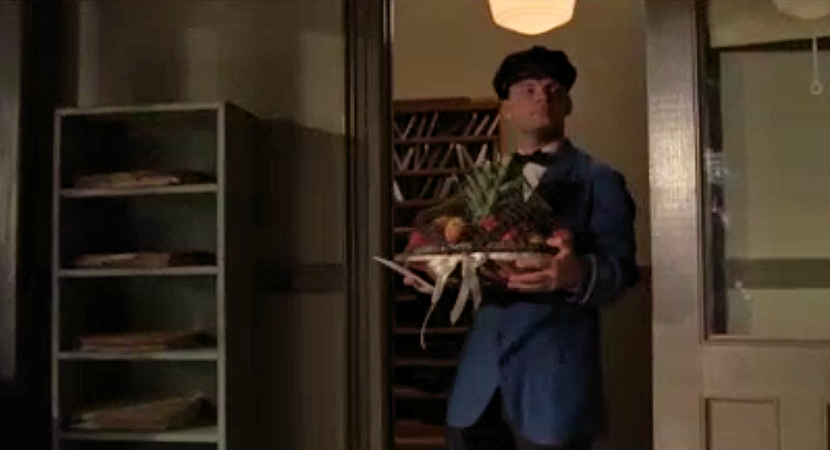
If you’re from Anderson or went to USC or have been involved in Republican politics or used to watch the WB or UPN networks on WASV in the Upstate and you saw a familiar face while watching HBO’s Emmy nominated, Golden Globe winning hit series Boardwalk Empire last night, you weren’t imagining things.
That was 1992 TL Hanna and 1997 University of South Carolina graduate Jonathan Dickson serving as your humble delivery boy.
CRESCENT caught up with Jonathan and talked with him about his appearance on one of the biggest shows on television. If you missed last night’s episode of Boardwalk titled “Two Boats and a Lifeguard,” check your listings, and make sure to look out for South Carolina’s Jonathan Dickson.
YOU FOUND BOARDWALK OR BOARDWALK FOUND YOU
I had actually auditioned several times for Boardwalk Empire. Different roles and what not. The way they work here in New York is, if you go into an audition, so for like a show or something and the casting director likes you, you might not be right for that role or that part, but they like you and they want to see you for other roles. They will just keep calling you in. Yeah, my agent submits me for things but the one thing with hanging in there with the acting industry, you start to get to know casting directors. They like you, they remember you and they go “You know what? This would be a good role for so-and-so.” Or “I’d like to see so-and-so for this role. Maybe this isn’t working, but we’re shooting an episode 2 or 3 episodes down the road where I think this might be a right fit for that person.” So you get called back in. When I came in for this role, which, it’s not a glorious role or anything, it’s under 5 lines, which is called an “under 5.” But you get a SAG voucher for it, you get a credit, so I get a credit on IMDB because I have lines. I am not, what they call in the industry “a piece of meat,” which are the extras who just stand around all day and are moved from place to place to place. I actually get a dressing room. I get a wardrobe. I get a stylist. I get a makeup person. I get all the bells and whistles that go with that. It just happened, when I came in, my dressing room was right new to Steve Buscemi’s dressing room. I got to talk to him. I got to see him. That was cool. Talked to him. Super nice guy “Hey, man, how you doing?” I’m like “You’re Mr. Pink…you’re Mr. Pink!”
Actually, I had just read a thing about him with 9/11. I actually thanked him. “Thanks for what you do.” He was a fireman and he actually went down, put on his gear and went down 9/11 and helped pull people out of the rubble and stuff. Didn’t say anything to anyone, just went to the old fire station. And they say he still hangs out with fire station guys. There’s some bar the boys all go to. His unit. He’ll go down there sometimes and just drink with them, and whoop and holler it up with them. And on 9/11…I’m sure there is an article somewhere you could look online about it. He actually went down and helped pull people out. All dressed up, all in his fireman gear. (NOTE: We found a piece about it HERE.)
And they say, he’s just a down to earth, nice guy and you know what, he is. You might think he is creepy and crazy if you watch Con Air and other flicks, but when you meet him, he’s just nice and down to earth and I actually wasn’t finished with my scene when he left and he left the set in t-shirt, shorts and a backpack. “Well, man, I’m done. See you later.” “See ya, Steve, nice to meet ya, nice to talk to you.” His kids take swimming lessons at the YMCA. He’s just a down to earth nice fella. And that was really cool because I was a little….and I’m not normally intimidated by people, but … and I’m never star-struck but when I was having to go get my hair cut for the show. They have to give you the high and tight and comb me over and all that, make it look that era. I’m just in regular clothes and I had a production assistant who was assigned to me to take me around so I’m on the elevator and we’re going down… they do a lot of the scenes and things at the Brooklyn Naval Yard in Brooklyn, which is not far from where he lives. So we’re going down in the elevator, and I’m just excited to be working on this show. It’s a great show, it’s a new show, it’s won some Emmys and got a lot of buzz. We’re going down the elevator and the doors open on the bottom floor where I’m supposed to get my hair cut in one of these trailers and who is standing there, right when the doors open? I mean right on the door, not even back so you kinda take him in, but right on the door, and I’m standing by the door and it opens and there’s Nucky Thompson. I mean, all dressed up. He’s got the full outfit on, the full everything, the hair slicked back…
So, he’s standing there, all makeup on, and I was just like “Uuuuuhhhh, hey!” I wanted to say “Hey, Nucky” but it was sort of like “Whooo, hey!” The doors opened and he’s just there. You know, I’ve never seen him. I’ve never met him before, I just know him from TV. And most of the people I’ve ever met, ever worked with have been really nice.
Tina Fey and Tracy Morgan, Jimmy Fallon, everybody is nice and great and fun. And Steve Buscemi is just standing there looking like hardcore Nucky Thompson. I was like “Hey!” He was like “Hey, man, how you doing?” I’m like “Going to get my hair cut.” He’s like “I just got out of there.” It was so cool. And then we ended up sitting next to each other getting our make up and stuff done a little later. So that was neat. And I just talked to him for a few minutes in his dressing room.
It was funny. Our dressing rooms were away from everyone. Everyone else’s was way down this hallway and Steve Buscemi and I are literally next door to each other. And I don’t know if that was just by design or they just said, put the delivery guy in this room and this just happens to be next to Steve Buscemi.
I’ve seen people now, talk to him, “Oh, my gosh, oh, my gosh.” Then you meet him and he is just seriously, you could just sit down and have a drink with him and cut up and laugh and tell jokes. He is just an everyday Joe like you. He’s very appreciative and he’s very kind and very down to earth. We got along great. Like I said, we didn’t really have this big half hour conversation because there was a lot of work to do and you’re moving and it’s hurry up and wait, go here and to there and what not. But in the few minutes that we spoke, he was just a cool guy. Just a good guy. I was like “You’re cool, Nucky, you’re cool.” So that was great, I really enjoyed….then the fact that I teach at the YMCA. I teach kids to swim. He has kids in swimming lessons at the Y. So immediately, found a way to relate and I thought that was kind of cool. That he’s doing it to me. How neat is that?
It was awesome.
AFTER THE ELEVATOR RIDE, IT WAS TIME TO GET TO WORK.
They do rehearsals for everything. There are a million people on the set doing a million different things and you shoot the same scene over and over and over so they get different angles and different things. You do the wide shot and the close up and the medium shot and the long range. Those sort of things. And you have to remember…and this is another thing that makes a good actor a good actor. Called continuity. What you do in one shot, you have to do in the next shot and you have to do in the next shot and you have to do in the next shot. So you’re doing something over and over and over.
You’re here to work. You’re here to create characters. You’re here to be part of a team to make this show come off and make people out there enjoy what’s going on on the Boardwalk.
We’re in there and we’re rehearsing a few times and they take us back and forth to our dressing rooms while we wait and then they bring in stand-ins for us. We actually get to where we are going to film it. We’ve gone through it. We’re not dressed yet. We’ve done the hair cuts and all this stuff, but they let us keep off part of our outfits. So nothing gets wrinkled. Nothing gets messed up, that sort of thing.
While they’re building the different sets and things and changing things around and camera angles. When we actually go in for the shoot after we’ve done umpteen thousand rehearsals, oh, my gosh, it was so cool. I tried to take a picture with my camera, but it didn’t come out. It was terrible.
Once you’re on set, that’s very unprofessional. You don’t take pictures of stars, you don’t pull your camera out and start hemming and hawing and everything. That why they have an on set photographer that does all that stuff. I may never see those pics, but they have someone who does that. And when you’re a regular or recurring role on the show then you get privy to that sort of stuff. So I’m trying to be taken as a serious actor so I don’t do that.
I’ll do it off stage and behind the scenes. Taking pictures of wardrobe, things like that. That’s one thing, but for me to pull out my camera and say, “Hey, Steve Buscemi,” no. Act like you’ve been there. It’s like when the Gamecocks were tearing down the goalposts every game we won. Act like you’ve been there. I wanted to email Dabo Sweeny after he was crying on the field after he beat Auburn. Dude, act like you’ve been there. Clemson has a history. They have a storied tradition. Act like you’ve been there.
Anyway, the coolest thing, and I hadn’t dealt with this on set before because I had never been in a show set way back in the day, prohibition, 20s, 30s, 40s, that whole era. I’ve never been in that type of period show before. So when I came back, the set looked completely different. It was the same set we had been rehearsing on, but they had released the steam fog all over the whole sound stage, the whole studio stage had the fog set in. So everything kind of looked like that old time hazy, smoky kind of environment and it just gave this whole appearance to… I was like “Wow, I am really in Boardwalk Empire. I am here. This is Boardwalk Empire. This is awesome.” So I’m really excited to see it.
JONATHAN DELIVERS HIS SCENE
I did my scene and we did it a thousand different ways. I had to hit different marks. They wanted me to walk different ways because…the scene I’m in…and it’s not a long scene. I actually come walking in and just with the way they want the shot set up and what not, they make me walk in different ways, walk to different places because I’m a delivery man, so I’m dressed like a delivery guy and I have a delivery package from Nucky Thompson to this federal prosecutor.
Her name is Esther Randolph, played by Julia Nicholson, who is really sweet.
When I walk into the scene, you’ll see postal people with their letters and bags walking around and what not, and I come walking in with this big ol’ basket full of ripe peaches. They smelled good, man. They smelled like good ol’ Southern peaches. I wonder if these are South Carolina peaches or Georgia peaches? That’s my question.
In this scene I come walking in with this big basket full of peaches and a card from Nucky Thompson and so I go over to one of the characters. I actually I yell he motions me over, and I come over and tell him these are from Nucky Thompson and I hand him the basket. I put the basket on the desk in front of the prosecutor and him and he pulls the card off from Nucky and it says “Thanks for saving my life, you’re a peach.” I was like “That’s just classic.” Thanks for saving my life, you’re a peach. He reads that and I walk out. And that’s pretty much it. Those are my lines. I walk in and holler for the guy, then I come over and tell him these are from Nucky Thompson and hand them over and he reads it and I’m out of there.
It’s funny, this episode of Boardwalk Empire is called “Two Boats and a Life Guard.” That’s actually what I’ve done my whole life, the swimming, the pool, the life guarding, the teaching. I thought it was kind of ironic to come full circle.
Look for Jonathan next this coming February on a new reality show on BRAVO called “The Love Broker.”
You can also follow Jonathan on Twitter (@JonnyDHollywood) or Facebook.






You have a voice. Use it.











































Tweet

Comments

CRESCENT Things: Keowee Going Green -- Protecting its Greatest Asset
Published Date : November 14, 2011
Author : admin

The Reserve at Lake Keowee has been recognized over the years with a myriad of awards, honors, and accolades praising the residential community for its design and amenities. Spanning 3,900 acres in the foothills of the Blue Ridge Mountains, on more than on pristine Lake Keowee, the beauty of The Reserve has attracted families from across the nation. Protecting the beauty of its 30 miles of shoreline and 3900 acres is one of the highest priorities of the community’s employees, residents, and members.
Among The Reserve at Lake Keowee Foundation’s functions is being an active steward of the environment, and each year The Reserve’s foundation organizes events and volunteer efforts that include small acts of care, kindness and protection of the land, water and wildlife.
In 2010, The Reserve adopted five islands in Lake Keowee through the “Adopt-an-Island” program created by Friends of Lake Keowee Society (FOLKS) and Duke Energy Island Keeper. Islands 17, 17A, 17B, 17C, and 17D have been adopted by The Reserve and its members. The property owners and staff from The Reserve cleaning the lake and islands in conjunction with the bi-annual “Lake Sweep”, a lake-wide clean-up effort organized by FOLKS.
One of the purest lakes in North America, Lake Keowee is more than 26 miles long, dotted with islands, and with some waterways spanning two to three miles wide. Lake levels remain near full pond throughout the year to depths well over 125 feet. A drinking water source for Greenville County, S.C., Lake Keowee enjoys 18,500 acres of mountain-fed waters and three hundred miles of shoreline and is the second cleanest lake in South Carolina behind Lake Jocassee, which is 90% protected from development, according to Sandra McGee, Community Relations Manager for Duke Energy. Lake Keowee is a haven for outdoor recreation and home to many freshwater fish including largemouth bass, smallmouth bass, bluegill and white bass.
Reserve residents adopted and maintain a four-mile stretch of Highway 133, just off the Cherokee Foothills Scenic Highway (Highway 11) in Sunset, S.C. Four “Adopt-A-Highway” clean-up weekends are conducted each year in February, May, July and October. Clean-up efforts in the past have resulted in collecting nearly 100 bags of litter from the roadside.
Additional environmental stewardship acts have included special events and partnerships with FRIENDS of the Blue Ridge Parkway, in honor of the Parkway’s 75th Anniversary last year, as well as well as being a pilot member of The Audubon Lifestyles Sustainable Golf Facility Program, the most comprehensive program to measure sustainability in golf course management.
“One of the reasons we formed The Reserve Community Foundation was specifically geared toward environmental stewardship, so we are excited do more ‘little things’ that add up to big, positive impacts,” stated Kathryn Coleman-Gravely, executive director of The Reserve at Lake Keowee’s Community Foundation. “Lake Keowee is a tremendous asset to our area, and we want to do our part in helping it stay clean and beautiful so that it can be enjoyed responsibly for generations to come.”
Stay Tuned for Part 4. For Part 1, click HERE. For Part 2, click HERE.
Tweet

Comments

WHAT’S GOING ON: Obama Administration Delays Decision on Jobs and Energy Project. SC Congressmen Want Open Debate
Published Date : November 11, 2011
Author : admin

As the Wall Street Journal criticizes President Obama for delaying decision on construction of TransCanada’s 1,700-mile, $7 billion Keystone XL underground pipeline that would deliver 830,000 barrels of heavy crude oil a day to Oklahoma and Texas refineries from Alberta, two members of South Carolina’s congressional delegation are adding their voices to the discussion.
Representatives Joe Wilson (R-SC2) who serves on the House Foreign Affairs and Armed Services Committees and Jeff Duncan (R-SC3) who serves on the House Natural Resources, Homeland Security, Foreign Affairs Committees jointly signed a letter today asking the presidential candidates in tomorrow night’s debate to address energy independence as it relates to national security.
The open letter to Republican presidential candidates begins, “Tomorrow evening, at Wofford College in Spartanburg, SC, each of you will have the opportunity to discuss some of our country’s most pressing national security concerns.”
“We urge you to use this occasion to focus on the topic of American energy independence and what you would do as our next Commander-in-Chief to ensure that the United States breaks its addiction to Middle Eastern oil.”
At issue is a pipeline that, according to US State Department environmental impact statements, would have “no significant impacts” on the environment. According to the letter from Congressmen Duncan and Wilson, of the total 340,000 new jobs created as a result of the pipeline’s construction, 2000 of them would be in South Carolina with an addition of $128 million to the state’s economy. One of those beneficiaries would be Michelin’s Lexington production facility which produces the giant tires used by earth movers to transport oil sand. Other equipment manufacturers in the state would be similarly affected.
President Obama said the administration’s decision will not come until after the 2012 election in order to address environmental concerns. He said in a prepared statement yesterday, “Because this permit decision could affect the health and safety of the American people as well as the environment, and because a number of concerns have been raised through a public process, we should take the time to ensure that all questions are properly addressed and all the potential impacts are properly understood.”
At the same time, a Wall Street Journal editorial claims that members of the environmentalist left are using the Keystone decision as a litmus test of the president’s greenworthiness. The Journal notes that “eco-agitator Bill McKibben recently warned” the administration at an Occupy Wall Street event, and “the Sierra Club has threatened that it won’t ‘mobilize the environmental base’ in 2012 if he approves the project.”
According to Representatives Wilson and Duncan, “Americans are desperate for a president who will restore our prestige abroad and our pride here at home. We think that restoration can and should begin on the Wofford College stage tomorrow night with your unwavering commitment to the immediate approval of the Keystone XL pipeline project and to domestic drilling.”
The90-minute debate focusing on national security and foreign policy will begin at 8:00 PM EST. The first hour will be broadcast live (8:00-9:00 PM EST) on CBS. Additional portions will be broadcast on FACE THE NATION, CBSNews.com, NationalJournal.com and will be available to CBS affiliate television and radio stations.
EXTRA: Read the letter from Congressmen Wilson and Duncan HERE.

Tweet

Comments

FROM THE DESK OF: A Lot Of Things Made Me Mad Yesterday
Published Date : November 10, 2011
Author : admin

BY: Taft Matney
A lot of things made me mad yesterday. I’m not going to tell you how many because I might forget one, and my only recourse would be to say, “Oops. I really stepped in it.”
One was the Penn State “situation.” Almost anybody with a TV and who leaves the house at least once a day knows what this “situation” is and has an opinion on it. I’m not going to get in to it here other than to say that those who lost their jobs got off light. As a father, had one of those victims been my son, the wrath that came down upon that school would only be rivaled only by Armageddon itself.
On a MUCH lighter level of irritation, I got mad at my hometown newspaper – the one I quit subscribing to a while back because its parent company gutted the newsroom through layoffs and substantially decreased local news coverage.
I mean 2A is a literal rehash of USA Today. Nevertheless, there are times when I need to access the paper, so I resubscribed. Well, long story short, I paid for Saturday / Sunday delivery so I could get 24 hour access to the web site and iPad app. Unfortunately, my access to the electronic outlets wouldn’t start until my first weekend of delivery.
That didn’t work for me because I paid for (I thought) immediate access (access that “customer service” was more than happy to give me IF I upgraded to 7 day delivery for $6.20 more per month when I only wanted the electronic component). Frustrated, I cancelled the subscription I just got.
After taking my case to Twitter, the newspaper addressed my concerns, came up with a work-around, and this morning I’m renewing my subscription for the second time this week.
The third thing that lit me up yesterday was Christmas. Not the holiday, but an asinine new fee hanging on live Christmas trees.
On Tuesday, the Obama administration approved a $0.15 fee on live Christmas trees to fund a marketing campaign to promote “benefits of live trees” over artificial. The fee was expected to collect around $2 million.
I know that $0.15 isn’t even enough to argue about, but it’s the principle. Who taxes a Christmas tree? That goes on the list of “Stupidest Things I’ve Heard this Year.”
It’s also really bad economic policy.
Think about it. How much sense does it make to tax the people who are already doing what you’re going to tax them for so you can run a marketing campaign that encourages them to do what they’re doing?
That’s dumb. After all, the people they need to convince to buy fresh trees are the ones currently buying imported artificial trees. They’re the ones the advertising will be geared toward, not me.
I understand that a large segment of the public would rather have artificial trees. They’re easier to put up and take down. They’re used for multiple years, so they’re more cost-effective. They’re easier to store. They don’t shed needles. They usually come prelit. They’re good for people with allergies. I get it.
There are a lot of upsides for buying an artificial tree, but I’m buying a live tree. I always buy a live tree. Don’t punish me for buying what you want me to buy. I’m already buying it and obviously don’t need the “benefits of live trees” promoted to me.
Besides, IT’S A CHRISTMAS TREE! Taxing a Christmas tree? Who does that?
UPDATE: Apparently the “Christmas Tree Tax” has been shelved as quickly as it was approved. According to The Huffington Post, “White House spokesman Matt Lehrich said the USDA would delay the program, but defended it, saying it was not a tax.” And what happened then? Well, in Whoville they say that the Grinch’s small heart grew three sizes that day.
Tweet

Comments

WHAT’S GOING ON: City of Walterboro Invites You Out to Nature and In to the Season
Published Date : November 8, 2011
Author : admin

The City of Walterboro, known for its historic charm and abundant natural resources, invites residents and visitors to get out and take in the incomparable fall weather with two events that will take participants outdoors to take a deep breath and savor nature before the busy holiday season begins. Shopping, tree lighting, festive concerts and caroling will celebrate the season while tapping into some of the local treasures that the city, known as the “front porch of the Lowcountry,” has to offer.
“Walk and Talk” in the Great Swamp Sanctuary with Master Naturalist Joe Grange
Saturday, November 12, 2011, 9 a.m.
Master Naturalist Joe Grange will lead visitors on a guided walking tour through the Great Swamp Sanctuary, one of the East Coast’s largest estuarine preserves, located just on the edge of historic downtown Walterboro. This is part of a series of free educational talks organized by the Friends of the Great Swamp Sanctuary. It will begin at 9 a.m. at the De Treville Street entrance. For more information, visit www.walterborosc.org/greatswampsanctuary.aspx.
Band of Blue Third annual Palmetto Classic Stride 5k walk/run through the Great Swamp Sanctuary
Saturday, November 19, 2011
Registration starts at 6:30 a.m. at the Hargo Hill parking lot on the corner of W. Washington and Jefferies Blvd. The Run/Walk starts at 8 a.m. at the Washington Street entrance to the Great Swamp Sanctuary. Registration forms are available at FitLife & Jus Sports, or download from www.bandofblue.org or call 843-908-0319.
Holiday Open House South Carolina Artisans Center and Downtown Historic Walterboro: A Folk Art Celebration
Saturday, November 19, 2011, 10 a.m. to 5 p.m.
South Carolina Artisans Center, located at 318 Wichman Street
This is a free event featuring artisan demonstrations, a holiday craft show, and many shopping options. For more information call 843-549-0011 or visit www.scartisanscenter.com
City of Walterboro Christmas Tree Lighting Ceremony and Christmas Parade
Sunday, December 4, 2011
The tree lighting ceremony will begin at 5:00 p.m. and will be followed by the Christmas Parade at 6:00 pm. This is a free event. For more information, visit www.walterborosc.org.
Christmas Caroling by the Lowcountry Community Players
First three Saturdays in December, 1-3 p.m.
Christmas caroling by the Lowcountry Community Players will take place at the Waterfall Plaza on historic E. Washington Street. Residents and guests are invited to take part in the family holiday entertainment. Each week will feature a different theme, and the Walterboro Merchants Association will be offering treats to participants. For more information, visit www.walterborosc.org.
Charleston Symphony Orchestra Brass Quintet presents “Holiday Favorites: From Bach to the Silver Screen”
Thursday, December 8, 2011, 7:00 p.m.
Hosted by the Colleton County Arts Council, the concert will be held at Historic St. Jude’s Episcopal Church. A reception will follow. Tickets for adults are $25; tickets for students are $15. For additional information, visit www.colletoncountyarts.com.
Tweet

Comments

YOUR TURN: “Fiscal Fitness Matters” by Senator Phillip W. Shoopman
Published Date : November 8, 2011
Author : admin

Last year, the voters in the Upstate and across the country spoke loudly that they wanted real reform and real conservative solutions to the spending habits and inefficient government practices both in Washington and in Columbia. The 2010 election was a revolution for a change in Washington to fix a system where overspending and budgetary deficits were not only hurting economic development but saddling our children and grandchildren with incredible debts. Unfortunately, we are facing similar problems with budgeting and spending in Columbia. We have a responsibility to the people of this state that it be a place that is financially sound and one in which our children’s future is not diminished by our reckless present. This requires that we get our financial house in order.
During the past session, I was a member of a subcommittee that examined the problem of agencies incurring deficits even though our state constitution requires that we have a balanced budget each year. In fact with all the alarm over the federal deficits in Washington, South Carolinians have taken solace that “that could not happen here.” Unfortunately, last year, three agencies were prepared to ask the Budget & Control Board (Board) for permission to run deficits for a total of over $250 million. By the end of fiscal year 2010-2011, two agencies were able to reassess their budgets, make spending cuts, and end the fiscal year without running a deficit. However, the other agency, the South Carolina Department of Health and Human Services, was not able to do so and was allowed by the five-person Board to run a deficit of over $220 million.
We learned that the South Carolina Code allows a loophole for bureaucrats to bypass the legislature and be allowed to overspend. Section 1-11-495 allows the five member Budget and Control Board, if it makes a finding that “the deficit is unavoidable due to circumstances that are outside the control of the agency,” by a four-person vote, recognize the agency’s deficit, meaning the Board authorizes allowing the agency to spend more than your elected representatives budgeted for them. The Board must then notify the General Assembly of this determination. If the General Assembly does not act, then the Board’s vote stands, and the agency is allowed to run a deficit. The Board then gives additional money to the agency to make up the deficit amount. The additional money is taken from surplus revenues or surplus funds and from funds available in the Capital Reserve Fund and General Reserve Fund.
Fundamentally, we have whittled down to the central question of – if an agency has a legal mechanism to bypass their budget limits, then why budget at all?
I have observed in the General Assembly that financial problems that were estimated to be in the millions of dollars quickly became tens of millions of dollars. And, while I would like to believe that self-control would prevail in future spending practices, the prudent approach would be to ensure that it does. For that to happen, issues such as deficit prevention, regulatory reform, spending caps, trust fund protection, and other topics must be addressed and enacted in South Carolina.
The President Pro Tempore, Senator McConnell, has asked me to serve on his Fiscal Fitness subcommittee to consider those financial issues facing our state. As such, we are conducting public hearings around the state so that we can hear from the public and get their opinions as they relate to those issues. However, attendance at these public hearings is not necessary for your voice to be heard. We need support from the grassroots, the business community, and the families of this state to unite and say we will not go the way of the federal government. I encourage you to contact your senator and representative and let them know that you do not want South Carolina to go the way of the federal government and generate an enormous debt for our children and grandchildren to pay.
We can get South Carolina’s fiscal house in order and we cannot fall into the trap of throwing away our children’s future at the expense of current short-sighted spending practices.
Senator Phillip W. Shoopman represents District 5 in the South Carolina Senate.
DISCLAIMER: The opinions, beliefs, and viewpoints expressed by the author are those of the author and do not necessarily reflect those of CRESCENT: The Magazine.
Tweet

Comments

WHAT’S GOING ON: Upstate Congressman's Facebook Account Hacked
Published Date : November 7, 2011
Author : admin

Late yesterday afternoon, the Facebook fan page of Congressman Trey Gowdy (R-SC4) displayed a status update that, at first glance, would appear that the Upstate representative or the staffer in charge of his account flipped the calendar a month and a day too soon.
The status read, “Today is the 60th anniversary of the attack on Pearl Harbor. December 7, 1941 is a ‘date which will live in infamy.’-FDR”
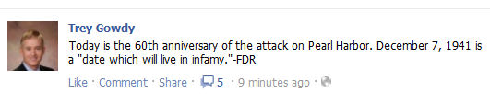
A source close to Congressman Gowdy’s office confirmed that the House freshman knew exactly what date it was and that his fan page had been hacked.
The post was quickly removed.
Tweet

Comments
Mark Brian
If someone hacked a Congressman's FB page, I would think they could come up with something worse than this? Strange but then again I often wonder about people that like to do things such as hack a FB page or twitter account. Too much time on their hands?

CRESCENT Places: Dark Corner Distillery — Bringing Moonshine to the Sunshine (Part 2)
Published Date : November 7, 2011
Author : admin

JUMPING THROUGH HOOPS TO MAKE SHINE
It’s a long process. You’ve got all the good red tape if you’re going to make weapons or anything else like that — that’s what I compare it to – that we were going to make weapons, because it is a very big deal.
The government wants their money off of what you’re making and they’re going to get it whether you like it of nor unless you’re out shining in the woods. Going into that, it was sort of overwhelming to think that the day after we conceived the idea, we were tasked with…to sum it up, we had to get a building and get it completely ready. We had to get all the local permits satisfied. We had to get a state permit to be a micro-distillery, and we had to get a federal permit to distill spirits.
When you sit back and look at that and you look at your budget which I call a string budget, it’s very daunting. It’s painful to think how bad you want to do this, but you’re got so much red tape and hoops to jump through that there’s no way you’re going to be able to do it in under a year. For us, we wrote the business plan right at October and here we are opening on September 21st. We did it within a year, which was phenomenal. Yeah, there are a lot of hoops to jump through but, honestly, for me, I did most of the paperwork, if you will, and as scary as it is up front, if you stay on the government, don’t pester them, but stay with them, constantly follow up, you can get it done pretty quick. If you have a hiccup or snag, that’s what your local politicians are for.
So I had to call on Senator DeMint’s office at one point, because I knew the government was dragging their feet. We were coming up on tourist season and I knew we needed to open before tourist season got here. Not just for us so we can survive but this is a big historical draw for the area. Not to include that we’re providing jobs. We’ve already hired 2 new people on our staff recently. I had to call on Jim DeMint to have him pull strings and say, “Get it in gear for these guys. They’re trying to do something good, if you’ll just let them open.”
CALL YOUR SENATOR AND SAY, “HEY, I’M JOE, I’M MAKING SHINE.”
You know what? Sometimes, I found that while I’m a phone guy or an in-person guy, I like talking, electronic doesn’t usually work for me very well to get the point across. With that one, I had a lot of thoughts that I needed to put out on the table. I pretty much knew that I had one shot to do it to do it. If I blew it, if I said the wrong thing that could possibly turn them away, I’d ruin it so I wrong them a 2-page letter, a really, really nice letter and hand-delivered it and let him read the letter so I actually didn’t have a conversation. But there were certain points that I needed to get off to where when you get in front of someone that’s used to hear talking all day. You know, if you get lost or you start rambling, you’re going to lose him and he’s going to lose focus on what you really need. That’s why I started the letter off with our problem, that we need to open to stay afloat and the solution, I gave him the solution, was to just call the federal government, the TTB, the Alcohol and Tobacco Tax and Trade Bureau, call them and ask them to pick my application up off the desk and sign it, and believe it or not, within 24 hours of talking to Jim DeMint’s office, we had permit in hand.
It’s amazing and it just showed me not to knock the government. It just showed me there are a lot of applications sitting around in Ohio on the federal government’s desk from people that want to do exactly what I’m doing and they’re not going to get them approved until they just pick them up and sign them.
WHISKEY ≠ LEMONADE
A lot of people don’t understand, and it’s not anything bad, but a lot of people don’t understand drinking a glass of lemonade or a neat whiskey is not the same thing. You can’t drink whiskey the way you drink lemonade. A lot of people don’t understand that. I had a guy come in last night from Hawaii and he had a taste of our Bourbon, our 7-day Bourbon, it is 135 proof. It is going to have a little sting to it. He drank it like it was a shooter, like it was a shot. All of a sudden, he’s coughing and leaned over and his eyes are red and he said “Who can drink that stuff?” I said, “You drank it wrong.” You know, it’s all about sipping and about preparing your throat and esophagus for what’s about to go down because if you drink it like lemonade, you’re going to end up letting it go down to your esophagus and you’ll be dying over there.
DECIDING HOW STRONG TO MAKE IT
The government has set up classes and types of what you can make.
Rum is a class. Whiskey is a class.
A type would be corn whiskey. Bourbon whiskey.
So you’ve got classes and types.
They pretty much define out what some of the proofs can be for each class. Really, you can make whatever you proof you want. It’s very difficult to get above 195 proof but if you’re at 195 proof, you’re neutral grain spirits, that’s one of the classifications that specifies a proof. I think to be neutral grain, you have to be at least 165 proof. Anything above 165 is no longer whiskey. It’s neutral grain. They make that in a different type still than what we’ve got. They’ve got a column still which produces higher proof alcohol, what have you. But we can make whatever proof we want.
The reason we chose 100 proof is 2-fold. One, we want you to feel a little bit of a kick because whiskey or moonshine for hundreds of years has had kick to it. People enjoy a little bit of kick, but at the same time, we want to limit it to a kick that does not desensitize your taste buds. Because if you drink 120 or 130 proof, your taste buds are going to be gone the first time the spirit hits it. For us 100 proof is good. 80 proof is typically expected in the spirits industry. A lot of people claim that’s the best proof for tasting it. I personally like a little bit stronger and when I drink an 80 proof, a lot of times, it’s a little watery for me. You’ve got copper pots out there that can put 80 proof out but no real distilleries in the world are cranking out 80 proof which means they’re putting a lot of water in the spirit after the fact.
Our still naturally pumps out anywhere from 130 down to about 95 proof. By the time we blend together, if we have to add water, it’s very, very minimal. If you’re pumping out, like most of the big distilleries are, if you’re cranking out 165, 180 proof alcohol and you’re adding half water to get it down to 80. It’s not natural for half water and half whiskey to be mixed together. The less water you have to add the better off you are. Cause you’ve taken a beautiful process of taking a good water, great alcohol and you’re distilling it and extracting the alcohol off, you really don’t want to go back and add more water to it. You just did a good job of taking the water out. You just don’t add it right back in and expect it to be OK. We’ve tasted other whiskeys after ours, it tends to taste watery.
FLAVORED VARIETIES?
We get that question every day, probably 40 times a day. E-mail, phone and in person. And my first response to that would be, if I were not from the South…I ask you, would you go into Glenlivet or Glenmorangie and ask them if they have peach or “apple pie” scotch, they would ask you to leave and not come back. That’s my first answer, but being from the South, my answer is, “We’re creating awareness through this product but we want you to appreciate the settlers’ moonshine the way they drank it. Down the road, we would like to introduce some flavored products.”
We don’t want to alienate anyone, but at the same time, why is it that the first thing everyone thinks is that, “Where are your flavors at? Where’s your peach? Where’s your apple pie?” Because I have to come back to the guy asking that and ask him “Well, what did the moonshine taste like?” He says “It tastes like apples and peaches.” And I have to tell him that if you take water with apples and cinnamon and brown sugar, it’s going to taste pretty good. It’s going to taste really good, actually, so anything you mask with apples, cinnamon and sugar is going to taste really, really good. So you’re asking me to take a product that it takes me a week to make, work 80 hours a week on, to put sugar, cinnamon, apples on it to cover up the beautiful natural flavor. That it’s just hard to do right now.
NOTE: Joe did say that he plans to introduce flavored varieties, but he wants to do it correctly and not take shortcuts like some do to add peach schnapps to his whiskey to create peach moonshine.
BUILDING DISTRIBUTION OUTSIDE OF THE STORE
Well, we pretty much put Dark Corner Distillery together off of a local concept knowing that we wanted to provide spirits to local people. Moonshine in general, was the local drink of the Dark Corner, so our first objective was to let everyone local sample what we called real moonshine. With that, you have huge demand for it to the point that you could be spreading the word. You could be spreading the product much further if you could just get it out of the store. The fact that you have one place to get it at can sometimes limit people. So the only reason we cannot move outside the store today is because of production capacity. We’re running 24/7 right now and this is the first week our shelves have been full. We sold out the first 3 weeks we were open. We’re bottling batch 6 tonight and we’re pretty much out of batches 1-3 the second they hit the shelf. So to distribute locally, it is quite a process because we have to sell the product to a distributor, let’s say Southern Wine, and the distributor would then make his mark-up, make his money off it and he would sell it to the packaging stores, let’s say Green’s. They would get their price out of it, what have you, and then the packaging store would actually have to let the restaurant know or the restaurant would have to request it and if all worked out well, the restaurant would buy it from the packing store and they would sell it. So, really it has to go through quite a process from here to Columbia and back to Green’s then to the restaurant for us to be able to distribute there. We’re going to hopefully have that set up by Halloween. It’s going to be very small quantities.
It’s very, very ambitious but we’re running 24/7, around the clock, 7 days a week to produce 10 cases. Right now, today, we’re in line to have 10 cases ready the week of Halloween and hoping to have it in the Main Street bars and restaurants by Halloween. That’s what we’re shooting for and then, after that, if that does well and the demand is still high, which we hope it is, we should be able to invest more capital in to capital equipment actually expand into the basement and do a second operation like we’re doing upstairs. And at that point, if we doubled our capacity, that would allow us to distribute in South Carolina. We’d still be very small. We’re still talking very small quantities, but we would like to be in every county in South Carolina.
NOTE: Joe met his Halloween goal. Dark Corner’s moonshine was featured in seasonal cocktails at Blue Ridge Brewery, also on Main Street.
Stay Tuned for Part 3 Next Week. For Part 1, Click HERE.

Tweet

Comments

CRESCENT Things: Keowee – Supporting the Arts
Published Date : November 7, 2011
Author : admin

Emphasizing its commitment to the arts, The Reserve at Lake Keowee Foundation shows how serious it is by making opportunities available for top-notch artists to develop their talents with a unique residency experience in the picturesque Blue Ridge Mountains.
The Reserve’s foundation has announced a call for submissions for its 2012 Artist-in-Residence Program. Coming into its fifth year, The Reserve’s Artist-in-Residence program allows The Reserve to share the natural beauty of its community with artists so that they may experience a peaceful retreat that gives them outreach opportunities and time for reflection and inspiration. The program includes classes and field trips open to the public and other community outreach initiatives in and around The Reserve property.
Past artists included classical guitarist Jhon Akers, pianist Martha Beaudrot, and painters John Smith, Jeffrey Callaham, and Mark Horton. All artistic backgrounds are welcomed and encouraged.
For details and submission guidelines, consult The Reserve’s 2012 Artist-in-Residence Submission Form. The submissions deadline has been extended to December 30, 2011, and a final decision will be made in early 2012.
The Reserve at Lake Keowee and its foundation have been supporting the arts though other programs, as well. Some of these include regular on-site events, exhibits, and sponsorships for all manner of visual and performing artists, mixing well-known local artists with nationally- and internationally-acclaimed talent. The Reserve is also an annual sponsor of ARTISPHERE, an annual signature event for Greenville, SC, showcasing the arts, reflecting the area’s international flair, and maximizing existing arts programs by providing a diverse menu of experiences that center around the arts visual and performing and Greenville’s multi-cultural offerings to appeal to visitors from throughout the world, as well as citizens throughout the region.
Stay Tuned for Part 3. For Part 1, click HERE.
Tweet

Comments

FROM THE DESK OF: The Corso Curse -- An Explanation and a Request
Published Date : November 4, 2011
Author : admin
BY: Taft Matney
Unless you’re a fan at some level of either Clemson or USC (The real one. The one founded in South Carolina in 1801. Not the one founded in Southern California in 1880.), this will have no meaning for you. If, however, you spend your fall Saturdays clad in some combination of Garnet and Black or Orange and Purple, you know what this is about.
ESPN’s “College GameDay” broadcast team owns football Saturday mornings. There’s Chris Fowler, Kirk Herbstreit, Desmond Howard, and, rounding out the pigskin quartet, there’s Lee Corso.
Without a doubt, Corso has the experience and street cred to be a part of ESPN’s college football mainstay.
After all, he played his college ball at Florida State, he had assistant coaching posts at Maryland and Navy, and he served as head coach at Louisville, Indiana, and Northern Illinois before stepping in to the world of the short-lived USFL.
He knows where of he speaks. He knows football. He knows how to pick ‘em on Saturday mornings.
Not so fast, my friend.
When he delves in to Palmetto State pigskin picks, it’s figuratively possible to hear a collective, “Awwww,” whenever Coach Corso picks USC and/or Clemson to win their respective games. You can feel the excitement of the day slip away as fans bury their heads in their hands with the thought that the Corso Curse has struck.
More often than not, or at least that’s the way it feels to Gamecock and Tiger Nations, a pick by Coach Corso means defeat. Now that social media has become such an integral part of communication, Twitter and Facebook abound with comments that cheer when he picks the opposition and sob when he taps our teams to win.
Last weekend as Clemson traveled to Georgia Tech with an 8-0 record, I tweeted, “No! @CollegeGameDay’s Corso picks Clemson over Tech! C’mon, Tigers! You can win anyway.” A number of friends echoed my sentiment.
You see, Corso lied to us. He said only a couple of weeks prior that Clemson’s season would end at Georgia Tech. This wasn’t fair! We called “no takebacks.” He couldn’t change his mind the day of the game. It was just wrong.
Nevertheless, he did, and we got whipped like a government mule.
It was a game that on paper we should have won. Tech lost its two previous match-ups. Friends from across the country were texting and emailing me before the game saying, “Clemson’s got this. Tech’s too far down this year.” Watching game tapes, Clemson even had a blueprint of how to stop Tech’s offense.
It was a lock…except Lee Corso went back on his word and picked Clemson for the win.
As far as Carolina goes, yeah, Corso picked them, and they won, BUT they had a tough time in their game and could have easily blown it. I guess the worst of the bad juju had already spilled on to Clemson since he picked our game first.
All I know is this. South Carolina likes Lee Corso as a person. He comes off as a nice guy with an affable demeanor. He had an admirable career as a player, a coach, and now as a broadcaster. We think the personal adversity he works every day to overcome as a result of his stroke a couple of years ago is an example in tenacity and a model of intestinal fortitude.
We just don’t want him picking our teams to win.
So, with that, I have a request for ESPN and Coach Corso.
On behalf of my fellow football fans across South Carolina, don’t pick us to win. Always believe that the Gamecocks and Tigers are overmatched or that their successes are no more than fluke victories. Always underestimate us. Just pick us to lose. Well, maybe not always. If you want to pick Carolina on November 26, I’d be OK with that.
UPDATE: Well, Arkansas beat USC. Coach Corso was right on this one, but as my good friend Chad has often been known to say, “Even my broken Mickey Mouse watch is right twice a day.” Please, Coach Corso, don’t pick us to win.
Tweet

Comments
J
Just so you know, pretty much everyone dreads Corso picking their team. You are almost guaranteed to lose that game and (in the case of UCF this year) it could just ruin your entire season.
sterlingrogers
Great read! But,..not so fast. Gamecock fans do NOT "CARE" for Mr. Courso! E.G. the video Spurrier made and released taunting Courso's claim that Carolina would NEVER recruit,then Lattimore & ? Clowney are shown committing & Carolina would never even win the SEC East (insert more video) LOL! There is no love loss between USC & COURSO! He's the shunned relation of the loud and obnoxious Prick Vitale!! UGH! Could ESPN find two more horrid commentators if they tried? Maybe they did? !!!...I HAVEN'T SEEN AN (reCAPCHA)...!!!????????

CRESCENT Things: The Reserve at Lake Keowee – A Banner Blue Ridge Citizen
Published Date : November 4, 2011
Author : admin
Created in 2000, The Reserve at Lake Keowee is a residential community spanning 3,900 acres in the foothills of the Blue Ridge Mountains with 30 miles of Lake Keowee shoreline and convenient access to Greenville, SC. With a 200-slip Marina, Village Center, Jack Nicklaus Signature Golf Course, and more than 1,400 acres of parks, preserves, trails, and green spaces, The Reserve has approximately 650 members from 30 different states, with an additional 660+ extended family members who enjoy club privileges through the multi-generational Legacy Membership program.
Aside from the family amenities throughout the community, The Reserve at Lake Keowee is home to a non-profit charitable foundation created to enhance the area’s quality of life and fulfilling philanthropy.
Sponsoring regular cultural events that include concerts, plays, lectures, and an annual art festival, The Reserve at Lake Keowee Foundation is designed to help preserve the area’s natural resources, provide educational programs for members and guests of The Reserve, promote the arts, and provide outreach activities for neighboring communities in Pickens County, SC.
To that end, The Reserve at Lake Keowee Foundation gave more than $40,000 to local charities in 2010.
The Reserve at Lake Keowee Community Foundation is holding the following events this month, both of which are open to the public.
The Princeton Nassoons — Saturday, November 5 – 7:00 pm at Founders Hall (The Reserve at Lake Keowee)
- The third oldest collegiate group in the country and oldest a cappella ensemble at Princeton University, The Princeton Nassoons will pack the house for this one-night-only show mixing music, comedy, and showmanship. The Nassoons have performed internationally for 65 years, including at The White House as well as sets of national morning shows. Seating is limited; advance reservations recommended.
Journey on the Wildside, featuring wildlife artist John Seymour — Through November 30th at The Hill House Gallery, 534 Pine Grove Church Rd., Sunset
- Voted SC Wildlife Federation Artist of the Year in 1986, John Seymour will exhibit his watercolors and graphite drawings of animals he experienced during trips to Africa.
To learn more or make reservations to attend, please contact Kathryn Gravely, the Foundation’s Executive Director, at (864) 481-4010 or via email. A full description and calendar of Foundation events, updated frequently, is available on The Reserve at Lake Keowee’s website.
Stay Tuned for Part 2.

Tweet

Comments

WHAT'S GOING ON: Carolina Ballet Theatre Ushers in the Holidays with The Nutcracker
Published Date : November 1, 2011
Author : admin

Many families’ most cherished and memorable holiday tradition is going to see Tchaikovsky’s The Nutcracker. This season, Carolina Ballet Theatre (CBT) under Artistic Director Hernan Justo brings back this iconic ballet to the stage to usher in the holiday season. With its incomparable pageantry, beauty and charm, The Nutcracker will bring out the child in everyone.
Four shows are planned and will take place in The Peace Center Concert Hall on December 2-4, 2011:
- Friday, December 2 – 7:30 pm
- Saturday, December 3 – 2:00 pm and 7:30 pm
- Sunday, December 4 – 2:00 pm
Tickets for The Nutcracker are $35/each, with discounts available for seniors, students, and groups. This year, CBT is offering an additional ticket package for $50 for the Saturday and Sunday matinee performances. Those who purchase $50 tickets for the Saturday, December 3 matinee will be invited to a post-show Nutcracker Tea Party with special photo-op. On Sunday, December 4, $50 ticket holders will receive “Sweet Seats” that include premium seats in the Orchestra/Floor level and post-show refreshments and photo-op. Tickets may be purchased from The Peace Center’s website (www.peacecenter.org), on the Carolina Ballet Theatre’s website (www.carolinaballet.org), or by calling the Peace Center Box Office at (864) 467-3000.
This year also marks the 9th Annual Community Nutcracker, a fundraising drive held each year through Carolina Ballet Theatre to give hundreds of children in the community a chance to see and experience The Nutcracker. Each pledge of $15 will send one child to The Nutcracker. A contribution of $1,000 will send an entire classroom, including two teachers, to The Nutcracker.
Contributions to CBT’s Community Nutcracker can be made by calling (864) 421-0940 or (864) 297-1635, or by sending a check made payable to CBT to PO Box 135, Greenville, SC 29602. All donors to Community Nutcracker receive recognition in The Nutcracker performance program.
The Community Nutcracker has historically provided free tickets to the following partner organizations: A Child’s Haven, Catholic Charities Piedmont, Charles Lea Center, Connie Maxwell Children’s Home, Crossroads Group home, Fuller Normal School, Generations Group Home, GHS Child Life, Greenville County Schools Early Childhood, Greenville County School District Social Work Services, Greenville County Department of Disabilities and Special Needs, Parkins Residence Homes, Greenville Disabilities Foundations, Happy Feet, Make a Wish, Pendleton Place Children’s Shelter, Pleasant Valley Connection, Serenity Place, SHARE, The Urban League of the Upstate, and United Way Child Care Resource and Referral. This year’s efforts will also bring in new children’s support organizations, including Clement’s Kindness.
In further community outreach associated with The Nutcracker, Carolina Ballet Theatre will be hosting a canned food drive benefiting Harvest Hope Food Bank and Loaves and Fishes. Drop-off locations include the School for Carolina Ballet Theatre, located at 872 Woodruff Road, or at The Peace Center for the Performing Arts during performances of The Nutcracker. Each canned food donor will receive a coupon good for 10% off items in CBT’s Nutcracker Boutique.
Tweet

Comments

CRESCENT Places: Dark Corner Distillery -- Bringing Moonshine to the Sunshine (Part 1)
Published Date : October 31, 2011
Author : admin
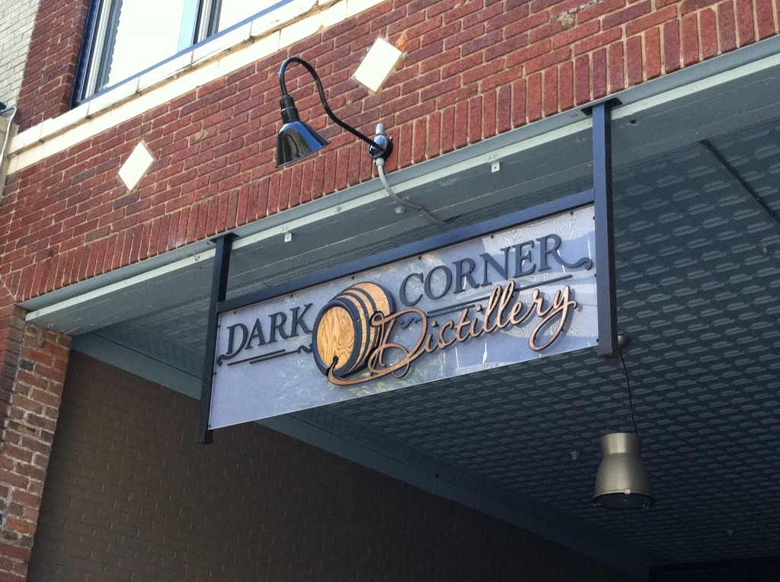
George Jones and Jimmy Buffett sang about IT.
Otis tried to get IT past Andy and Barney — only to be foiled as he rode a cow through downtown (though he did convince the Morrison Sisters that “National Potato Week” was cause for celebrating with IT).
Bo and Luke Duke faced the wrath of Sheriff Roscoe P. Coltrane because Uncle Jesse and Boss Hogg “ran” IT.
NASCAR was founded because of IT.
Now, with open arms, IT welcomes people to the north end of Greenville’s Main Street.
IT, you may have figured out by now, is bootleg, firewater, home brew, hooch, mountain dew, rotgut, white lightning.
IT is moonshine, and under a relatively new South Carolina law allowing microdistilleries, this traditional Southern liquor has moved from the light of the moon to a downtown storefront and in to a new era of legitimacy.
Dark Corner Distillery Co-Owner and Clemson engineering graduate Joe Fenten talks with CRESCENT about the time-tested processes he uses to put a moonshine still on the Main Street gateway of a city that’s on every magazine’s travel list today.
A MOONSHINER WALKS IN TO A MAIN STREET DISTILLERY AND WANTS TO COMPARE STILLS…
I told him we made a few modifications. We wanted to keep the equipment and methods sort of time-tested. So we knew there were basic principles we needed.
We needed a copper pot. Pot stills are known for flavor and quality. The Scots-Irish still use pot stills today to make Scotch whiskey or Irish whiskey. So we knew we wanted a copper pot for flavor and quality. We knew we wanted 100% copper. Copper sort of has the ability to extract all flavors from the spirits so the more copper contact with the distillate or the spirits, the better your spirit’s gonna taste. In the 1700, when the Scots-Irish moved down through the Shenandoah Valley into this area, they actually strapped their copper pots on the bottom of their wagon when they came over. Sort of like taking your mixer or your waffle machine when you move from an apartment to a house. That for them was a typical piece of equipment used on a daily basis to make whiskey. So there are tons of copper pot stills you can see today whether it’s on a piece of land, a rusted copper pot, or whether it is in an antique store. We knew that we wanted a copper pot. The problem was that the price of copper was going up in the 18th century and it was harder to come around copper as opposed to steel.
A steel barrel was easy to come by so folks began to use steel instead of copper which still doesn’t have the ability to extract out the off flavors from the spirit like copper does. So the moonshiner said that his operation used steel barrels and four steel barrels welded together with the middles cut out. He pretty much had a 200 gallon process. So that was the major difference.
He was used to using steel barrels while we were used to using copper.
And another thing was, his stills he built, which are reminiscent of stills you can still find in the Dark Corner, they didn’t have a head on them, so our copper pot has a head on it, which is the bulbous thing on the top.
It is really neat because it helps with reflux which cleans the spirit up, gives you a little more alcohol, makes it a little bit smoother. So that was the major difference.
Now all the moonshiners used to use what they called “little man” or “thumper.” We had built and sized a little man or thumper for our system and pretty much the idea is that, in between your cooling condenser and your copper pot, you’ve got a 55 gallon barrel of either oak, copper, or stainless steel, and it’s filled up with either water or distillate from the previous day and, ultimately, what you’re getting is steam coming off the still that heats the thumper, which is full of distillate or water, and you’re getting a re-distillation. The more times you distill the spirit, the smoother it gets and the higher proof you get off of it. That was another thing. He noticed that we had removed our thumper. We took our thumper out because you get some pressure problems with thumpers. Pressure is not a really big problem with what we’re doing today because we hardly get any pressure. The system is actually open on the end for the distillate to come out, but the pressure built-up in the thumper, let’s say, if you had some solids block the inlet to the thumper, you get some bad pressure build-ups. There are plenty of pictures where moonshiners have blown up thumpers from too high a pressure. We can’t have that. So that was the two major differences in his system and ours.
IT MIGHT NOT TAKE AN ENGINEER TO MAKE MOONSHINE, BUT IT HELPS.
I think a lot of people are very surprised by it (chemical process of distillation) and don’t really…you know, it’s almost hard for them to believe that we have to look at the elements of the process that we do.
If you take a typical moonshiner’s recipe, and there are millions of moonshiners so there are going to be millions of recipes, but a typical recipe would be where a gentleman would take, let’s just say some corn meal or cracked corn…about 50 pounds of corn meal and 50 pounds of sugar, they would put it in a 55 gallon barrel, they’d cover it with some lukewarm water, stir it up, pitch some yeast, some bakers yeast or bread yeast, cover it or not cover it, usually they would cover it to keep the bugs out, and they’d let it sit for 14 days and whatever they get when they’re done, that’s what they’d put in their still. So they’d drain it off, throw it in the still, heat it up and cook it and keep most of what they get out. And they kept a major portion of the whole run.
That’s where a lot of people went blind and got hurt. The government started putting out signs saying, “Moonshine is dangerous. Don’t drink the moonshine.”
So comparing to what we do today, there is a lot of science involved. Keeping in mind, we want to keep it a time-tested product but, at the same time, there are certain things we can do to make the flavor better or we can increase the time that we do it, just by simple things that are more science than techniques that were passed down from generation from generation. So yeah, there is a lot of science involved and there are a number of elements of it that a lot of the moonshiners…some of them probably knew more about it than I’m claiming, but you have guys who don’t know a lot about yeast, that really don’t understand enzymes and why they do what they do. They don’t understand the different cuts you make on the distillate to get a smoother product, to get more character for the whiskey.
So yeah, we get very, very deep into it. We want to understand how the settlers did it but we also want to understand today how to make the process better and make the product more palatable for the consumer.
IT TAKES TIME TO COME UP WITH THE RIGHT RECIPE.
You know, I guess I came into the venture as a huge whiskey fan. I had an idea of how I wanted the whiskey to taste. I also had hundreds of whiskeys before to where 80% I pretty much said, “That was nothing great. I don’t really enjoy that.” The other 20% I found qualities in it I really liked.
For me personally, I like sweeter whiskeys as opposed to spicier whiskeys. And I have found that rye doesn’t really give me the flavor that I enjoy. Now, a lot of present day shiners really enjoy rye. I’m not crazy about it. Your typical Bourbon recipe would be corn, rye and barley. We chose not to use rye in our final recipe. We use red wheat, which we really like.
So to get to that point, we actually did 34 test batches and the first couple we did, honestly, were just not good at all. I’ve got a sample in the back. I think that’s typical for anyone that makes their first shine or product. I think it’s that way with beer, as well. Had to get over some humps and some learning curves, just like a lot of moonshiners do. You taste it. You do the process and realize, “This is terrible. Nobody is going to drink this.” So we got up to about recipe 8 and 9 and we said “Wow, this is really starting to turn around.”
We started smelling recipe 1. We said “Gah, that’s a lot better than recipe 1.” We found that every 5 recipes we did, the 5 before were not nearly as good as the one we’re presently on. So it was like we evolved quick and fast.
We got better and better at what we’re doing and we’re homing in on what we wanted. By the time we got to recipe 20, it came off the still and we had a couple of guys from Blue Ridge Brewery here, I had my best friend here, my business partner. We’re all in still area getting ready for the hearts which is just the most magnificent portion of the whole run. It tastes the best. It’s smooth. Everyone wants to taste the hearts. I pulled off a little bit for everyone, and the first thing everyone said on their face was, “It’s creamy. It’s buttery. It’s sweet.”
At that point, I knew we had what I thought we were looking for. If you tasted the hearts of our recipe of recipe 22, it tastes like caramel or cotton candy. It’s really nice, it’s different.
I use the word different because every spirit we make we try to be different. It’s all about innovation. If you want a 200 year old recipe, there are plenty of those out there. Just go get a bottle of Jack Daniel’s. We didn’t want that, we wanted something different.
When we hit recipe 22, it was different, it tasted good and it was on the sweeter side, which is what I was looking for. Now tasting a lot of the competitors’ clear whiskeys, it’s (DCD’s product) a sweeter whiskey. I have yet to have one which is as quite as sweet as ours is. Not to say they can’t make a sweeter whiskey, it’s nice and sweet. So 22 was perfect for us so when we went to 23 and we tried to sort of perfect 22 and make little minor modifications to see if it made it a little bit better.
So by the time we got to 28, we were actually working in the wrong direction. We went to 28 to 34 for a few more tries and at 34, we said, let’s back up. 22 is our best. Let’s cut it there. So out of 34 recipes, 22 was by far our best.
THINGS A SHINER MIGHT DRINK IF HE’S NOT DRINKING HIS OWN PRODUCT
I like…just keep in mind that when someone comes to the tasting bar and the first thing I start talking about is settlers’ whiskey and I talk about the Scots-Irish settling the area, I never had a 1700s whiskey, obviously, but after reading, doing research, talking to families that settled the area back then, the descendents of the families and listening to the way they drink their whiskey and the qualities they enjoyed in the whiskey, it was clear to me that I wanted us to produce a whiskey in that style.
There are a couple of words that really jump out when I say that. I’m looking for a full-bodied, oily whiskey. Oily, fatty. Both of words work out really, really well for me. A lot of people hear it and say “I don’t want fat in my whiskey. I don’t want an oily whiskey.” But, honestly, once you’ve had an oily or fatty whiskey, you realize that’s where all the flavor’s at. It’s in the oily whiskey. It really coats your mouth. It’s not thin. It doesn’t feel like it evaporates. It hangs around when you drink it. That’s the type of whiskey we wanted to make.
Now, as far as in the industry, who makes a whiskey that’s similar to our moonshine right now? I got hooked on Red Breast. It’s an Irish pot-distilled whiskey. It’s very, very, oily. Coats the glass well. Has very thick legs if you look at it in the glass. Just a great whiskey. That’s probably my personal favorite that I’ve had thus far would be the Red Breast.
It’s very good. Sometimes it’s hard to come around. You’ve got Red Breast and Green Spot, two Irish whiskeys that are known for their oily character, being a full-bodied whiskey.
Just keep in mind, the idea of being different is really, really cool for me. Change is not always the best thing in the world, but right now, in the spirits industry, I like the idea of change because we’ve got some guys who have been producing the same stuff for hundreds of years. Same recipe. They’ve got rick houses, and by “rick houses,” I mean a place to store all their barrels. They’ve got rick houses that are as big as a Lowe’s and they’ve got them lined up one after another so you’re talking about millions of barrels of whiskey lined up to be bottled. So I’m all about being different. I like the idea of different. And with that, one thing I’ve learned is that the palates of people in general, not just Americans, the palates of people in the world that drink spirits and beer have lightened.
And by that, I mean, you’ve got a lot of us drinking Bud Light, Miller Light, Pabst Blue Ribbon for beer and then you’ve got a lot of people drinking blends. They love these blended whiskeys. Every guy in the world is like “Just give me a bottle of Crown for Christmas.” That’s a blended Canadian whiskey. Over the past hundred, hundred and fifty years, our palates have lightened and manufacturers have realized it’s much easier to water-down or blend a whiskey than making their own whiskey and not adding water than it is to make a quality product the way we’re doing it. So people automatically go into that mode where they think, “Give me a Bud Light,” or. “Let me get a Crown on the rocks,” because that’s what they’re used to.
They taste our whiskey and they’re a little bit shocked because it is…it’s mouth-filling. It’s very oily. It’s a full-bodied whiskey. There’s not many of them you can actually buy in the store. and if you consider the fact that most packaging stores whether it be Green’s or Total Wine, I challenge you to go in and ask for a micro-distilled whiskey. You’d be lucky to get one at any store. They just don’t carry them. So, unless you’re in the area where there is a microdistillery which, obviously, they’re hard to come buy lately, you won’t get a chance to sample something like that. Like a full-bodied whiskey like we make.
Stay Tuned for Part 2 Next Week.
Tweet

Comments

CRESCENT People: Aaron Tippin (Part 1)
Published Date : October 31, 2011
Author : admin
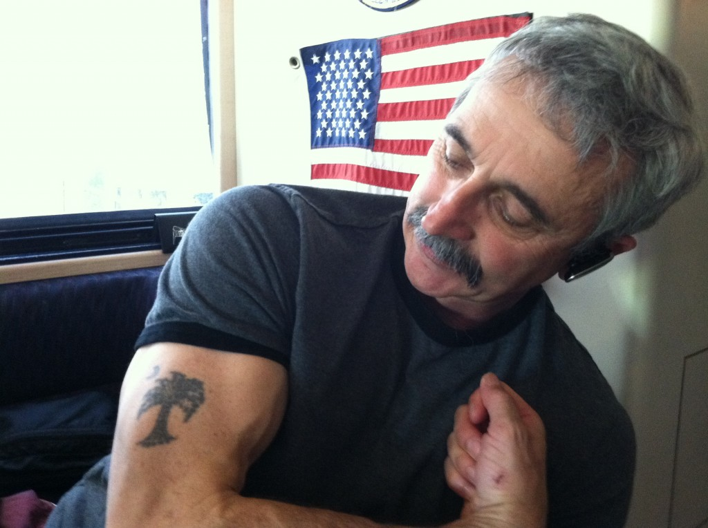
You’ve got to stand for something, or you’ll fall for anything.
It’s great advice to get and to give, and for South Carolina’s Aaron Tippin, it put him on the highway to country music super stardom.
With nine studio albums (five gold and one platinum), Aaron has had over 30 singles on the Billboard chart including 3 number ones and a string of top tens.
Traveling the world performing for American troops overseas, signing at venues across the country, and still recording music that resonates with country music audiences, Aaron is continues earning his “Working Man’s Ph.D.”
On a recent tour stop in the Palmetto State, Aaron closed his MacBook and sat down with CRESCENT to talk about coming home, the rebirth of country, and how the industry has changed.
AARON COMES HOME
I’m glad to be back home. Even though most folks may not know, I wasn’t born in South Carolina. I was actually raised here, and if anybody asks me where I’m from, I always say South Carolina.
The way I talk, the raisin’ I had definitely came from here. In that regard, I consider myself a South Carolinian, enough to where I’m wearing this tattoo which is the South Carolina state flag, so, to me, that makes me a South Carolinian.
My daughter still lives here (Blue Ridge/Travelers Rest), Charlotte. Matter of fact, I’m a brand new Pawpaw.
There’s been a lot of excitement in our family. She’s the only one left up there, though. My Mom is gone. Both my sisters, one of them lives down south in Greenville. The other one lives in Florida. And Dad’s gone. He lived his last years in North Carolina. She’s the only one left where I grew up.
VISITING THE OLD HOME PLACE
Oh, man. It breaks my heart to go back and see my home place. That’s the farm, where I grew up and I look up there, and that’s my home. Somebody else is living in it. It’s always tough for me to drive by and look up on that hill. I love to go travel the community where I grew up. I took my boys through there several times and say, “That’s the creek I used to swim in, right down there. We had us a swimming hole, we dammed it up.” All kind of things I’d tell them I did when I was growing up. It’s changed quite a bit. Lots of development out there where I grew up on Jug Factory Road. Boy, now, there’s houses lined up and down it. Used to be nothing but woods. Boy, me and a dog and a .410 shotgun.
THE EARLY 90s: A REBIRTH OF COUNTRY MUSIC
Those were great days in country music. The biggest genre on the radio stations. Country was big. I wrote a song of that time called “I Was There the Day Country Took the Throne,” and it was a great heyday. Me, Joe Diffie, Sammy Kershaw, Mark Chestnut, heck, there were a ton of guys who all came out about the same time. Tracy Lawrence was right behind us. It was just really, really awesome days, boy. Country music was big and everybody was selling platinum records. It was a time when the music ruled, and it showed. It shined. Folks came to the shows in droves. We sold a lot of records, and things were good. Somewhere along the way, I guess the formula got changed, but those were good days. I’m happy to have been in that class because still to this day, I can go places and they’ll go “Wow, we saw you back in 1992. Your song had just come out.” It was just an awesome time. I remember those days and how great they were.
CHANGES IN THE MUSIC INDUSTRY PROVIDE ADVANTAGES
Well, it’s changed quite a bit. The recording industry…I was one of the first guys to ever record digitally in Nashville. My album was the first on RCA to be digitally recorded. That was all new. And that went from being digitally recorded to being nowadays it digitally recorded but it is so simple and so easy to do. Sitting in front of me is a Mac laptop and you can record a whole session, master an album, on this computer. It’s very capable. It has a program that fits right in. It’s very different. We don’t have to spend as much time in the studios as you used to. I have a small studio at home and do all my vocals and all the backup vocals. We do ‘em all at our house, at our own studio. We’re capable of doing that instead of having to pay for a big studio downtown. In that regard, it’s really, really moved, advanced and been quite an advantage for somebody. Now, myself, having my own record label, doing more than music, I feel that Aaron Tippin fans want to hear out of Aaron Tippin. It’s a blessing to have that opportunity now to be able to do my vocals, do other parts, guitar parts, harmony parts, everything right there at my house. I get a chance to stay on the job a little bit more without having to drive so far.
For Part 2, Click HERE.
Tweet

Comments

Free Lunch? No. Free Gift? Yes
Published Date : October 30, 2011
Author : admin

You’re right. There is no such thing as a free lunch, but we do have a gift for you.
We want to build CRESCENT’s readership the right way. First, we want you to like what you read. Second, we want you to tell your friends that you like what you’re reading and encourage them to read us, too.
You’re asking yourself, “How can I help?”
Well, we’re asking that you send the following message to your email contact list:
I wanted to tell you about a new web-based magazine that focuses on what’s good about South Carolina. It’s called CRESCENT, and you can find it at www.CrescentMag.com.
It’s easy to view on your computer, tablet, or smart phone, and it does a great job bringing current events and lifestyle issues together.
You can even sign up for a free subscription to be delivered to your inbox every week by going to www.crescentmag.com/subscribe. All you have to do is enjoy the articles, but if you want to interact with CRESCENT, you can also “Like” CRESCENT on Facebook or follow CRESCENT on Twitter.
Sign your name to the email, and that’s all it takes. When you send it to your contact list, make sure you copy tell_a_friend@crescentmag.com on the message. Every person who gets at least ten new readers to subscribe will be entered to win a special gift.
So, there may not be such a thing as a free lunch, but there is such a thing as a free gift from CRESCENT.
Tweet

Comments

WHAT'S GOING ON: Congressman Tim Scott to Conduct Presidential Town Hall with Senator Rick Santorum
Published Date : October 28, 2011
Author : admin
Congressman Tim Scott (R-SC1) will host Senator Rick Santorum in the next installment of his First in the South Presidential Town Hall Series, on November 12 at 11:30 am, at the Summerville Country Club in Dorchester County. Refreshments will be served.
The Town Hall will follow the format of Scott’s previous events with Presidential candidates, allowing as many voters as possible the chance to ask Senator Santorum a question. In addition to questions from the live audience, voters can submit their questions on Facebook.
“The race for President in South Carolina is far from over,” said Congressman Scott. “Many Republican voters are just beginning to tune in, and they are looking for a leader who will articulate – and fight for – conservative values. Rick has a proven record as a conservative – in a state where it is not easy to be one – and he brings an important voice to the race for President.”
“I am excited to join Tim for the Town Hall,” said Senator Santorum. “The people of South Carolina made a tremendous decision in electing Tim Scott to Congress in 2010 and he has been a leading conservative voice from the moment he arrived in Washington. I look forward to the opportunity to join him as we discuss solving the critical issues facing South Carolina and the nation.”
The Town Hall, set to last 60 minutes, will begin at 11:30 am at the Summerville Country Club, 400 Country Club Blvd., in Summerville, South Carolina. Doors will open at 10:30 am, with seating on a first-come, first-served basis.
Senator Santorum is the fifth candidate to participate in Rep. Tim Scott’s First in the South Presidential Town Hall Series, which brings 2012 Republican presidential candidates to South Carolina for discussions with grassroots voters. Previous town halls have been held in Charleston, Berkeley, and Horry counties.
The series is cosponsored by the Berkeley County GOP, the Beaufort County GOP, the Carolina Forest GOP, the Carolina Patriots, the Charleston County GOP, the Charleston Tea Party, the Dorchester County GOP, the Georgetown County GOP, the Georgetown Patriots, the Goose Creek 9/12, the Horry County GOP, the Horry County Young Republicans, the Mount Pleasant 9/12, the Myrtle Beach Tea Party, the North Myrtle Beach GOP, the Northern Horry County GOP, the South Strand GOP, the Summerville 9/12 and the Waccamaw Neck GOP.
“Our country is ready for a new beginning,” said Congressman Scott. “Our Town Hall Series gives South Carolina voters the opportunity to actively participate in that process, and make sure we get it right – as we have done in every Presidential election since choosing Ronald Reagan in 1980.”
For more information, or to submit a question to be asked of Mr. Santorum, please visit: www.timstownhalls.com.
Tweet

Comments
Spartanburg Tea Party » Tim Scott to Host Rick Santorum Town Hall
[...] Crescent Magazine reports that Rick Santorum will be Tim’s next guest. I guess Rick will be seeing a LOT of SC as the November 12 date is the same date as the Wofford debate here in Spartanburg. Congressman Tim Scott (R-SC1) will host Senator Rick Santorum in the next installment of his First in the South Presidential Town Hall Series, on November 12 at 11:30 am, at the Summerville Country Club in Dorchester County. Refreshments will be served. [...]

WHAT’S GOING ON: UPDATE -- Greenville Neighborhood Area On Lockdown As Police Search For Suspect
Published Date : October 28, 2011
Author : admin

Around 9:40 a.m., a police officer conducting a license plate check at a Laurens Road area motel discovered a tag that was later found to be stolen. The officer worked to identify the vehicle’s owner, and the suspect fled the scene in a silver Chevrolet Tahoe. A chase ensued, but since it was only a traffic violation at the time, the officer terminated pursuit.
A female City of Greenville Police officer saw the vehicle in the Berkley Point Apartments and attempted to locate the owner. The suspect (a black male wearing gray pants and a gray shirt, aged 30-35, and with long hair tied in a pony tail) fired at the officer from a breezeway. The officer sought cover and returned fire.
The two exchanged multiple rounds, and the officer was not hit. It’s not currently known if the suspect was hit.
The suspect fled and is being tracked by K-9 units and the Greenville County Sheriff’s Office helicopter. SWAT, SLED, Highway Patrol, and the Greenville County Sheriff’s Office are on scene assisting with the search and investigation.
Christ Church Episcopal School, St. Joseph’s Catholic (Middle and High) Schools, Sara Collins Elementary, Washington Center, Patrick Center, JL Mann High School, Greenville Technical College, Virginia College, Our Lady of the Rosary Catholic School, and the UPS distribution facility are all on lockdown.
Law enforcement officials set a wide perimeter that includes Mauldin Road (from I-85 to Cavalier Drive), East Parkins Mill Road, and Fairforest Way at Ridge Road.
Area residents are urged to stay inside with their doors locked and to call police at 911 if they see anything suspicious.
UPDATE: After an exhaustive day, Greenville area law enforcement officials have called of the search for the suspect now identified as 25 year old Patrick Dean Lowrance of Duncan, SC. Greenville Police Chief Terri Wilfong said around 4:00 this afternoon that she and others feel, based on evidence, that Lowrance was able to get outside the police perimeter and escape by vehicle with the aid of an unknown individual or individuals. Wilfong said that based on conversations with someone who had been in contact with Lowrance, he was apparently hit by a bullet. She said local area medical facilities have been alerted to Lowrance’s condition. While the search area has now reopened and Lowrance is not believed to be in the area any more, Wilfong said that people need to remain observant of their surroundings, “act smartly,” and to call 911 if they observe any suspicious behavior.
UPDATE: Responding to a tip, Greenville County deputies arrested Lowrance at a home located at 105 Mooremont Avenue in Greenville County.

Tweet

Comments

