Created in the cloud with Aspose.Words for Cloud. http://www.aspose.com/cloud/word-api.aspx

CRESCENT People: Kelly Tilghman. 15 Years at Golf Channel, but Her Heart’s Still in Horry County
Published Date : December 12, 2011
Author : admin
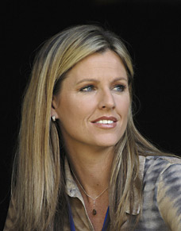
Being part of Golf Channel’s original team, what were those first days like? Getting in on the ground floor. Launching a network. What did you see the network becoming and has it gotten there yet or are you still moving forward?
You know, it’s funny. When I started there, it was July of ‘96. I believe we were in 100,000 homes, and there was all this speculation of people starting to want to buy us out. We had private investors, and there were these larger corporations looking at us… like Fox was taking a peek. Who was going to buy the place out? The future was really undecided. Shaky at best. And then flash forward to today.
We’re in some 83 million homes. You can add millions to it if you want to go the international route. Worldwide, it’s 120 million. We went from 100,000 to 120 million in my span at the Golf Channel about 15 years I’ve been there now. Just celebrated by 15 year anniversary in July. So that’s a lot. And every time I thought we had hit the ceiling, somehow we busted through it. It’s always been a glass ceiling at Golf Channel and that’s one of the reasons I’ve never left.
I mean, I’ve had opportunities to go elsewhere. Sure, they’ve been tempting, but Golf Channel has always, always broadened its horizons and I love that about it. If I can stay close to golf, why would I want to leave? And Golf Channel keeps making it easier and easier to stay. It’s just a great place to work. I’m astounded at what they have been able to accomplish, but all the while, I believe in them.
But starting with such limited partnerships with the (PGA) Tour and now, it is an integral partner of the Tour.
Yeah, I mean it’s really mind-boggling when you really think about it. Back in ‘06 when all these negotiations were going on, you’d hear rumblings that maybe Golf Channel was in the mix for some tournaments on our air and you just weren’t really sure how much of the pie you were going to get. When I heard we had landed a 15 year deal, I was just shocked and amazed, excited, thrilled. There aren’t enough superlatives to describe what was going through all of our bodies. We were ecstatic. So that’s kind of where my break came along.
I remember a VP at the time, named Tony Tortorici, called me in his office. I was hosting a lot of studio shows, kind of the company mutt. “Versatile” is the word that I think is on my bio. It is kind of more glamorous version of the word “mutt.”
You mean “utility player?”
Yeah. Utility player. I had kind of done everything in the studio, and he called me in and said, “Kelly, we’ve been looking at potential names to do some play-by-play, and I thought about you. I thought you pretty much made a living by teeing guys up. And all the shows you’ve ever done and we’ve always thought you’ve done a nice job. What do you think? Would you like to do this?” I thought, “Wow, I never thought about it before, but, yeah, let’s do it.” That’s kind of how it started.
So now you’re sitting in the first chair. You’re the first female to do that in the history of PGA Tour broadcasts. What kind of pressure do you feel to perform in that role or do you feel pressure? Do you do things the way you want, or are there outside expectations you feel you need to tailor your style to meet?
That’s a great question. I think when I first got the news that I was in this role, there was the initial excitement. I’ve always been one to crave new challenges. Every day, new challenges. Still to this day. To me, that was an ultimate gift for a new challenge. Then the media started pouring in.
A female had never done what we were about to do, and I started becoming the subject of national attention and again, exciting, but I also began to feel that pressure. Saying to myself, “I’m going to have to perform.” I’d never called a tournament before in my life, and our company kind of wanted to save it for that moment. I’d gotten some practice in privately, but I hadn’t called one publicly for the television audience. Yeah, there were a lot of emotions churning in there, but when the day finally came, I was ready for it. I had studied a lot of people that were in that job for years. Mike Tirico, Jim Nantz, Dan Hicks. I’d studied people in other sports, outside of those boundaries of golf, as well. And, of course, I had practiced on my own. All that combined, I was ready to get that day over with. But I also wanted to embrace the moment along the way.
What’s your travel schedule like for the year?
You know, I haven’t counted ‘em up recently, but I traditionally do between 23 to 25 tournaments a year. That’s usually a pretty solid number for me. I’ll probably end up right around there this year, too. The bulk of it is tournament broadcasts and then I’ll do “live froms” like at the PGA Championship.
I’ll do 4 or 5 of those a year, actually maybe 6 a year including a Ryder Cup or a President’s Cup and The Players Championship. Yeah, there are quite a few of those as well.
My reporting days seem to be in the past right now. I’ll still do the occasional field report for Golf Channel if it is a special assignment and a special interview, if it pops up. I just love doing those, sitting down with players and getting the chance to dig in a little bit.
That’s a lot of travel every year. How do you maintain a personal life outside of that?
Take it with you at times. The good thing is, when I’m home, I’m home.
I do balance a life of tournament broadcasting and studio work, but I would say there are times when I have 7, 8, 9, 10 days off in a row. Just this year alone, I’m treating myself a little bit. I’m taking 2 baby hiatuses.
I’m taking a couple of weeks vacation here and there in the fall and just unclog, something I’ve really never done before. But after you celebrate a 15 year anniversary, you kind of owe it to yourself. I’m kind of a go, go, go person, I don’t like to sit still very much, but believe me, when my days off come, I don’t sleep in. I’ll shoot out of bed, but I will relax throughout the course of the day in different ways. Sometimes, relaxing for me is getting on a kayak or taking a long walk with my dog.
Chefs tend to stay far away from a kitchen when they aren’t cooking, and many will even admit that their favorite place to eat is Waffle House. When you’re not on camera, in the studio, or working a golf course, what are you doing for fun? What are those things that entertain you?
I’m running. I like to do races. Half marathons. Triathlons. I’m constantly participating in some type of road race to keep the competitive edge going.
I’m also a big water person. I do a lot of wake boarding, wake surfing, boating and I’m huge on that. A little surfing here and there. As I said, extremely outdoorsy.
My dermatologist is mad at me for that, but I love it. That’s how I get away.
Anything but golf.
People ask me how many rounds I play a year thinking I’m going to throw out something in the 50s or 60s, and I’m telling them 5 or 6 and it’s all charitable.
I don’t crave the sport like I used to because I eat, sleep and breathe it verbally and visually. I love it, I just don’t want to eat too much of it.
How often do you get home? To North Myrtle?
The goal is once or twice a year. There has been the occasional year when it has been brutally difficult to get back there.
My mother still lives there. I believe she’ll live there her entire life.
My father retired and got away to the east coast of Florida.
For me, I hope to get back once or twice a year. Don’t want to miss my mother’s cooking around the holidays, but because of my rigorous travel schedule, I’ll try to fly my Mom in to me on occasion to get her out of the city she’s always in. Get away from it and come visit me in Florida or I’ll take her on the road to a city she’s never been before.
One of my goals is to make sure she gets to go to places she hasn’t seen, and I have the unique ability to provide that for her, and I think that’s just fantastic. That’s a way for us to bond and do new things together.
To Read Part 1, Click HERE.
Tweet

Comments

YOUR TURN: “Liberty Summit: The Solution to Our State’s Problems in One Room?” by Phil Noble
Published Date : December 12, 2011
Author : admin
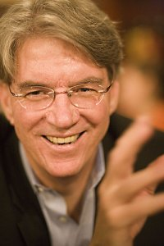
There are those of us who believe that we in South Carolina have within our borders all the resources we need to solve virtually any problem our state faces. Last week, all the people we need to make it happen were assembled in one big room at one time. It was the Liberty Fellowship Summit in Columbia.
Let me explain. The Liberty Fellows program was started by Hayne and Anna Kate Hipp of Greenville, and it is a truly visionary project. It identifies emerging leaders in our state, helps them look at our problems in new and different ways, and then guides them to take positive steps to make the changes we so desperately need. The project is affiliated with the Aspen Institute and its larger global leadership programs. In this state, we are truly blessed to have people such as the Hipps with the vision, resources and commitment to start and run such a project, as well as the universal respect required to assemble such a group.
Each year since 2004, about 20 individuals ages 30 to 45 have been chosen as Liberty Fellows and mentored by senior advisers, older blue-chip leaders in the state. The Fellows go through a two-year long series of seminars, briefings and discussions, and then each Fellow develops their own special project to tackle a specific problem. Their work has begun to make a real difference with some of the toughest issue facing our state — in education, health care, race relations, environmental protection, government reform and a host of other important issues.
Last Wednesday, Liberty Fellows held their second annual summit at the Columbia Metropolitan Convention Center. The event brought together not only the Fellows and their mentors, but also several hundred others from around the state and beyond. The theme was Transcending Tribalism — getting beyond the self-imposed barriers of geography, race, sex, politics, religion, etc., that keep us isolated in our own silos or tribes and prevent us from solving the common problems of our state. Clearly there has been no greater plague on our state throughout its history than these artificial divisions that have held us back.
In addition to the South Carolina leaders, the summit brought some of the best and the brightest from around the county to help grapple with these tough issues. Among them were: Walter Isaacson, president of the Aspen Institute and award-winning author of biographies of Steve Jobs, Benjamin Franklin, Henry Kissinger and Albert Einstein; Gov. Jack Markell of Delaware, one of the most respected and innovative governors in the country; Kim Smith, a founder of Teach for America; Anton Gunn, a former South Carolina state legislator and now Southern Regional Director for the U.S. Department of Health and Human Services and others.
The Summit was not just about a few luminaries sitting up on a stage pontificating with a lot of pie-in-the-sky, thumb-sucker analysis. Instead, dozens of action groups spent three hours delving into the nitty gritty of tackling some of our state’s toughest problems. And most importantly, they developed detailed action plans with specific steps that we can begin to take today to turn things around.
One of the most notable features of the Summit was the absence of high-profile speechmaking by our state’s politicians; there was none. Those few elected officials who came joined in the work like everyone else without any special recognition or leadership role. And, that is as it should be. In the past, we have been too quick to abdicate our civic responsibility to the politicians — and, in turn, they have largely failed us and given us a broken government that has been corrupted by special interest politics and money.
Will this Liberty Summit result in big, immediate changes overnight? Of course not. But something important is happening here: The people of our state are coming together on their own to try and solve our state’s problems with intelligence, vision and a commitment to hard work, and their efforts could have a profound long-term impact.
In the great room of Independence Hall in Philadelphia 224 years ago, our nation’s founding fathers proclaimed that “we the people” are the ones who must make the decisions about what kind of nation we want and then work together to make that future a reality.
There were no three-cornered hats or quill pens and inkwells in the room in Columbia last week, but there were a lot of smart and committed people determined to make South Carolina a new state, a better state — and they just might do it.
Phil Noble is a businessman in Charleston and President of the SC New Democrats, an independent reform group started by former Gov. Richard Riley. Contact Mr. Noble at phil@SCNewDemocrats.org or www.SCNewDemocrats.org.
DISCLAIMER: The opinions, beliefs, and viewpoints expressed by the author are those of the author and do not necessarily reflect those of CRESCENT: The Magazine.
To submit an op-ed for CRESCENT’s “Your Turn” section, please email it to input@crescentmag.com.
Tweet

Comments
wesley donehue
Great stuff. This was my second year attending and i loved it. What an amazing group of people.

WHAT’S GOING ON: NLRB Drops Case Against Boeing
Published Date : December 9, 2011
Author : admin
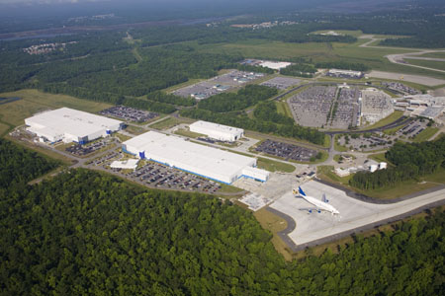
After claiming that Boeing violated federal labor law by locating its 787 “Dreamliner” facility in Charleston, SC, the National Labor Relations Board’s acting general counsel Lafe Solomon announced today that the NLRB dropped its case against the aircraft manufacturer.
According to Solomon, the machinists union requested that the NLRB withdraw the charges after the union brokered a four-year collective bargaining agreement with Boeing earlier in the week. The machinists union originally alleged that Boeing’s move to a right-to-work state was an illegal tactic designed to punish union workers for previous strikes.
“Based on that request, the administrative law judge presiding over the case dismissed the complaint and remanded the case to our regional office in Seattle for further processing. This morning, Regional Director Richard Ahearn approved the union’s written request to withdraw the charge, and the case is now closed,” Solomon said.
He added, “After we issued complaint in April, and as the trial began in June, the parties came to realize that their mutual success required a new approach. The result is a contract that helps guarantee their success and creates job security for workers. I am pleased that the collective bargaining process has succeeded and that the parties have begun a promising new chapter in their relationship.”
The business community expressed a somewhat different tone for the situation. “Although it is a welcomed development that the NLRB is dropping a complaint that never should have been brought in the first place, more needs to be done to prevent this outrageous overreach in the future. The NLRB case against Boeing will stand as one of the great examples of pro-union activism and government overreach in history. Congress should recognize this unfortunate episode by passing legislation that restores the confidence of American employers that their investments in this country aren’t subject to the whim of an unaccountable board with a political agenda,” Randy Johnson, US Chamber of Commerce senior vice president of Labor, Immigration, and Employee Benefits said.
Tweet

Comments

WHAT’S GOING ON: Senate Panel Votes to Prohibit State Agency Deficit Spending
Published Date : December 8, 2011
Author : admin

A state Senate Judiciary Committee panel favorably polled a new set of initiatives yesterday designed to curtail “fiscal irresponsibility in state agencies,” according to Senate Republican Caucus spokesman Wesley Donehue.
The panel’s slate of bills targets waste and is aimed at making agencies more accountable for spending practices.
Measures include spending caps, deficit limits, and budget provisions “that will benefit South Carolina taxpayers and reflects our commitment to a smaller, leaner bureaucracy. They will introduced for consideration by both houses in the upcoming legislative session,” Donehue said.
According to a caucus statement, “For years it seems that state agencies have dodged fiscally sound management, and as a result not only the agency has suffered, but the taxpayer has as well. Rather than implementing cost-effective, results based solutions to serve the public; state agencies have gone with budget increases as a quick fix. An increased budget in turn has only created more waste and financial mismanagement. These measures will serve to tackle the root of the problem- how agencies function and disperse funding to programs in the first place.”
“Instead of throwing more money away in hopes of a solution, agencies can eliminate unneeded programs and divert funding towards a realistic, ‘fiscally fit’ agenda,” Donehue said.
Tweet

Comments

WHAT’S GOING ON: Spartanburg and Amazon Reportedly Agree on Deal
Published Date : December 8, 2011
Author : admin
After delaying a vote that would bring an initial investment of $50 million and a total of 400 new jobs to one Upstate county, Spartanburg County Council has reportedly reached a deal with Amazon.com (NASDAQ: AMZN) to clear the way for the company’s new distribution center near I-26 on John Dodd Road.
Included in the online retailer’s incentive package will be a 30 year fee-in-lieu of taxes (FILOT) agreement, but when council meets tomorrow morning for a third reading and final vote on the deal, more details are expected on the plan that was known for months only by the code name “Project 300.”
According to Spartanburg County Council member Roger Nutt, “Spartanburg is poised to play a pivotal role in South Carolina’s economic recovery and is consistently ranked in the top 5 places in the nation for new business location by Site Selection magazine”
Nutt added, “As a councilman for Spartanburg County, I realize that if you want to bring jobs to your area, you have to take care of the Big 3: infrastructure, workforce, and customer proximity/access. We have worked very diligently here in Spartanburg to ensure that we are ready for whatever comes our way. We’ve been working on the Amazon deal for a while now, and we are all very pleased that it’s finally coming to fruition. Companies like Amazon certainly get a lot of media attention, as they should, but all along we’ve been bringing new businesses in at a steady pace and filling up much of our available square footage around the county. South Carolina will certainly recover from this bad economy, and it is my intention to see to it that Spartanburg leads the way.”
Tweet

Comments

WHAT’S GOING ON: Lowcountry Experiences Earthquake, but Many Slept Through it
Published Date : December 7, 2011
Author : admin

The US Geological Survey recorded a magnitude 2.2 earthquake 5 miles SSE of Summerville around 4:49 this morning.
Although the rumbling could be felt as far away as Atlanta and Savannah, according to South Carolina emergency management officials, there were no reports of damage in the affected areas.
The state’s history of quakes makes it no stranger to seismic activity, but today’s 2.2 is nowhere near the East Coast’s benchmark earthquake in Charleston which registered a magnitude 7.3 in 1886. That quake could be felt as far away as New York and Cuba.
If you felt today’s rumble, the USGS wants to know. Tell them HERE. Tell us about it in the “Comments” section.
Tweet

Comments

YOUR TURN: “Top 10 Charleston Restaurants” by Joseph Morris
Published Date : December 7, 2011
Author : admin
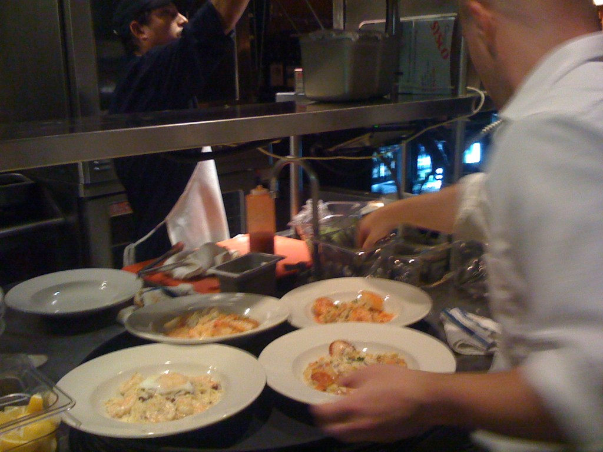
Within the past few decades, the restaurant scene in Charleston has become one of the most talked-about in the nation. Top chefs from all over the nation are flocking to this city filled with historic traditions to create a new spin on Southern cuisine fused with international flavors. Delight your taste buds with fresh seafood, local produce, and some the finest meats in Charleston’s top restaurants.
1. Charleston Grill – Chef Michelle Weaver’s menu takes tradition to the next level by mixing world cuisine with Southern favorites. To complement the atmosphere, a jazz ensemble plays live music every night of the week. Fabulous food and exceptional service put this restaurant among Charleston’s best. Appetizers $12-25 / Entrees $25-48
2. Peninsula Grill – This restaurant has won several awards from publications such as The New York Times, Wine Spectator, and Food & Wine. Chef Graham Daily combines fresh local produce and seafood with ingredients from around the world. In the summer, guests can even eat in the illuminated courtyard. Don’t forget to try the famous layered coconut cake! Appetizers $9-18 / Entrees $25-39
3. Cypress – You’ll find a contemporary menu with a touch of the orient at Cypress. From crispy appetizers to fresh seafood and delectable meats, Chef Craig Deihl’s menu is certainly unique. Aside from the food, the modern interior design presents a departure from tradition. Appetizers $8-15 / Entrees $20-42
4. Circa 1886 – Chef Marc Collins has created a Low Country-inspired menu that’s healthful and full of flavor. Enjoy elegant dishes inspired by Southern favorites without too much butter or cream! Located on the grounds of Wentworth Mansion, Circa 1886 is consistently a customer favorite. Appetizers $8-14 / Entrees $25-35
5. Magnolias – Magnolias opened in 1990 and was one of the first restaurants to spark a dining renaissance in Charleston. Chef Don Drake cooks traditional Southern dishes with an international flair to make your dining experience “uptown…down south” (so the restaurant’s motto goes). In particular, Sunday Brunch is a specialty at Magnolias. Appetizers $5-15 / Entrees $20-32
6. Hank’s Seafood Restaurant – Hank’s is the place to go for Southern seafood dishes. Choose from a variety of seafood platters or pick and choose what you like. For a unique social experience, sit at the Community Table, which seats 15 diners – you’ll get to eat with a whole group of people you’ve never met before! Appetizers $7-15 / Entrees $20-30
7. Hall’s Chophouse – Eat some of the best prime steaks in Charleston in this old-world steakhouse atmosphere. The menu also features fresh seafood, veal, pork, and chicken cooked to perfection. The restaurant also provides vegetarian or vegan dishes on request. You’ll have great food and service in this family owned and operated establishment. Appetizers $7-15 / Entrees $22-85
8. Husk – Since Chef Sean Brock came to Charleston from Nashville in 2006, he has established two high-quality restaurants dedicated to local food. The menu changes daily, but you can be certain to dine on authentic Southern dishes prepared in an innovative way. Appetizers $8-14 / Entrees $22-26
9. Coast – Dine on local seafood fresh from Charleston’s coast. Try classic favorites made in a hickory and oak wood burning grill for a rustic flavor you won’t find anywhere else. You can also enjoy live music on Sunday evenings. Appetizers $7-15 / Entrees $20-25
10. Slightly North of Broad – Affectionately known as SNOB by happy customers and employees alike, this restaurant features an eclectic mix of creative dishes featuring local cuisine. Chef Frank Lee mixes Southern ingredients with French techniques to make an elegant menu. Appetizers $5-13 / Entrees $18-32
Joseph Morris is a longtime food enthusiast who enjoys traveling around the country in search of inspiring restaurants. He also owns the site Culinary Arts College for students interested in getting a degree in culinary arts.
DISCLAIMER: The opinions, beliefs, and viewpoints expressed by the author are those of the author and do not necessarily reflect those of CRESCENT: The Magazine.
To submit an op-ed for CRESCENT’s “Your Turn” section, please email it to input@crescentmag.com.
Tweet

Comments
JD
Charleston has more world-class restaurants per capita than probably any city in the country, unfortunately a list of top restaurants without FIG completely diminishes your credibility.
Stacy
Where's McCrady's on this list? COAST???? Magnolia's? No way man. n
Stacy
Where's McCrady's? Really Magnolia's, SNOB, Hall's, Hank's, and Coast make this cut but McCrady's doesn't. That's silly.
RAP
While this list contains many of the excellent restaurants in Charleston, any list that omits FIG is just not right.
Rick Hiott
You should also try Trotters in the Town and Country Inn

CRESCENT People: Kelly Tilghman. From North Myrtle Beach to Golf Channel's Lead Anchor. SC Remains "First in Golf."
Published Date : December 5, 2011
Author : admin
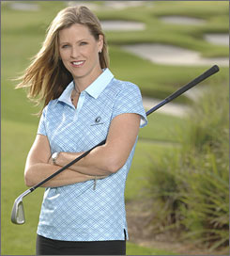
She played golf for Duke and as a professional overseas. She was one of the original Golf Channel team and now works as the lead anchor for the network’s PGA broadcasts – the first female lead announcer in PGA history. She’s North Myrtle Beach’s Kelly Tilghman, and she recently sat down with CRESCENT to talk about the Kelly we don’t see on Golf Channel.
In the first part of the series, Kelly talks about growing up in North Myrtle Beach, her family’s golf lineage, why she left professional golf, and how she “tripped through that door” to initially get in to the broadcast booth.
You really are the face of the Golf Channel, but there is not much out there about Kelly from North Myrtle Beach. There is a lot out there about Kelly Golf Channel, but who is Kelly from North Myrtle Beach?
Born and raised in North Myrtle, in that little section of town right around 11th Avenue. Basically lived in one square block my entire childhood life there until I was 17 and went to college. My father was a politician who also co-owned and operated a golf course for 22 years called Gator Hole. I worked every odd job there. The game was kind of spoon fed to me in that sense. I always had access to it. I also lived on the 3rd tee of a semi-private club called The Surf Club. So I had a lot of access to golf. My mother worked in the radio business for WKZQ. She was in sales and advertising and she is still in sales to this day. She works for Sunny Day Guide now, for 25 years she’s been working there. Long time. Valued employee. My parents were very plugged in to this city. Ambassadors, if you will. Very social, very involved in politics and all kinds of activities that were going on there. Sun Fun Parades, etc., etc. So we were definitely an out-and-about family.
I also was a big time beach kid. Love to surf. We went to the beach every weekend. But golf my primary sport. That and basketball in high school. We had a great basketball team and won the state championship my junior year. So between golf and basketball, I was an extremely outdoorsy, athletic kid. Kinda of kept me out of trouble. So that’s a brief description of life there in North Myrtle Beach.
But just one step further, my roots also come from Columbia, South Carolina. That’s where my mother is from. Her family is the Hemphill family and my grandfather, Melvin Hemphill, was a 47 year teaching professional in Columbia. He and his sister, Katherine Hemphill, are in the South Carolina Golf Hall of Fame. Him for teaching. He actually worked with Jack Fleck before he won the U.S. Open. Worked with a couple of other players before they went out and won their respective majors. Neat story with him. And Katherine Hemphill was on the Curtis Cup team with Patty Berg and the likes of players like her in the 30s. I believe it was 1938. Great golfer in her own right. Strong amateur player. Hung out with Babe Zaharias and all these great players. Many of the founding members of the LPGA. Yeah, golf is in my blood. I would say I’ve got a few drips of the great talent they had pouring out of their faucet, nonetheless, that’s how I got started in the game.
You played professionally, overseas. Why did you leave competitive play?
Annika Sorenstam. Pretty simple. I was paired with her in a collegiate event and I didn’t even know who she really was when I was paired with her.
I played for Duke, she played for Arizona. We were grouped in threes with Tulsa, as well. All three schools playing together. This little blond hitting it 2 clubs longer than me, but she was probably 4 inches shorter than me. Didn’t say a word to either of us in the group the whole round. Shot in the 60s. At the end of the round, I had to ask her how to pronounce her name and she told me. She said “Annika Sorenstam.” I said, “I’m going to have to remember this name.”
My first pro tournament was the Australian Ladies Open in 1994 at Royal Adelaide in Australia, hence the title of the tournament, sorry. That was Annika’s first pro win and I thought, “I can’t shake this woman. She is good.”
So that said, I kind of knew what my competition was like. It was tough to make a big check if you weren’t finishing in the top 20. I made some cuts. I made that one. Made a few others on the European tour. Got my card there. Tried LPGA Q School couple of times. I kinda wasn’t getting it done.
So after sponsorship ran out, I had some local investors from North Myrtle Beach that were pouring money into my account. I could only pay them back incrementally and certainly wasn’t paying them back nearly what they were paying me, so I had to come to the realization that this was a short-lived dream and it was time to get real and move on into a different direction.
So then you moved on to broadcasting. How did you get your foot in the door? That’s a big switch — going from competitive play to broadcasting.
I tripped through that door. It was not intentional in the slightest. I had walked away from the game in ‘96 after the Asian Tour, hung up the clubs.
I had hit balls every day in my life since I was 13. Probably didn’t miss a day. I took about a month off and finally I started kinda wanting to hit some golf balls, so I went out to a driving range and there was a man there who just caught a look at my swing…caught a glimpse of my swing and came over and started watching me hit balls.
He said, “Are you on the tour?” I said, “No, I’m done trying.” He said, “Really?” We talked for a little bit longer and he said, “I can’t help but notice you have this distinctive voice. It is authoritative. Have you ever thought about sports broadcasting?” I said, “Really never.” He said, “Listen, I used to own a broadcasting firm and I’ve got some connections and if you’d like to get an internship at a local station, I can hook you up. You’d have to work for free but at least you’d get to see what it’s like. Maybe put together a resume take and see what happens.” I thought about it for a couple of days and finally gave him a call and said, “You know what? I’m interested.”
So he hooked me up with a local NBC affiliate in West Palm Beach and I worked for free for 2 weeks, shadowing the anchors. I was their gopher. Turns out they kind of liked what I was doing. They started out paying me $5 an hour and after 6 weeks, my time was up.
I made a really, really, really bad resume tape. Gave it to a guy at a Media Day in Port St. Lucie, Florida. A golf Media Day. He worked for The Golf Channel. He took it back. They took a look at it and called me and said, “Come on up in Orlando. We can’t put you on the air just yet, but we like what we see. We’re going to start you in the video tape library.” And that’s where it all began. I was working in the library, checking in and out tapes for people who knew what they were doing. I didn’t have a clue. I didn’t know the difference between a VHS and a Beta. But slowly, I started to learn the difference and that’s where it all began.
Stay tuned for Part 2.
Tweet

Comments

After Two Months, What Do You Think of CRESCENT?
Published Date : December 5, 2011
Author : admin
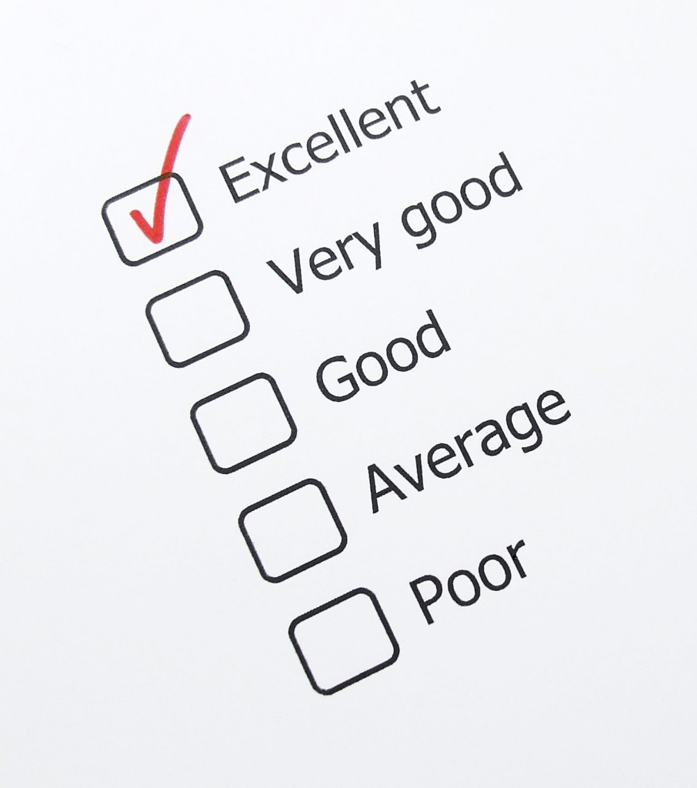
CRESCENT turned two months old this past weekend, and we’re continuing to grow during our soft launch period.
We know we can’t be all things to all people, but we want to put out content that interests you.
Working to give you “South Carolina life, politics, and a little bit in between,” we want to know how we’re doing. Do you like CRESCENT? What can we do better? Where do we really shine?
Who or what would you like to learn about that showcases some of the great stories that South Carolina has to offer?
We want to know, and we’re asking for your feedback. Tell us what you think in the “Comments” section below, and you may wind up with some CRESCENT swag to show for it.
Tweet

Comments

WHAT’S GOING ON: SC State Farmers Market Opens Christmas Tree Season and Opens Holiday Market
Published Date : December 2, 2011
Author : admin
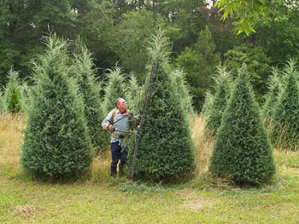
The South Carolina State Farmers Market at 3483 Charleston Highway in West Columbia will officially kick off the Christmas tree season with an evening of family events tonight from 6-8 p.m. The center of attraction will be live Christmas trees, wreaths and other holiday greenery available for sale.
Cookies and hot chocolate will be served, children’s games will be available, and carolers will perform throughout the evening. Attendees will also be eligible to win a Christmas tree from participating vendors.
As a reminder, tomorrow, Saturday, December 10, the SC Specialty Food Association and the SC Department of Agriculture will host a Holiday Market from 10 a.m. to 4 p.m. in the Corbett Building at the State Farmers Market (Click HERE for details.).
Tweet

Comments

CRESCENT Things: Woodlands at Furman to host Holiday Open House
Published Date : December 2, 2011
Author : admin
More than 20 local companies are taking part in The Woodlands at Furman’s inaugural Festival of Trees.
The companies are decorating the trees that will be part of a live auction on Dec. 15 at the Woodlands at Furman. Proceeds of the auction will benefit The Sunshine House in Travelers Rest.
The December 15 Festival of Trees coincides with The Woodlands at Furman’s annual Holiday Open House and Tour of Homes from 4 p.m. to 6 p.m.
The event will feature carolers from Berea First Baptist as well as hors d’oeuvres. Guests are asked to RSVP to 864-371-3123.
Companies taking part in the event include Amedysis, Alzheimer’s Association, Comfort Keepers, The Glade, The Heart Association, Home Care Assistance, Envirocare, Heritage Health Care, Interim Health, Leopard Forest Coffee Shop, Bank of Travelers Rest, Gentiva Hospice, Senior Helpers, TD Bank, Osher Life Long Learning Institute, Walgreens, Southern Care, Brett, Inc. and Love, Thornton, Arnold and Thomason, PA.
The Woodlands at Furman is a non-profit, mission driven continuing care retirement community owned and operated by a local board of directors and managed professionally by Greystone Communities. The 22-acre campus, adjacent to Furman University, opened in March 2009 and consists of 132 apartment homes in addition to 32 assisted living apartments, 16 memory support suites and 30 skilled nursing suites. Residents enjoy a wide range of amenities – enabling them to continue an active and engaged lifestyle. For more information, please visit www.thewoodlandsatfurman.org.
Tweet

Comments

WHAT’S GOING ON: South Carolina Club for Growth Releases 2011 Legislative Scorecards -- Names 43 “Taxpayer Heroes”
Published Date : December 1, 2011
Author : admin

The South Carolina Club for Growth released its 2011 Legislative Scorecards, awarding its “Taxpayer Hero” award to 8 Senators and 35 Representatives based on their voting records since January 2011.
Scorecard ratings are based on 38 votes taken since January 2011 that the group considers “pro-growth and government reform.” According to Club for Growth officials, the House of Representatives had 16 scored votes and the Senate had 12.
Explaining the group’s rating system, votes scored were taken from the best version of the bill or from an amendment that would have strengthened the bill. Scores are on a scale of 0 to 100 with each vote assigned a certain number of points depending on its relative importance. Legislators earn the title of Taxpayer Hero by earning an “A” or “B” rating.
Club for Growth Chairman Bill McAfee stated, “The scorecards are a valuable tool for Club for Growth members and South Carolina voters. Taxpayers in Allendale and Abbeville counties can’t watch every vote on every bill, but this scorecard gives them the opportunity to see if their legislator is just giving them lip service or really fighting for good government and pro-growth legislation. The votes on this scorecard were carefully selected to show how lawmakers voted on meaningful legislation that could bring about actual reform in South Carolina.”
McAfee added, “The 2010 election cycle showed voters are tired of politicians saying one thing and voting for another. This scorecard is a great asset to citizens heading to the polls in 2012. It helps them answer the question, ‘Is my legislator really fiscally responsible or just when they are on the campaign trail?’”
See the SC Club for Growth’s 2011 House scorecard HERE and the Senate scorecard HERE.
SC Club for Growth “Taxpayer Heroes” in the SC Senate
- Lee Bright
- Kevin Bryant
- Tom Davis
- Shane Martin
- Greg Gregory
- Mike Rose
- Greg Ryberg
- Phil Shoopman
“Taxpayer Heroes” in the SC House
- Kevin Ryan
- Rick Quinn
- Ralph Norman
- Deborah Long
- Tom Young
- Gary Simrill
- Garry (G.R.) Smith
- Greg Delleny
- Jay Lucas
- Thad Viers
- Tom Corbin
- Dan Hamilton
- Nathan Ballentine
- Andy Patrick
- Murrell (G.M.) Smith
- Bill Taylor
- Phillip Lowe
- Roland (J.R.) Smith
- Eric Bedingfield
- Phyllis Henderson
- Phil Owens
- Shannon Erickson
- Anne Thayer
- Mac Toole
- Bill Chumley
- Alan Clemmons
- Tracy Edge
- Wendy Nanney
- Mark Willis
- Todd Atwater
- Chip Huggins
- George Hearn
- Peter McCoy
- Mike Sottile
- Kit Spires
Tweet

Comments

YOUR TURN: “Thanksgiving Turkey Wars, Politics, and The Main Thing” by Phil Noble
Published Date : November 29, 2011
Author : admin
Many years ago as a small boy sitting at a crowded and noisy Thanksgiving dinner, I learned a valuable lesson about turkey, politics, and priorities. It is a lesson that our national and state politicians have yet to learn – and it’s hurting all of us.
As with most families, Thanksgiving has always been a big deal in our house. The women (yes, it was always the women) began planning and cooking for the big event days in advance. The relatives would come from far away and we would see those distant cousins that we really didn’t like but were expected to be nice to and play with at family holiday gatherings.
The day’s activities began at the television with the official kickoff event, the Macy’s Thanksgiving Day Parade, and then morphed into a college football game and then into an ever growing crowd of noisy adults that must be kissed hello and then ignored if possible.
This particular Thanksgiving was an especially memorable occasion for me as it was the first year that I was being promoted from the kids table in the corner to the big table with all the adults and most importantly, to a chair within arms reach of the turkey.
The plates were all served and since my father was a preacher, he was always called on to say grace, expressing thanks for all our bountiful blessings as a nation and our family in particular. I understood that this blessing was really supposed to be the main thing, the whole point of the holiday – giving thanks. But, to me, it always seemed way too long, especially as we were forced to sit quietly while the biggest and best meal of the year began to get cold sitting in front of us. Finally, the prayer ended and we could all begin eating.
There is an old saying that to ensure a harmonious occasion, one should avoid discussing politics and religion at the dinner table. With the exception of Uncle Fred, we were all Presbyterians so religion was never an issue. Fred was a rock-ribbed Southern Baptist but since he was so outnumbered by his in-laws, he had the rare good sense to remain quiet about religion. However, he just couldn’t hold his tongue about politics – and thus my life lesson began.
Despite having a shared common Southern upbringing and heritage, our family had a surprisingly wide range of views about politics, and they were not shy about expressing those views. And given that this was the early 60s in the Deep South, there was no shortage of volatile topics to explore.
Well, when Uncle Fred made a racially charged reference to Dr. Martin Luther King, the place exploded.
In about two minutes, we went from polite conversation about the virtues of Aunt Nellie’s sweet potato casserole to loud insults about outside agitators and then straight to a virulent, full-throated defense of the Lost Cause by Aunt Betty Sue, proud Immediate Past President of the Greenville, Mississippi chapter of the United Daughters of the Confederacy.
I didn’t understand very much of what was being said, but one thing was clear to me – while the adults were so busy fighting, they were totally ignoring the food, and I had a clear shot at all the good parts of the turkey.
Within about twenty minutes, the Battle of Thanksgiving Dinner had played itself out. Half the family was threatening to leave and the other half was wishing they would – and all were just plain mad as hell. As for me, it was my best Thanksgiving dinner ever; I was fully entertained by the adults’ harangues while I gorged myself on the juiciest parts of the turkey.
Last week, I thought about that long ago dinner as I watched the Democrats and Republicans in both Washington and Columbia bicker and fight about the latest trivial political issue of the day while the vast majority of Americans were worried about simply having a job and feeding their family.
Gov. Haley Barbour of Mississippi recently remarked about politics, “The main thing is to remember that the main thing is main thing.” He is so right. Today, the politicians, like my family, have ceased to focus on “the main thing.”
People in this country are hurting and they are afraid. Economic forces they don’t understand are hurting them and they are afraid that events beyond their control are going to force them and their children into more pain and even downright poverty.
And when they look to our so-called leaders for help, they see nothing but senseless fighting and bickering, a government that is broken and a politics that is corrupt.
At Thanksgiving, the main thing is to come together as a family and give thanks for all of our many blessing. In politics, the main thing is for our leaders to come together and find solutions to our countries problems.
The main thing is the main thing – at Thanksgiving and every day.
Phil Noble is a businessman in Charleston and President of the SC New Democrats, an independent reform group started by former Gov. Richard Riley. Contact Mr. Noble at phil@SCNewDemocrats.org or www.SCNewDemocrats.org.
DISCLAIMER: The opinions, beliefs, and viewpoints expressed by the author are those of the author and do not necessarily reflect those of CRESCENT: The Magazine.
To submit an op-ed for CRESCENT’s “Your Turn” section, please email it to input@crescentmag.com.
Tweet

Comments
Mark Brian
Sadly, there are those that will discount this excellent article just because of who the author is. Which is a fine example of what this article talks about......

CRESCENT Places: Dark Corner Distillery — Bringing Moonshine to the Sunshine (Part 4)
Published Date : November 28, 2011
Author : admin
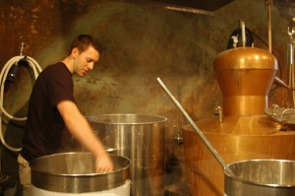
HOW YOUR WIFE DEALS WITH THE IDEA OF YOU MOVING FROM ELECTRICAL ENGINEER TO MOONSHINER
When I went home to tell her, she knows my passion, my drive. She’s seen it her whole life because everything I do I try to be the best at, like all of us. Student body president, captain of the baseball, basketball team. Started an engineering company 4 years out of college and then I had this idea of this distillery. So she’s definitely on board with it, loves it, and what made it even sweeter deal was I told her that if we got our ducks in a row, I’d like for her to be at the distillery while I’m working my full-time job and carry out my portion of the vision here (at the retail store) on a daily basis, which she is doing a good job of.
She’s one of the people that I can rest assured is doing what I want done. She’s treating the customer the way I think they should be treated. I’m a jack-of-all-trades. I’m not really good at anything, but I love people. I know how to take care of people. I’m passionate about taking care of people and that’s what I want her to do out there. I asked her if she would help me make this happen and she’s done a great job. She left her job after 4 years of being the production manager and now she runs our store and the distillery during the day. Yes, she was really receptive of it. Really liked the idea because none of us want to work for corporate America. That’s why I sort of have an entrepreneur attitude and it doesn’t matter what I’m doing.
NOW THAT THE DISTILLERY IS IN OPERATION
We’re very proud of what we’ve done. It’s beautiful, but it takes a long time to make money with something like this because it’s funded out-of-pocket, which means we don’t owe the bank any money, but our 401Ks have been tapped a long time ago. There are no savings. The paychecks go back into the business.
I’ll leave here at 6:30 in the morning, and I’ll be back opening at 10. I’ll do a 20 hour shift on Saturday and can easily work 40 hours here on the weekend. It’s beautiful. It’s not work for me. It’s bettering the industry. It’s providing jobs. It’s being environmental.
Obviously, our historical preservation efforts have gained us attention. I think that’s a lot of word the BBC, the CBC, the Times-News interviews come into play, but you’ve also got this idea where we’re trying to be environmentally sustainable, and I’d like to mention that because with environmental sustainability, we go back to the idea of promoting strong relationships with local organizations and small businesses.
The first thing that we did, we got a partnership with Native Meats, which is a local meat processing company that sources everything between Columbia and here. They don’t go outside that little radius. What they’re doing, they’ve offered to come by and pick up our grains because we have to get rid of them, hundreds of pounds of it a day we have to get rid of. They pick it up in buckets and feed it to the hogs and, in return, they donate us boloney from the hogs, which is really neat. It is just a complete little process. So rather than throwing the grains out, we give them to the Native Meats guys and the grain, at that point is detached of starch. and it’s full of protein. It’s very good grain. The other thing we’re doing is that my 9th grade teacher, Ms. Tawana Weicker, who actually had me suspended in 9th grade, which is really kind of funny. I wish she’d hear that, she gets a kick of that, but she actually has her own biodiesel distillery now and makes her own biofuels. One of her big things also is soap.
She started making WARHORSE soap out of a barbecue restaurant’s left over fat and it has been phenomenal. We use it in our still area to clean our equipment. It’s the only thing that will get the black off of out soda kegs. That’s a really big product so she and I had this idea, well, why doesn’t she try to take some of our methanol, a byproduct that we can’t do anything with because it is pretty dangerous to drink, and she can actually put it in a biodiesel distillery and make glycerin soap out of it. So now, in the store, we carry shine glycerine body gel in men’s and women’s flavors. She takes our methanol and makes a gel body soap which is free of phosphates and sulfates. It is even pet friendly. So that’s pretty cool. Rather than pouring this stuff down the drain, she’s actually using it to make a more environmentally sustainable soap. We’ve got things like that. We even have a project right now to pitch to BMW, as well. So we’ve got a lot of really cool ideas from an environmental standpoint.
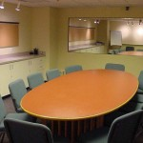




You have a voice. Use it.































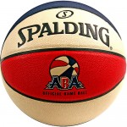

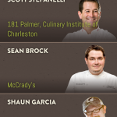





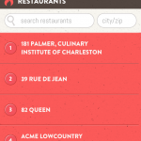



For Part 1, click HERE. For Part 2, click HERE. For Part 3, click HERE.
Tweet

Comments
Tawana Weicker
Some might think it odd that Joe would be collaborating on moonshine spirits, biodiesel, and our newest moonshine-infused soap project with his old high school English teacher. My grandfather and great uncle (Polk County Sheriff for 30 years, Boyce Carswell) ran the 'Shine up in Pea Ridge and even served some time in the state pen. I guess stills and distilling are both in our blood, but my biofuel setup and my glycerin soaps take a different recipe. I am glad Joe isn't harboring ill will from the school suspension incident that he obviously enjoys sharing. I will say he was a dedicated student and a leader in our school--his expulsion is not as "dark" as he might remember. In any case, that is his story to tell. I am just happy to have recycled our connection and now am recycling his unusable spirits into my sustainable biofuel and soap circle. My WARHORSE found a home in his and Roxanne's distillery. And, I handcraft a glycerin-rich, natural soap called "Shine just for their place. My dark soaps shine at the Dark Corner Distillery. Thanks Joe and Roxanne.

CRESCENT People: Aaron Tippin (Part 2)
Published Date : November 28, 2011
Author : admin
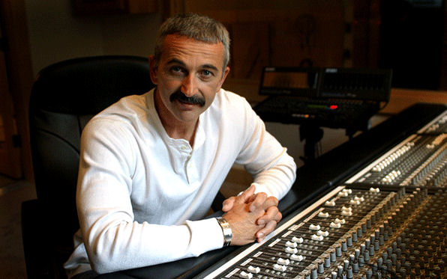
THE RECORDING INDUSTRY TODAY
It’s still the same old way. There are still no stars ever born without a great song. You’ve got to have a great song, and it always starts there. That hasn’t changed. That’s one thing in the music business that hasn’t changed, you’ve got to have a great song. If you do, then that’s the first step. And then just like you said, some young guy who’s really a whiz on these computers can do amazing things with a small bank account can come out with a good sounding record. Everybody, what they call garage bands or basement bands, put out an album that’s just terrific. And they do it just off their computers or laptops.
ON AARON’S iPOD
On the bus, we listen to any great singer. That may range from Frank Sinatra to, heck, to Faron Young. Everything in between. We’ve got quite an array of music we listen to on the bus.
THE CURENT CLASS OF COUNTRY ARTISTS
Pretty different from what we did except for Jamie Johnson, maybe Brad Paisley, pretty different from what I did. They’re the only guys doing country music the way I did. It’s very different, Taylor Swift. Really, girls are kind of ruling the roost right now. More power to ‘em. I have a little trouble relating to Taylor because her songs are really aimed and geared toward a younger audience so that’s probably something that’s different. It’s hard for me to grasp, but you know what? She’s selling a lot of records and obviously doing very well.
OUTSIDERS’ PERCEPTIONS OF SOUTH CAROLINA
I think the first thing anybody talks about South Carolina, the first thing they think of is Myrtle Beach. There’s nothing bad about that. You know, golly, I’ll watch the news and there’ll be something about South Carolina comes up, but there are just as many states and just as many problems that come up. Just as many things that are distasteful that come up on the political scene or whatever but I don’t think we got ‘em any more than anybody else. I think when folks look at South Carolina from the outside, it’s a pretty laid back state. Come here to go to the beach on a big vacation. Golly, I guess we’ve got some of the best golf courses in the world at Myrtle Beach, along the coast. I’m a mountain boy, and quite a few people now are moving up to that area so I think our state’s a cool little state. Like I said, boy, I’m always proud to be from here.
COMING HOME
I always have to go by The Li’l Rebel and get steak fingers and a chili dog. And if I’m in the Upstate and we’re drinking from the Greenville reservoir, I got to have a drink of water from the tap. I’ve got to have a drink of that water. To me, that’s the best water I’ve ever put in my mouth. Every time I come across those hills, I try to stop somewhere and stick my head under a spigot.
A DIFFERENT LINE OF QUESTIONING
Now, I guess they’ve asked me about being hit by lightning twice, almost being plucked out of a baby carriage by an osprey – by the head. I can’t think about much else there is to say.
SUPPORTING OUR TROOPS AND VISITING OVERSEAS
I’m getting ready to leave my family, yes, there’s some risk involved. I do feel very comfortable with our troops. Americans with lots of guns. I’m as safe as I can be. However, there’s an enemy down there, and they can shoot us down as easy as they could the helicopter right behind us. I think you don’t think about that. You think about we’re going to get out there and we’re going to give these guys a little taste of home. When you’re 50 miles outside the wire, there’s not much there, everybody now and then you’ll pass a shepherd and a flock of sheep. You’ll land at a forward operations base and there are the special operations guys. You’ll go jump in a bunker somewhere, play them a few songs, jump back on the helicopter and head back in. That’s generally, how we do it and then we do our …when we arrive at the major base, my crew guys and most of my band guys will stay there and build the stage or put our equipment on the stage to get ready to do the show and me and Dave, my guitar player, we jump in the helicopter and head out the forward operating bases and entertain special forces guys who don’t get anything.
They usually get turkey and Thanksgiving in a bag, but that’s usually what we do and it’s rewarding. I mean, when I come back every time, I’m so proud to be an American, I’m so proud of them, who they are and the job they do. What wonderful, great, merciful warriors they are. They’re the greatest on earth. There is more compassion for the citizens than, I’m sure, any other armed force on the planet. These guys have total regard for the citizens, and their collateral damage is important. When they’re after somebody, what’s going to happen if they do this is important. It’s important. That’s the way we do it. That’s how we think. That’s who we are. It is so different from other countries and how they would conduct war and how we watch them conduct war around the world. We’re definitely a different breed of people.
RESONATING WITH REGULAR AMERICA
Working class America, that’s the meat and taters of the Aaron Tippin career, without a doubt. It’s the music, it’s songs like “You Got to Stand for Something.” It’s songs like “Working Man’s PhD,” “I Got It Honest.” You know, those … I’ve never been one to just put out the next greatest love song. I’m about lifestyle, and that’s what all my music is about. “Big Boy Toys” is another good example. The real people of this world, that’s who I think I’m entertaining, the good working class Americans. Man, it’s an honor to get to do it a little bit different from everybody else. Now, I’m not out there hunting for a love song, I’m hunting for a song that’s going to move them and who they are in their life and about their life and about their job and their family, and their home. That’s where I want to entertain them.
For Part 1, click HERE.
Tweet

Comments

FROM THE DESK OF: Support “Small Business Saturday” All Year Long
Published Date : November 25, 2011
Author : admin

NOTE: While “Small Business Saturday” was this past weekend and today is “Cyber Monday,” there are lessons we need to take with us for our other shopping days during the year.
BY: Taft Matney
Today is “Black Friday,” a day when the members of the brotherhood of man, after giving thanks for the blessings they received in the previous year, shoot each other at 1:00 a.m. in the Wal-Mart parking lot as they begin the Christmas shopping season.
A little pepper spray to gain an advantage over other shoppers is all part of the fun, too. Isn’t it?
In addition to the Clemson/Carolina game, tomorrow is “Small Business Saturday.”
Ironically promoted by American Express, it’s a day when we encourage shoppers to keep their money local, to patronize small business instead of the “big boxes.”
Don’t get me wrong. There’s nothing wrong with the big box retailer. I’ll make my way to more than one of them over the next month where I’ll stand around frustrated because none of the sales staff 1) acknowledge my existence, let alone help me or 2) have a working understanding or even cursory knowledge of the products in the areas of the store where they’re supposed to be working.
Personally, though, I prefer working with small business. It’s the backbone of our economy. It’s the segment that provides most of our jobs. Without it, and by making the business environment hostile to it, we close the door on entrepreneurialism.
Sure. It’s cheaper for me to go to a large retailer and get a pair of pants, but if I go to my local family-owned clothing store, I’m greeted when I walk in and have someone who knows the product and can point me in the right direction understanding my needs.
I could go to the Buy More when my fridge goes out, and when I finally get someone’s attention in the store, he or she will be happy to have someone deliver my replacement unit within 3-5 business days between the hours of 6:30 a.m. and 7:00 p.m., or I could call a local appliance store, explain my situation, and have someone put together some options for me. I can make my selection and often have it delivered the same day. Customer service? I know. That’s just crazy talk.
We shouldn’t dedicate one day a year to promoting small business. We should embrace it whenever we can and do it enthusiastically. You may spend a few dollars more, but the return you get is more than worth it.
From retail to restaurants, towns across South Carolina are filled with locally-owned small businesses that want to see you. Support “Small Business Saturday” tomorrow, and let that be your springboard to supporting small business all year long.
Tweet

Comments

WHAT’S GOING ON: Holiday Market to be Held in the Corbett Building at the State Farmers’ Market in Columbia
Published Date : November 23, 2011
Author : admin
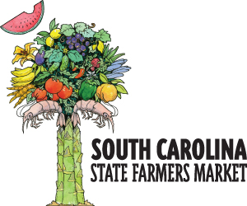
Saturday, December 10, 2011, the SC Specialty Food Association and the SC Department of Agriculture will host a Holiday Market from 10:00 a.m. to 4:00 p.m. in the Corbett Building at the State Farmers’ Market (3483 Charleston Hwy in West Columbia, SC).
Twenty vendors will be on hand offering market visitors specialty foods, soaps, honey, gift items, and other Certified SC products great for holiday gifts.
A vendor will also be available at the Holiday Market with baskets and other containers to create customized gifts so that customers can visit the market, choose items to fill the container, and return to have it wrapped for presentation.
In addition, Jacobs Country Store and Mazyck Store in the Corbett Building will feature specialty items and fresh produce for the holiday season. Judy’s at the Market restaurant and demonstration kitchen will be open, as well.
Outside, farmers’ sheds and other areas of the market will be open to showcase Christmas trees, poinsettias, wreaths, and fresh produce.
For more information about the Holiday Market visit www.agriculture.sc.gov.
Tweet

Comments

YOUR TURN: “Bright Spots in SC Education” by Phil Noble
Published Date : November 22, 2011
Author : admin
When it comes to education in our state, we expect bad news. We have all had that sinking feeling in the pit of our stomach when we pick up a newspaper or click on the local evening news and we see a story about education.
However, there is cause for celebration, really, because we have some ‘bright spots’ that prove we can do things right.
There are a lot of really smart folks who spend their time trying to figure out how to bring about breakthrough change and improvements – in education, in health care, in job creation, and in society in general. A common theme that runs through their work is to begin by focusing on what they call ‘the bright spots’, those examples of where things are done right, where progress is being made and where there are models that can be replicated on a larger scale.
There are many education bright spots in our state and here are just three big ones that we should all know about.
Two Top 100 High Schools – Recently US News and World Report magazine did a study of over one thousand top quality high schools in the country and came up with a list of the Top 100. South Carolina had two schools on the list; the Academic Magnet School in North Charleston was ranked 15th and the Governor’s School for Math and Science in Hartsville was 39th. Both of these schools had a 100% graduation rate and the average SAT score at the Governor’s school was ranked 2nd. That’s right, the average SAT score of a South Carolina high school was the second highest of these Top 100 high schools in the county.
Some skeptics will say that these schools are highly selective and they get lots of attention and they don’t really give a fair picture of what is possible. There may be some truth in this but these schools’ performance is still impressive.
No Excuses Schools – If you were making another type of list with the school districts in the state that had the most going against them, Darlington schools would be on it. The Poverty Index is a whooping 81%, yet their overall ranking on the State’s District Report Card for 2010 was 12th out of 85 school districts.
Overall, the district rating was ‘excellent’; they have a four-year graduation rate of 88% and the parents are deeply involved, with 95% of parents attending conferences with teachers. And it’s not just about money — per pupil spending was $8,779 in the Darlington district or $361 below the state media average.
These stats are for a whole school district and not just one school – and the difference has been leadership. The District’s Superintendent, Dr. Rainey Knight, has been providing strong leadership for eleven years and she has a ‘no excuses’ philosophy of education. Clearly, these kids have a lot going against them but Knight believes in expecting a lot from her students and providing the support they need to succeed, not excuses.
SmartState is Smart – In 2002, the SmartState program was created by the legislature to recruit top quality researchers at Clemson, USC, and the Medical University in Charleston in the hopes of spurring innovation, economic growth and jobs. It’s working. These schools receive state grants of $2-5 million in state lottery funds per school that must be matched by private dollars. The program has created over 40 endowed chairs and Centers of Excellence to lead research teams in such fields as biomedicine, automotive engineering, advanced materials, future fuels and nanotechnology. This seed funding has generated over $1 billion in investment and created 7,000 jobs.
In simple dollars and sense, the return on investment has been tremendous and the jobs they are creating are knowledge and tech jobs that are focused on the industries that will help make South Carolina competitive in the global economy of the 21st century.
Success breeds success and these bright spots, and lot of others in the state, give us something to build on and to be proud of. We can replicate and expand these successes to all parts of our state – especially in those school districts that have suffered the most from years of neglect.
If we as a state are smart enough to focus on these bright spots, then perhaps the next time you see an education story in the news, instead of your stomach sinking with sadness, it will flutter with excitement.
Phil Noble is a businessman in Charleston and President of the SC New Democrats, an independent reform group started by former Gov. Richard Riley. Contact Mr. Noble at www.SCNewDemocrats.org or phil@SCNewDemocrats.org.
DISCLAIMER: The opinions, beliefs, and viewpoints expressed by the author are those of the author and do not necessarily reflect those of CRESCENT: The Magazine.
Tweet

Comments

CRESCENT Things: An Upstate Golf Event Raises the Awareness of Great Need in Pickens County -- Keowee Tees off Fore the Good of the Community
Published Date : November 21, 2011
Author : admin
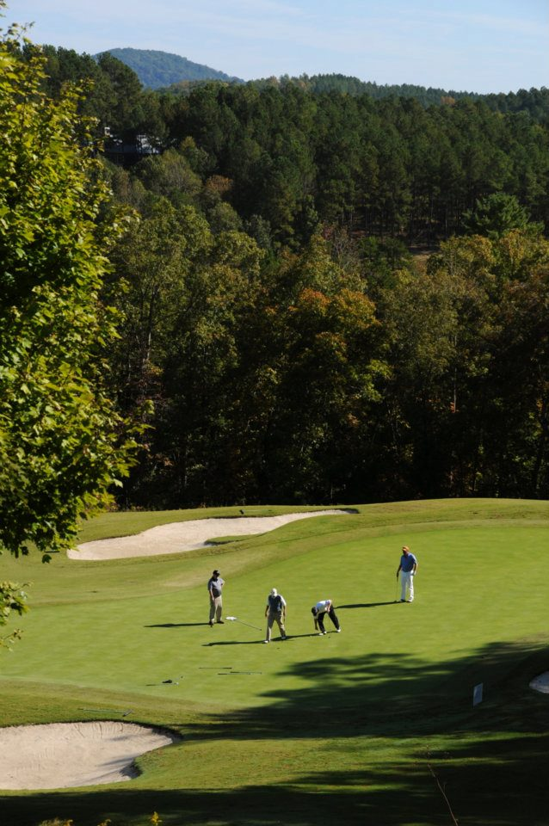
No one likes to think about children or the elderly going hungry, or a child being abused. Unfortunately, these are everyday realities, made worse in times of economic distress. One Upstate community’s residents are trying to raise the awareness of these issues and raise funds to help area non-profit organizations combat them.
The Reserve at Lake Keowee hosted its charitable foundation’s 3rd Annual Golf Classic recently to benefit four Pickens County-based non-profit organizations: Helping Hands; Pickens County Meals on Wheels; The Parenting Place, Home of Prevent Child Abuse of Pickens County; and the A.R. Lewis Elementary School’s Weekend Backpack Program.
The event, which took place in October and drew more than 100 players this year, is estimated to raise $20,000 or more for charity. The event was held on The Reserve at Lake Keowee’s award-winning Jack Nicklaus Signature Golf Course. Players enjoyed a “step aside” scramble format, with putting contests and silent auction.
Kathryn Gravely, Executive Director of The Reserve at Lake Keowee Charitable and Community Foundation remarked, “The Reserve at Lake Keowee and our community enjoy giving back to Pickens County, both through volunteerism as well as the annual Charitable Golf Classic. The sponsorship and participatory support we receive for this endeavor is amazing. Thank you to everyone who helped make this year’s event a success.”
“Thank you a thousand times over to the generous sponsors, the participating teams, and all those involved in The Reserve at Lake Keowee Charitable Golf Classic. Your donation to The Parenting Place will provide home visitation services, parenting education, and support services to teen and first time mothers helping to prevent child abuse and neglect in Pickens County,” stated Gloria Morris, Executive Director of The Parenting Place, Home of Prevent Child Abuse Pickens County.
Meta Bowers, Executive Director of Pickens County Meals on Wheels, said, “Thank you to everyone involved in The Reserve at Lake Keowee Charitable Golf Tournament. Because of you, Pickens County Meals on Wheels will be able to purchase nutritious meals for the homebound elderly and disabled across Pickens County. With each meal delivered, our caring volunteers will also see that each person is safe and well in their own home. The time you have taken out of your busy schedules has made a difference in the lives of over 230 homebound individuals across Pickens County. Thank you.”
Jennifer Barbour, Executive Director of Helping Hands of Clemson, echoed those sentiments, “Thank you so much to everyone involved in The Reserve at Lake Keowee Community and Charitable Foundation. This generous donation will provide shoes and clothing to our children. Thank you again for helping us make this possible.”
The 2011 Charitable Golf Classic was presented by Keowee River Club, LLC and The Reserve at Lake Keowee Real Estate. Sponsoring the tournament were Justin Winter and Associates (Platinum Sponsor); Elliott Davis, Michelin North America, Upstate Metro Services, and Sexton Griffith Builders (Gold Sponsors); IPM, Fusion Systems, The Acker Agency, Isaqueena Prosthodonics, PA, Pickens Savings and Loan, and The Budd Group (Team Sponsors); Palmetto Dunes Resort and EG Image (Prize Sponsors); and Doug McKinney / Nationwide Insurance, James Chisman, Jeff Holder Builders, Kroeger Marine Construction, The Berry Group, Palmetto IT Services, Professional Party Rentals, Strickland Marine Center, The Acker Agency, and The Gravely Law Firm (Hole Sponsors).
A photo gallery from this year’s tournament is available on The Reserve at Lake Keowee’s website, or by clicking here.
For Part 1, click HERE. For Part 2, click HERE. For Part 3, click HERE.
UPDATE: At a dinner last Thursday evening (December 1, 2011) at The Reserve at Lake Keowee, members of the community’s Charitable Foundation presented $26,000 in funds raised over the past year to four charitable organizations serving Pickens County: Helping Hands, Pickens County Meals on Wheels, The Parenting Place, Home of Prevent Child Abuse of Pickens County, and the A.R. Lewis Elementary School’s Weekend Backpack Program. The funds were split equally among the four organizations, with each receiving a check for $6,500. These four non-profit organizations were chosen by The Reserve’s membership to share the Foundation’s annual donation. Though the organizations were informed in advance of their being chosen to receive the funds, the amount of the gift given to each was a surprise revealed at the check presentation dinner.
Tweet

Comments

CRESCENT People: Phillip Barron Shows how "Outspokin" a Simpsonville Boy can Be
Published Date : November 21, 2011
Author : admin
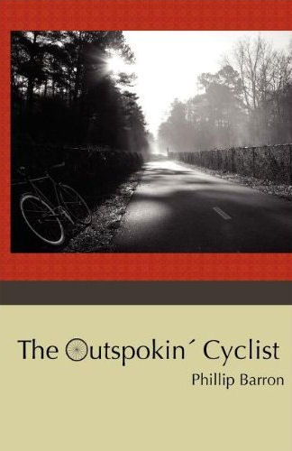
As South Carolina’s larger cities work to make traffic flow more friendly and attractive for bicycles, Simpsonville’s Phillip Barron’s new book offers itself as a cyclist’s encouraging companion.
For four years, readers of The (Durham, NC) Herald-Sun newspaper enjoyed Phillip Barron’s monthly columns on bicycling. The Outspokin’ Cyclist gathers the best columns together in one volume.
With insights into cold-weather bike commuting, urban design, the spiritual solitude of solo mountain biking, and the philosophical problems with drug use in competitive sports, Barron’s columns offer glimpses into the life of a cyclist and a small city’s biking community.
His resulting book will appeal to Durham residents, all ranges of cyclists, and readers who simply enjoy a good story.
Barron graduated from Mauldin High School and attended Presbyterian College while learning to mountain bike. Now he lives and rides in Davis, California, but with family rooted in the Upstate, he looks forward to riding Greenville County’s Swamp Rabbit Trail from Travelers Rest to Cleveland Park.
“Now that Barron has wooed readers onto their bikes, he offers some support,” writes Courtnee Felton at Sweet Georgia Brown. “I appreciate the Zen nature of the book’s first part ‘Why I Ride.’ The essays here convey the sentiment of taking time out for oneself and slowing down to smell the roses. Barron speaks to both the sports cyclist enjoying those rare moments of being in the zone and the commuter experiencing their city to a degree that only bicycles allow.”
The Outspokin’ Cyclist is available online in paperback from Amazon, Barnes and Noble, and Books-A-Million. It is also available as an ebook from Amazon (for the Kindle) and from Goodreads.com in epub (compatible with the Nook, iPad, iPhone, Sony Reader, Kobo, and other epub reading devices).
Tweet

Comments
Crescent Magazine | nicomachus.net
[...] to Taft Matney for this note about The Outspokin’ Cyclist in the new Crescent magazine. “As South Carolina’s larger cities work to make traffic flow more friendly and attractive for [...]
Crescent Magazine | | The Outspokin' CyclistThe Outspokin' Cyclist
[...] to Taft Matney for this note about The Outspokin’ Cyclist in the new Crescent magazine. If you have not yet checked out Crescent, do so; it’s a great new e-zine covering news and [...]

