Created in the cloud with Aspose.Words for Cloud. http://www.aspose.com/cloud/word-api.aspx

House GOP Legislative Agenda Focuses on Government Reform in
Published Date : January 7, 2013
Author : admin
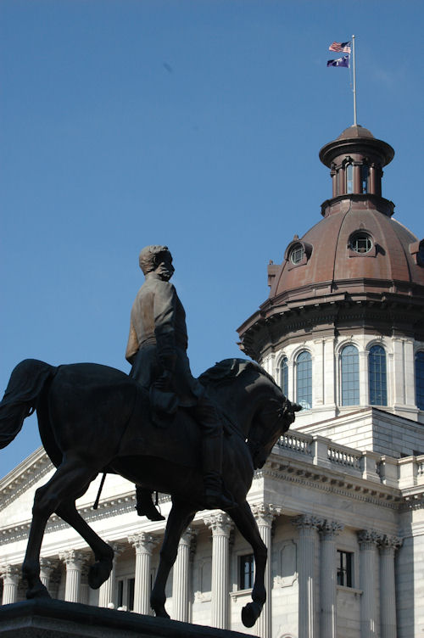

Broad government reform tops the South Carolina House Republican Caucus agenda for 2013, say GOP leaders.
“This is a smaller agenda than we have had in previous years because many of these items are very serious topics that will require a lot of debate,” said House Majority Leader Bruce Bannister, R-Greenville. “The Caucus and the House have study committees that have been working for months—or years—on some of these issues. This session will be marked by significant action on government reform.”
Caucus members will be reaching out to their constituents and to Republican activists statewide in the coming weeks to prioritize the agenda.
“From fighting against the new tax increases of Obamacare to better protecting our citizens most valuable personal information, we have some major issues our legislature needs to address this session,” according to House Speaker Bobby Harrell, R-Charleston. “These agenda items are certainly not all we will be addressing this year, but these are some of the top issues that voters told us last November—in no uncertain terms—that they wanted accomplished.”
“The House has a long history of accomplishing our agenda quickly and thoroughly. This year, the House again plans to be a leader on important reforms,” Harrell added.
This year’s agenda includes:
- Election Reforms: Legislation is being written to correct the 2012 election problems arising from SC court decisions that removed candidates from primary ballots.
- Data Security: Examining the data collected by the state and how it is protected
- Update Ethics Laws: Many of these was are two decades old, and House leaders say they need to be updated to “re-instill trust in our political system” and keep up with modern times.
- Oppose Obamacare: House GOP leaders vow to the implementation of the law and what they say is a substantial tax increase that follow it.
- Tax Reform: “We knew tax reform would be a multi-year effort,” according to Bannister. Reform efforts will include lowering manufacturers’ property tax rates, flattening personal income tax rates, and reducing “special interest sales tax exemptions.”
- Economic Growth: Including regulatory reforms, access to capital for small businesses, and enhanced skills training
- Government Restructuring: “We came within a Senate filibuster of the biggest government overhaul in two decades. The time is still right to get this needed restructuring through,” Bannister noted.
Download a PDF of the SC House Republican Agenda HERE.

Tweet

Comments

So, You Want to Be in Congress?
Published Date : January 2, 2013
Author : admin

If you do, now might be your time — especially if you’re in South Carolina’s First Congressional District.
Earlier this morning, Governor Nikki Haley signed an Executive Order scheduling a Special Election in the 1st Congressional District. The seat became vacant after Governor Haley appointed Tim Scott to the United States Senate. Candidates will file with their respective state party offices.
If you decide to run, here’s what you need to know:
- January 18 at Noon – Filing for Office Opens
- January 28 at Noon – Filing for Office Closes
- March 19 – Party Primary
- April 2 – Party Primary Runoff (if necessary)
- May 7 – General Election
The filing fee will be prorated from $3480, as required by law (around $3000).
Candidates must also complete all disclosure requirements as enforced by the Federal Election Commission (http://www.fec.gov/info/filing.shtml).
That’s it in a nutshell. Now you can run for Congress.

Tweet

Comments

Downtown Greenville's Smallest Restaurant Makes World's Largest Funnel Cake
Published Date : December 28, 2012
Author : admin

Downtown Greenville’s smallest restaurant is now serving the world’s largest funnel cake.
“Funnelicious” owner Mike Pennington is the mastermind behind this giant fried creation and proudly offers it on his menu as the “Mega Danny Cake” measuring 17 inches in diameter and served in a large pizza box to accommodate its generous size.
Like all of Pennington’s funnel cakes, diners can top the “Mega Danny” with fresh fruit, powdered sugar, chocolate syrup, and even frozen yogurt. Orders may be placed online or in-store via iPad.
According to Pennington, Funnelicious has applied with the Guinness Book of World Records to make the world’s largest funnel cake an official record. The application process to secure an official record takes several weeks to complete, and acceptance of proposals for the World Record book is highly competitive, but Pennington and his sweets producing team are confident that they will be successful with their application. University of South Carolina MGMT 479 students assisted Pennington on the project.
“We have done a lot of research on how the record process,” Pennington said. “We know we have the largest funnel cake out there and we think this is unique enough for the record books.”
Funnelicious is located at 155 Augusta Street across the street from Flour Field and is open seven days a week. Along with in-house dining and the world’s largest funnel cake, they also offer customized catering and party space rental.

Tweet

Comments

Hunt Free in SC
Published Date : December 27, 2012
Author : admin
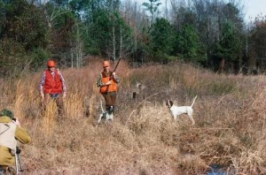

For the first time, the SC Department of Natural Resources (DNR) is offering free hunting days (Jan. 4-5, 2013) to any South Carolina resident.
“If you ever wanted to experience the thrill of hunting, the relaxation of spending time in the woods, or the joy of a new adventure with family and friends, this is the time to get out there and see all that South Carolina’s natural resources have to offer,” said SC DNR officials.
Free hunting days allow all South Carolina residents to hunt without a state hunting license or other required permits — to include the Wildlife Management Area (WMA) permit or Migratory Waterfowl Permit (formerly State Duck Stamp).
DNR officials want residents to understand that while the free hunting days eliminate state licensing requirements for those days, they do not waive any federal requirements for a Federal Migratory Bird Hunting & Conservation Stamp (Federal Duck Stamp) to hunt migratory waterfowl.
Free hunting days are available only to SC residents and apply to all lands on which hunting is allowed, to include private lands and Wildlife Management Areas (WMA) throughout the state that are not otherwise closed to hunting.
The list of open WMAs can be found by visiting the Managed Lands tab of the DNR website (https://www.dnr.sc.gov/mlands/lookup). Existing seasons, bag limits, and methods of take still apply on these days, so if you’re thinking about taking advantage of free hunting on January 4-5, make sure to check the 2012-2013 Rules and Regulations for more information (http://www.dnr.sc.gov/regulations.html).
UPDATE: SC DNR wants to clarify that the Jan. 4-5, 2013 free hunt days do not extend deer or any other season. Deer season in South Carolina ends on Jan. 1. Free hunting days are a chance for those unlicensed hunters to get into the field. All existing seasons, bag limits and methods of take still apply so check the 2012-2013 Rules and Regulations for more information.
PHOTO CREDIT: SC WILDLIFE/SCDNR

Tweet

Comments

Upstate Auto Dealer Spreads Christmas Cheer
Published Date : December 20, 2012
Author : admin


Less than 24 hours after organizers of an annual Christmas event to give gifts to children at Miracle Hill said the holiday tradition was in jeopardy, Best Chevrolet in Easley donated $1,000 to the Miracle Hill Children’s Home in Pickens County.
This is the second year in a row that Best Chevrolet has donated money to the Miracle Hill cause during the holidays.
“We have a soft spot for Children at Best Chevrolet,” said Peter Mirante, the dealership’s owner. “Miracle Hill does such a great job in the community that we are honored to help.”
The annual toy drive for Miracle Hill has been spearheaded by Michael Hedrick of Michael’s Pizzeria in downtown Easley for the past decade. Area residents take names from a Christmas tree in the restaurant’s main area or donate money to provide gifts for children at the Miracle Hill Children’s home.
The annual event features a Christmas Eve dinner at his restaurant for the children where they get to open presents, Hedrick said. Best Chevrolet’s donation along with several others will help make the event a reality, but Hedrick said the general community still is encouraged to donate items.
More information on the toy drive can be found by contacting Michael’s Pizzeria at 864-855-0025.

Tweet

Comments

NATIONAL GEOGRAPHIC Names Jocassee Gorges one of "50 of the World's Last Great Places"
Published Date : December 20, 2012
Author : admin


The Jocassee Gorges was recently named one of “50 of the World’s Last Great Places-Destinations of a Lifetime” in a special edition of National Geographic magazine.
“National Geographic‘s special recognition of Jocassee Gorges is quite an honor,” said Mark Hall, Jocassee Gorges land manager for the S.C. Department of Natural Resources. “We have one of the great wild places on our planet. It’s an exciting place to be, with the peregrine falcons appearing, more bald eagles showing up, Audubon designating Jocassee as an internationally Important Bird Area, and now we’re working to place an observation tower on the highest mountain in the state. Who knows what’s next?”
One of the best vantage points to see Jocassee Gorges is Sassafras Mountain in northern Pickens County, where a fund-raising campaign is underway to build an observation tower on the highest point in South Carolina. For more information on the Sassafras campaign, visit www.harryhamptonfund.org/sassafras.html.
The four-page spread in National Geographic’s special issue, titled “Jocassee Gorges: An Intense Concentration of Waterfalls,” features photos of Upper Whitewater Falls and Oconee bells.
“Thanks to the second highest rainfall in the continental United States,” the article begins, “the Jocassee Gorges area of North and South Carolina supports rare plants and one of the highest concentration of waterfalls in the eastern United States. The area was given added protection by the purchase of 40,000 acres by both states and several nongovernmental organizations, which connected some 200,000 acres and guarantees that plant and animal species would not be isolated. Living here are black bears, bobcats, wild turkeys, and the highest number of salamanders found anywhere in the world. Included among some 60 species of rare plants are 90 percent of the world’s Oconee bells, whose nearest relatives are in China and Japan.”
PHOTO CREDIT: National Geographic

Tweet

Comments

Winthrop Head Coach Calls for Everybody to "Step Up" Following Newtown Tragedy
Published Date : December 19, 2012
Author : admin
Following a near upset against 7th ranked Ohio State on Tuesday the 18th, in his postgame news conference, Winthrop University Eagles men’s head basketball coach Pat Kelsey unwittingly stepped in the national spotlight to call for change in the wake of the Newtown, CT school shootings.
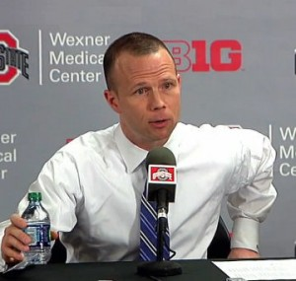“I’m really, really lucky, because I’m gonna get on an eight hour bus ride, and I’m gonna arrive in Rock Hill, South Carolina. I’m gonna walk in to my house. I’m gonna walk upstairs. I’m gonna walk in to two pink rooms, OK? With a five year old and a four year old in that pink room with a bunch of teddy bears laying in that room. I’m gonna give ‘em the biggest hug and the biggest kiss I’ve ever given ‘em,” Kelsey said remembering families in Newtown, CT who lost loved ones Friday.
Not politicizing the event and admitting that he didn’t have the solution to prevent such a tragedy from happening again, Kelsey called for elected officials, parents, teachers, rabbis, priests, coaches, and everybody else “step up.”
Kelsey told media in attendance after the Eagle’s 65-55 loss, “I’m not gonna have a microphone like this the rest of the year, maybe the rest of my life, and I’m gonna be an agent of change with the thirteen men I get to coach every day and the two little girls I get to raise.”
CRESCENT would like to take this time to not only express our deepest condolences to the entire community of Newtown, but we want to thank Coach Kelsey for stepping up himself and using his voice to say what so many others have been thinking over the past several days.
VIDEO CREDIT: ESPN

Tweet

Comments

YOUR TURN: “Upstate Flexes Its Export Muscle” By: Hal Johnson
Published Date : October 29, 2012
Author : admin
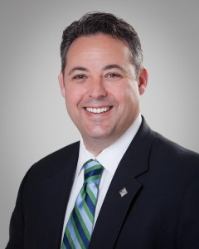

The ten counties that make up the Upstate SC Alliance have long been the engine that drives the South Carolina economy. But some recent numbers from the U.S. Commerce Department and the International Trade Administration show that the Upstate is helping to drive the national economy as well.
The Upstate’s three metropolitan areas; the Greenville-Mauldin-Easley MSA combined with the Anderson MSA and Spartanburg MSA account for 60.7 percent of all of the goods being exported from our state, according to the Upstate Alliance’s research. Or more succinctly, 22 percent of South Carolina counties are providing nearly two-thirds of South Carolina’s exports.
That is why we tell the story of the Upstate as a whole. It underscores what the Upstate SC Alliance has long been saying: our region is a more formidable competitor when we market our ten-counties combined as a region as one as opposed to separately. These numbers would rank us as the 26th largest exporting metro in the U.S. in between Pittsburgh and St. Louis with a total of over $14 billion in exports.
The growth in exports can be felt across the entire region from Burnstein von Seelen in Abbeville to Fuji Film in Greenwood to BMW in Spartanburg to Michelin North America in Greenville. Our ten counties include 372 international companies representing 31 countries including Germany, Japan, China, Italy, Korea and France, which means we are successfully competing globally from the Upstate.
Not surprisingly, transportation equipment ranked as the largest export category, accounting for $8 billion of South Carolina’s total shipments. Next came machinery with $3.6 billion; chemicals, $2.9 billion; plastics and rubber, $2.4 billion; and computers and electronics, $1.4 billion.
Manufacturing is driving our exporting success. More than 1,400 manufacturers call the Upstate home and by telling this growing success story globally, the Upstate Alliance is able to gain the attention of even more businesses seeking new locations—after all everyone wants to bet on a winner.
The Upstate enjoys other benefits from being a major exporter. By participating in a global market, to the degree possible, we minimize economic spikes in our local economy. If any part of the world is in an economic recession (the U.S. for example), the effects here are lessened by other areas of the world that are still prospering (such as Germany, Great Brittan, Japan or China) since we are exporting to both. Also, our local cultural experiences have been enriched by having citizens representing these companies live in our communities.
By having the vision to establish our region as a participant in the global economy years ago, the leadership from an earlier time created a track record of success and credibility for the Upstate as a global player in the world economy. This early success makes it easier for us to continue to attract new companies from all over the world to enjoy and enhance our quality of life now.
And with the $25-million Inland Port set to open next year in Greer, the Upstate will continue to flex its export muscle with thousands more jobs created for our citizens in the coming years. This is one more reason why it always is a great day in the Upstate.
Hal Johnson is the president and chief executive officer of the Upstate SC Alliance, a non-profit organization made up of a public and private investors aimed at promoting economic growth. Additional information is available through the Alliance’s web site, www.upstateSCalliance.com.
DISCLAIMER: The opinions, beliefs, and viewpoints expressed by the author are those of the author and do not necessarily reflect those of CRESCENT: The Magazine.
To submit an op-ed for CRESCENT’s “Your Turn” section, please email it to input@crescentmag.com.

Tweet

Comments

It's a Right. It's a Responsibility. It's a Duty
Published Date : October 29, 2012
Author : admin


By: Taft Matney
On several occasions, I’ve heard this coming election referred to as “the most important election or our lifetimes.”
I have my personal feelings, and if you don’t know them but have a burning desire to find out what they are, feel free to ask. This isn’t the forum for that, though.
It is, however, the forum for me to say this. Voting is a right. Voting is a responsibility. Voting is a duty.
It’s also the forum to say this. If you don’t vote on November 6, you DON’T get to complain.

BAGHDAD, Iraq (Jan. 30, 2005) – An Iraqi man proudly displays his blue finger, indicating that he has voted, after having been the first person to vote in an eastern Baghdad polling station, during Iraq’s first free national election today. U.S. Army photo.
Really. You can say you don’t like anybody on the ballot and don’t want to support any of them. That’s fine, and it makes a political statement, but you don’t get to use that as an excuse to stay home. With the presidential race, state and local races, and ballot questions, there’s plenty for you to vote for and against, and you can’t possibly object to every choice. Even if you don’t support your ballot questions, you can still vote, “No.”
See? NO excuses.
In South Carolina, you can call your local election office and request an absentee ballot. You can go to scabsentee.com and request to vote by mail. You can go to your county election office and cast your absentee ballot. You can show up to your regular polling place on November 6 between 7:00 a.m. and 7:00 p.m. and vote at your regular time. Plenty of opportunities.
See? NO excuses.
November 6 is almost here, and there’s no excuse for you not to participate.
Do you support Governor Romney? Great. President Obama? Fine. Neither one of them? Super. If you don’t show up, if you don’t stand up, if you don’t speak up, then shut up.
There are people across the globe who have and would give their lives to vote, and it’s important to remember that THIS country started that way, too.
On November 6, exercise your right. Take responsibility. Do your duty. Vote.
PHOTO CREDIT: US Army / ARCENT

Tweet

Comments

YOUR TURN: "A Classic Solution to Bullying" By: Paul Fallavollita
Published Date : October 15, 2012
Author : admin
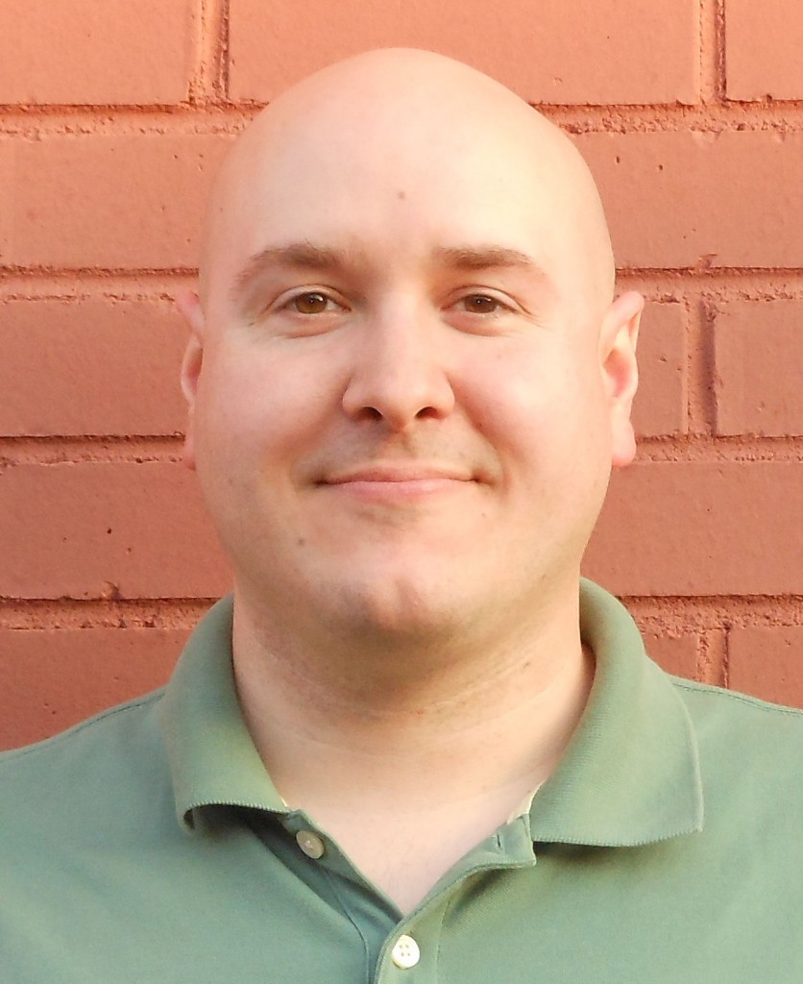

A mother recently filed suit against the Beaufort County School District seeking compensation for “emotional damages” arising from the bullying of her children on the school bus. Preventing similar fates in other counties depends upon our ability to get out of the way of students so that they may resolve their differences themselves.
It is puzzling that only in the last few years has “bullying” risen to prominence as a pressing public issue. Bullies, no doubt, have always comprised a certain segment of every crop of students for many decades and there is no reason to believe that proportion has changed. The population of bullies remains constant, but mass media coverage has increased the visibility of this issue.
Our increased sensitivity to the issue of bullying is not a positive marker. As a nation, we have become weaker and more prone to wallow in victimhood, real or imagined. In times past, it would have been considered laughable to focus public attention on schoolyard bullying. Indeed, if bullying is one of the major issues of the day, then we must lead very blessed lives. Today, in contrast, we are inclined to recruit an army of politicians and psychologists to intervene.
The solution to the faux problem of bullying does not reside in launching an “Oprahesque” public relations campaign, nor should it ever become a cause célèbre for any future first ladies. Rather, a classic solution still exists and it is the bullied students themselves who possess the power to implement it immediately: simply punch the bully in the face and regain some respect. Yes, South Carolina, sometimes violence is the right answer. This same principle holds true for that similarly run government institution known as the prison system (and perhaps that parallel reveals yet another reason to encourage homeschooling).
This sad nexus between schools and prisons also leads to the question of School Resource Officers (SROs), the law enforcement officers assigned to the district. When I was in school, our buildings were free of police barracks–which was the style at the time. If schools are environments where learning takes place, then what example are we teaching by deploying SROs? Accepting life in a police state is not a lesson worthy of the curriculum. Our contingent of SROs should promptly be re-assigned elsewhere to more legitimate crime-fighting duties. Further, were SROs to interrupt a bullied student while remedying his situation via the method of “self help” I’ve prescribed, surely the bullies would tease that student even more for needing to be rescued by the authorities.
The Greenville County Schools Board of Trustees can help restore the balance by lessening the severity of the punishment doled out to students for fighting. That way, the bullied will not be discouraged from defending themselves, since it is likely that they are more cognizant of, and constrained by, the rules than the bullies. After all, when fisticuffs are outlawed, only the outlaws will so indulge–leaving the bullied at a disadvantage.
Ultimately, student assertion of the right to self-defense is an idea “old enough to seem new” and one that is worth trying in Greenville County. What’s the worst that could happen, a Beaufort-style lawsuit?
Paul Fallavollita is a candidate for School Board Trustee in Area 17 of Greenville County. Contact him at pfallavollita@charter.net.
DISCLAIMER: The opinions, beliefs, and viewpoints expressed by the author are those of the author and do not necessarily reflect those of CRESCENT: The Magazine.
To submit an op-ed for CRESCENT’s “Your Turn” section, please email it to input@crescentmag.com.

Tweet

Comments

"Southern Girls" is More than Reality TV. It's Bringing Families Together
Published Date : October 15, 2012
Author : admin

Sometimes interviews bomb. You get the occasional person or group who speak in one word answers and it’s like pulling teeth to get them to talk. No. That wasn’t the case with the “Southern Girls Got Game” crew. They may not have needed anybody to facilitate the interview, and that’s not a bad thing. From the trips they take, the things they get to do, the people they meet, and everything else, they’re excited about what they’re doing, and they want to tell people about it. They want to make sure you’re watching, too.
—————————
Who do you want to watch it?
ASHLEY: I want everyone to watch it. I want anyone and everyone to watch it.
DANIELLE: Anything that you can watch and understand what’s happening.
KENNY: And that is a big thing. There has been a lot of ladies and a lot of men have been attracted to it.
TRINA: On our Facebook, the biggest percentage they have on their Facebook page are women.
KENNY: They have almost 3500 people.
DANIELLE: We have some people that think, just because we are women that men are only going to watch it but women…what she just said, we do have more women on our Facebook and that said whenever it comes out, they’re definitely going to watch it. But we also do have men that have their wives watch it and they watch it…
TRINA: Actually, just with them being out, you wouldn’t believe how many women and children have starting hunting because of them.
DANIELLE: Yeah, they say we inspire them.
ASHLEY: A lot of men are using Southern Girls Got Game as a tool to make a family activity more appealing.
KENNY: And it has. There are so many people who have come up…in Alabama, we had people asking…this couple come up and said, “Hey, my 2 young boys would love to hunt with y’all.” And they were like 8 and 10 years old so I gave them all our information and they gave us theirs and we told them when we come down to Alabama and make a show, that’s one thing we’ve reached out for, is to bring other kids into it because the sport is diminishing, no matter what people think. Our government and just today’s society is taking it out. It’s diminishing.
Why do you think that attitude is changing?
TRINA: Because they want to sit on the couch and play video games.
KENNY: They’d rather do that than be out there in woods. I think these two are showing kids there are more to being outside, just sitting under a tree…
DANIELLE: We want to get out in the outdoors rather than home. Yeah, we want them to be more outdoors than home, rather than being home like playing video games like … or either going out on the road and getting drugs. A lot of people are doing drugs.
ASHLEY: Yeah, it’s like they can use it as tool in their life to stay on track. That’s one thing I take pride in, that I’ve never smoked a cigarette, I’ve never taken a single drug. I mean, I’ve never done anything that could potentially harm my body as far as narcotics go, or anything like that. And I think one thing she’s trying to get a point out, is it’ll help you stay on that track to a healthier lifestyle because it gives you that pastime, and like we mentioned in the beginning, it’s a discovery. You go out there and it’s like an endless adventure. You never know what you’re going to see and you really learn to love the outdoors. You’ll find a lot of people who’ll say, “Well, how can you love animals? You kill them.” We have the most love for animals. I don’t look it as an animal is something down on the ground. I have respect for each animal. It doesn’t go in vain. It’s not laughed at and it’s taken very seriously. Animals ultimately were put here for people to eat and that’s their reason for being here. And not only for the people. You know, you have population control and all these other things, dangerous animals that ultimately could hurt the human race. So I think…
What’s your favorite to eat?
ASHLEY: My favorite to eat? Alligator.
DANIELLE: I love Alligator. I like alligator tail but my favorite to eat is deer or turkey.
KENNY: There’s one thing I want to say. So many of my friends have come back and wrote comments to me and said stuff to me I never thought I’d ever hear, as a guy, but it has been unbelievable, me going places like Alaska and being able to experience stuff with them I never did and I would…I would have the chance or her mother would have the chance to experience the outdoors like we have with them, it’s unbelievable. I mean, going to a ballgame and sit there with your kid is great, but when you go out there and you’re out there and there’s nothing out there but you and them, and you’re experiencing it. They’ve got a picture of us in a river in the middle of Alaska, out in the middle of nowhere, it’s unbelievable. The sights we’ve seen. We were driving around and all of a sudden, we seen this summit, this big huge mountain. Everything around it was green and we stopped and we were just all in awe and, to be able to do that with these two, especially with my daughter is just phenomenal. It lets you know God is truly and unbelievable God. I mean, it was unbelievable, some of the things we’ve seen and experienced. I wish a lot of parents could do that with them. And when you’re playing on a video game or on an iPhone or texting constantly and all that.
TRINA: They’re disconnected from their family.
KENNY: They are and hunting and fishing brings you back. You know, you go out there and sit in a boat with your family for 8 hours. I mean, Katrina, has got into doing it with us and before, she wouldn’t even think of it, so it…I truly think it is…I love sports as much as anybody but going out into the woods with these two has showed me there is more to life than just that.
The show aside, it has helped build y’all stronger as a family.
ASHLEY: Oh, yeah, like I said, we discovered ourselves and we’ve grown as a family. I literally look at these people right here as my family. Show or no show, at the end of the day, we’ll always have each other.
What’s your family back in Florida think about what’s going on?
ASHLEY: My family’s all here.
Oh, everybody moved up from Miami?
ASHLEY: Everybody but my brother. Yeah, they…at first, they were like “That’s surreal.” And I was like “No, it’s so real, it’s going through. It’s working and we’re having a show.” And now that they’ve seen how much it has progressed, they’re just in awe, too.
KENNY: Her dad’s not a hunter, never been a hunter but I heard her tell her daddy she wanted him to go back next time we go to Alaska and go kill bear and he said “OK.”
ASHLEY: My dad, and he’s going deer hunting with me this year, too, he said he’s let me take him…and my dad’s never hunted
DANIELLE: I’m pretty sure, from all of what mostly Alaska has gotten us to…not like all of our family, yes, but us two, so close, it’s like crazy. I’m not going to get into details how we got that close but we got very close.
ASHLEY: When you’re the only two girls out there, you know what I mean, and you have to really depend on each other and it gets to a point where it gets emotionally challenging, you’re just like…you need someone to talk to and we’re always there for each other.
KENNY: Put it this way, we were taken in a boat about 45 minutes to an hour trip from the landing and got docked on an island to hunt bears by ourselves.
ASHLEY: When you think about it, if something should happen, who do we have to depend on? If a bear gets on top of me, I have to know who to depend on because I’m not going to get it off. These 2 people are my lifeline, you know what I mean? So you really have to trust and really love the people that you’re going…when you go on…an expedition was what it was. When you go on these, to these places, if something were to happen to us, our team and Kenny, if something happened to Kenny and he couldn’t get away, who would he have to depend on? Us.
DANIELLE: I bet you if anything happens…
KENNY: Everybody is there to back each other up.
ASHLEY: There has to be that trust factor there.
TRINA: I want to add that, on their show, they do have other people that they’re asking questions to so the, in the…they’re really hard about feeling like having to ask a man how to do this, they’ll get a little embarrassed or something so the girls, they do ask questions. It informs other people…
DANIELLE: We don’t care if we embarrass ourselves. Do you not know who we are? Hello.
KENNY: They learned how to go out in crowds in Alaska. They learned how to do shrimp baskets. They were taught from ground zero, how you mark ‘em, how you tag ‘em, how you have to cut holes in them. They sewed their own crab baskets. They sewed their own shrimp baskets. We did all that. People will see that they did it and that show that they were learning how to do it.
DANIELLE: After every show, because we’re always going to have in the show that we’re learning. I mean, you’re always learning something when you go out in the woods. It just happens like that.
TRINA: They don’t go out and say “I’m a pro, watch me do it.”
DANIELLE: Yeah, we don’t want to do that because we’re not. We’re 12 and 23, we have a lot to learn because we’re literally not old enough to know everything. We’re never going to know everything. We’re always going to be learning. I know 80 year old people who try to go hunting who say they know everything but they don’t. But after every show that we have, we’re going to put on there, we’re going to have a tip, we’re going to have where we have people to send it like tips from our show. To have like, all different kinds of…we’re going to have trivia games on there, too. It’s kind of hard…to like get into it but…
TRINA: One of the things they had talked about doing, too, which is going to be kind of cute, it might not make this season, but the next season doing a kid’s tip.
DANIELLE: Yeah, have safety tips.
TRINA: Kids are so cute. You put them on camera, they’re so funny and they all want to give you a hunting tip. And they’re fun when they give their hunting tips. No telling what comes out of their mouth.
KENNY: One of my friends died in a hunting accident last year. He fell out of a stand without a safety vest, safety harness. And we met a young lady at a show in Columbia that her father just recently died and she wanted nothing to do with the woods or nothing. She bought one of the shirts and she spent a whole day over at our booth and she’s talking about going hunting with them again because they love it but she’s going to get on there again and we’re going to do a show with this young lady about the safety of wearing your harnesses and what it has meant to her family to lose her daddy. Because, her daddy, when he fell, he suffered very badly because he didn’t die from the fall, he ended up dying of a massive heart attack trying to crawl out. So that’s one thing they’re going to do. There may be a whole show that is not got any hunting at all. It’s just being out here with the kids showing safety things about why you need to have gun safety and harness safety and everything else. It’s not going to just killing every week. There’s a lot of reality.

For Part 1, click HERE. For Part 2, click HERE.
- Visit Southern Girls Got Game online HERE.
- Visit Southern Girls Got Game on Facebook HERE.
PHOTO CREDIT: Southern Girls Got Game on Facebook

Tweet

Comments

Belton Heritage Days at the Depot First Certified SC Arts and AgriCulture Event
Published Date : October 1, 2012
Author : admin
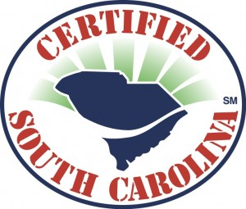

Agricultural history and traditional arts join hands at the 8th annual Heritage Days at the Depot in Belton, S.C. on Oct. 4, 5, and 6. Hosted by the Belton Area Museum Association on the grounds of the historic train depot, Heritage Days promotes the traditional arts and skills from South Carolina’s cultural past by showcasing the talents of folk artists, heritage artisans and historical interpreters.
Heritage Days is the first event to be held as part of the newly established Certified SC Arts and AgriCulture program. A partnership of the SC Department of Agriculture and the SC Arts Commission, Arts and AgriCulture is designed to enhance the Certified SC brand and bring awareness to the importance of the arts and agriculture to South Carolina’s economy and to the quality of life and cultural well-being of the people of the state. The program is a salute to those who not only cultivate ideas through their artistic ability but also to those who cultivate and nurture the land through their ability to grow food, fiber, and fuel.
Visitors who attend Heritage Days at the Depot will see a presentation of living traditions by heritage artisans. Festival participants can try their hand at a variety of skills necessary to navigate rural life in the past. Artisans sharing their knowledge at this year’s festival include two recipients of the Jean Laney Harris Folk Heritage Award – Gullah doll maker Jeanette Gaillard-Lee and chair caner Willie Van Brailey. Other artisans include indigo dyer Renee Gillespie, turkey call maker Bob Harwell, carver Joda Snipes, gourd artist Millie Chaplin, and primitive skills/fire maker Bob Perry. Nearly 2,000 schoolchildren from Anderson County join in the fun and gain a better understanding of the agricultural and artistic traditions that enhanced the quality of rural life and make up their community’s history.
“Our artisans are committed to preserving and sharing their craft with the public,” said Alison Darby, event coordinator. “They are invited to the festival because their work represents the highest level of artistic excellence and their craft has cultural significance and authenticity.”
Heritage Days at the Depot attracts thousands of community members and tourists each year and has been recognized with the 2007 Achievement Award from the South Carolina Federation of Museums and the 2008 Heritage Tourism Award from Palmetto Trust.

Tweet

Comments

Happy Birthday to Us
Published Date : October 1, 2012
Author : admin


By: Taft Matney
In almost every speech I ever heard him give (and I heard a lot), former South Carolina Secretary of State Jim Miles used to say, “He who does not toot his own horn will not have his horn tooted.”
For me, for us, for CRESCENT, let me take a moment to blow that horn.
This week, on October 3, we will celebrate CRESCENT’s first anniversary, and I’m excited about how far we’ve come.
If you’re one of the few who hasn’t been subjected to my ramblings about it, CRESCENT began as an idea when a certain former governor hiked the Appalachian Trail. When I saw how our state was portrayed in the national media, and even by the local folks, it really bothered me because that’s not MY South Carolina. It’s not your South Carolina either.
I’ve said it before, and I’ll say it again. South Carolina has amazing stories to tell and amazing people to tell them. That’s why CRESCENT exists. It’s on your computer, your smart phone, and your iPad to see and hear and read about people, places, and things that you won’t find in most other places.
South Carolina is a state filled with beauty and grace while its Southern hospitality welcomes new business and technological innovation. It has everything you could want – if you just know where to look.
It’s a place where moss-covered Lowcountry oaks are only miles away from the most advanced aircraft manufacturing in the world. It’s a place where bass-filled lakes are only a half hour drive from North America’s home of “The Ultimate Driving Machine” and global automotive ingenuity. It’s a place where you can find some of the country’s most amazing food and award winning chefs no matter what your taste might be.
Over the past year, we’ve introduced you to leaders in sports, music, food, style, entertainment, and even politics, and you’ve told us that you like what we’re doing. For that, thank you.
Thank you for your feedback. Thank you for finding us online. Thank you for subscribing and letting us be a part of your inbox on Monday morning. Thank you for telling your friends and neighbors and families about us.
Thank you for a great first year. Here’s to many more. Now it’s time to blow out the candle. Our little CRESCENT is growing up.
By the way, if you have something you think we missed in our first year, let us know. Email input@crescentmag.com, and tell us about people, places, or things we need to know about for the second year. As anybody with kids will tell you, two year olds are tough to keep up with.

Tweet

Comments

The Green Fairy Lands in Greenville
Published Date : October 1, 2012
Author : admin
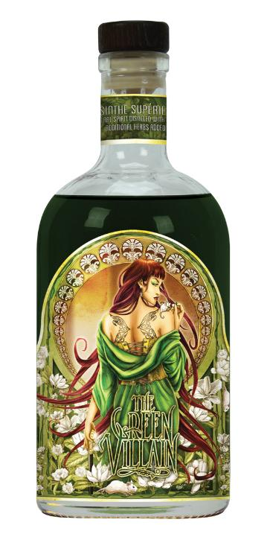

As Greenville’s Dark Corner Distillery prepares to celebrate its one-year anniversary after giving the state its first legally distilled whiskey since prohibition and its first and only hand-distilled gin, owner Joe Fenten says the small-batch micro distillery has a new title that has never been produced in the Southeastern United States.
The Green Villain Absinthe Supérieure debuted this past weekend at the distillery’s Main Street location.
“The Green Villain is a contemporary revival of a long-misunderstood Old World spirit based on a traditional recipe dating back to 1871,” Fenten said.
According to head distiller John Wilcox, “Producing an authentic French style of absinthe is a very time consuming and meticulous process. A bouquet of botanicals is required to achieve the correct color and flavor of this mysterious spirit. The holy trinity of absinthe, grand wormwood, sweet fennel, and aniseed are the primary ingredients for our recipe.”
Dark Corner previewed The Green Villain at Euphoria, a weekend long event celebrating the culinary and arts communities in the Upstate. The absinthe was traditionally prepared at the event as it was in the late 19th century Parisian cafés.
“The preparation of absinthe is an art itself,” said Wilcox. “Ice-cold water is slowly introduced into the spirit causing it to louche, or become cloudy. The color changes from rich jade to an opalescent emerald. Absinthe is definitely a beautiful spirit. It’s a show-stopper.”
Fenten told CRESCENT, “Dark Corner’s Green Villain is a celebration of tradition, craft, and innovation. Mirroring moonshine’s rebellious spirit during Prohibition, absinthe survived its multi-country ban in 1915 as bootleg. Its legend was a quiet footnote in history until the ban was lifted in the 1990s. Dark Corner Distillery is proud to share this unique and exciting spirit and offers education on its history and preparation at its Main Street location.”
PHOTO CREDIT: Dark Corner Distillery

Tweet

Comments

Drive Automotive Industries of America Expanding Greenville County Facility with $50 Million Investment
Published Date : September 28, 2012
Author : admin


Drive Automotive Industries of America will expand its existing facility in Greenville County. The $50 million investment is expected to generate 60 new jobs.
“We celebrate Drive Automotive’s decision to invest $50 million and create 60 new jobs. South Carolina continues to show that it is the right place to do business. Announcements like this one show we are doing the right things to help companies prosper and grow,” said Gov. Nikki Haley.
Drive Automotive Industries of America, a manufacturing division of Cosma International, which is an operating unit of Magna International Inc., will expand its manufacturing facility located on Moon Acres Road in Piedmont. The expansion will add approximately 150,000 square feet to the size of the existing facility.
“Given the competitive nature of obtaining funding for projects, we at the Drive facility are very appreciative of the support of Greenville County Council and the Governor’s Office,” said Craig Lane, general manager of Drive Automotive. “We truly believe it is a win for everyone.”
Drive Automotive manufactures automotive body panels and assembles body systems using state-of-the-art equipment such as multi-ton hydraulic presses and advanced robotic systems. This expansion will support a growing customer base among the major automotive and heavy truck manufacturers.
Since January 2011, South Carolina has recruited more than $4.4 billion in capital investment and more than 6,800 jobs in the automotive-related sector.
“We continue to build on our success in the automotive club. Drive Automotive’s announcement is another indication that South Carolina’s automotive industry, and manufacturing sector as a whole, continues to create wealth and new jobs,” said Secretary of Commerce Bobby Hitt.
Drive Automotive began production at its Greenville facility in 1994. The expansion is expected to be complete by the third quarter of 2013.
“Greenville County is committed to reducing unemployment and increasing per capita income in Greenville County, and Drive Automotive is a good example of a good quality employer with innovative business practices that fits nicely into our local economy,” said H.G. “Butch” Kirven, director of the Greenville Area Development Corporation and chairman of Greenville County Council. “We are very pleased that Drive Automotive has selected Greenville for this important new investment and business expansion.”
“Drive Automotive’s expansion is a vote of confidence in the competitiveness, quality and depth of the Upstate’s workforce when it comes to world-class manufacturing,” said Hal Johnson, president and CEO of the Upstate SC Alliance.

Tweet

Comments

Life's Too Short
Published Date : September 24, 2012
Author : admin
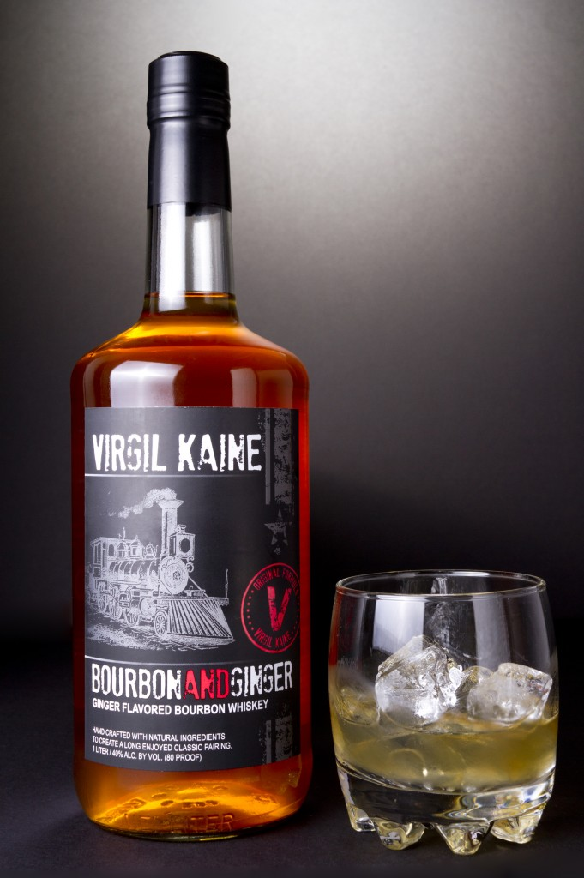

College kids will drink some really horrendous booze. By his own admission, Virgil Kaine co-founder David Szlam was no different. Now, he wants to make sure that his friends and other former college kids can step up their games.
“People love Bourbon and ginger ale,” Szlam says while asking, “but why do people always have to drink Bourbon and ginger ale with high fructose corn syrup and with all these unnatural flavors in there?” He tells CRESCENT that they don’t have to.
—————————
We’re starting to see a rise in infused spirits, especially whiskeys and vodkas in both mass produced and craft markets. Why are we starting to see the spirit industry go in that direction? Why are people looking for something outside their traditional whiskeys and vodkas?
That’s an interesting question, and I think it came down to how there are things that are available, so people are now interested, too. Fifteen years ago, when I went to college, you looked at the shelf and it was basically all just straight, just vodka, the regular whiskey, no infusion, so I think it’s pretty amazing how fast people are creating these things and I think it is because people are now okay with it. People are hip to it. They want to see different stuff. They want to be challenged. Their palates are becoming more sophisticated. Food is evolving, and alongside it, people want to see the same kind of thing with their cocktails. Food and beverage goes hand in hand, and when you see all these chefs being super creative, doing new things, it’s like, “Why not try this?” And people are really adapting to it well. They are more open to the idea of trying to new things, and I think as a creator, we just want to do the same things like we did with our food – bring things that people really love to life. People love Bourbon and ginger ale, but why do people always have to drink Bourbon and ginger ale with high fructose corn syrup and with all these unnatural flavors in there? Why can’t they have a more sophisticated Bourbon that has similar flavor to something that they love so much. That’s why, as a creator, we got into it, because we thought people want these kinds of things. People want options to the same old thing they’ve been having for their whole life.
As far as that Bourbon goes, because you talked about a lot of the college kids drinking cheap Bourbon and mixing it with things to mask that up front burn but you’re not going with a cheap Bourbon with this. You’re putting out a quality product. Where does that base ingredient, where does that Bourbon come from?
We source our Bourbon from Lawrenceburg (KY) and we use a younger Bourbon because we like the younger flavor of the Bourbon. Once the Bourbon sits in the oak for too long, the oak kind of masks the flavors of the ginger and the vanilla, and we really find that the younger Bourbon is more…it just fuses much better with the flavor of the ginger and vanilla without masking it with over-oakiness.
What’s the response been so far?
The response has been great. You know, our main challenge is getting people to try it. Once people try it, we’ve had an unbelievable response. People enjoy it on the rocks, they enjoy it straight. It’s really nice to see the creative cocktails that are coming out with it but the response for us as a company, we’ve been proud of what we’ve accomplished so far.
Are you, right now, planning to stick with the single product or are you looking to expand the line?
As a chef and an innovator, I’m always working on new formulas and new concoctions but Virgil Kaine is my focus. Bourbon and ginger is our focus right now. We are definitely wanting to expand our territories and grow Virgil Kaine Bourbon and ginger as much as we can before we start spending a lot of time and a lot of emphasis on other products. But there are definitely some other formulas in the works for future projects.
Who is the Virgil Kaine drinker?
That’s a funny question because, at first, we thought it would be the younger generation, and now we see that anyone from 25 to 55 to even 65. We found that Bourbon drinkers that have been drinking Bourbon for a long time, even in the older crowd, 45 to 65, really like Virgil Kaine because it’s a different type of Bourbon. It has a little bit of sweetness to it, it’s easier to drink. You put a couple of ice cubes in it, you’re done with it. They really love the smoothness of it. So Virgil Kaine, what sets it apart from most other products out on the shelf is that it is incredibly smooth. Because of how smooth it is, it shocks people who have never been a Bourbon drinker. But our demographic that we try to cater to are new professionals, 28 to 35. That’s who we kind of push towards but we’ve been very well received above that from 35 to 65 that are looking to try something new.
What is your message to Bourbon purists?
The Bourbon purists?
There are people who, before talking with you, would have been a little bit iffy because they’re self-admitted Bourbon snobs. With your passion, those purists would give it a shot because you get them interested and curious to see how those flavors marry with the actual ginger and in the infusion. What do you say to Bourbon purists to get them to come over to give it a try?
What I say to the Bourbon purists is, you know, they’re the educated people in the Bourbon community, which is great. You’ve got to know where you come from to where you’re going. And I’m a Bourbon purist. I mean, I love good Bourbon. I’ve been drinking Bourbon since college and before that and I’ve…and the reason why Bourbon is my first love is because of my love and respect towards Bourbon. But, being a Bourbon purist, I can’t always drink my top shelf Bourbon. I can’t only sit back with a glass of Pappy Van Winkle or not even something that expensive but Basil Haden or Knob Creek. Sometimes I just need something a little more subtle. But I love Bourbon, but sometimes I want something with a little sweeter touch to it. Give me an option to sit back, have something a little more refreshing. Maybe I’m at the beach, maybe I’m in a hot environment. I can have this Bourbon, I can put a little soda water in it, I can put a little lime in there and I’ve got a refreshing cocktail that is Bourbon-based and it brings me back to that. I’m still drinking Bourbon but I’m drinking Bourbon in an environment that I generally wouldn’t drink Bourbon because it’s hot outside or because it’s at a bar or because…now I can drink that same Bourbon and enjoy it in a new light, in a new refreshing way. I think, you know, it’s time, it’s time to have good products that are made a little different. If you’re a steak lover, if you’re a beef lover but if somebody puts a different type of twist on it or a different seasoning or a different spice rub that’s never been done before and it makes that steak taste delicious and different, why not take a bite of that steak? Why not try it? So I think that’s my message to the Bourbon community. It is a Bourbon, it’s a different Bourbon. It’s a different Bourbon for a different occasion. We’re not trying to change anybody because I’m not going to change what I drink at night, sitting on the porch, smoking a cigar. I’m still a Bourbon purist in that form. But there are times and occasions where this Bourbon fits my mood a lot more than a straight Bourbon.
Your personal preference. If you’re going to mix something with Virgil Kaine, what is it?
Soda water and lime. For sure.
From everything that you’ve heard from consumers and bar tenders, what’s the best cocktail recipe that you’ve gotten so far?
I mean, really, because of the formula, the way it is presented, the most sold is definitely the soda and lime. We’ve seen things that have blown our minds. There is an unbelievable drink at Basil that’s made with fresh ginger beer, mottled jalapeno and I think pineapple juice. I don’t want to destroy their drink, but it is an unbelievable drink over there and we’ve seen Manhattans done with it that have been exceptionally well and there are a number of drinks out there that seem to be working for other people, but we kind of keep it simple at Virgil Kaine. And the soda and lime seems to be a really big hit.
For Part 1, click HERE.
- Visit Virgil Kaine online HERE.
- Visit Virgil Kaine on Twitter HERE.
- Visit Virgil Kaine on Facebook HERE.
PHOTO CREDIT: Virgil Kaine on Facebook

Tweet

Comments

Southern Girls are Makin' Reality TV Real
Published Date : September 24, 2012
Author : admin


Reality TV is anything but real. It’s often scripted to the point that it’s no different than any other show in television – except the writing isn’t as good. Ashley and Danielle say that “Southern Girls Got Game” will be different because you’ll see them succeed in a hunt, but you’ll also see them fail. You may also see Danielle’s dad Kenny in his underwear brandishing a .357 (Kenny will have to tell you all of the details himself…unless somebody says the magic words to us).
—————————
KENNY: Tell where y’all have been.
DANIELLE: Where we’re hunting or any other places…
KENNY: Where the show has took you to.
DANIELLE: Well, we’ve been to Iowa, Ohio. We’ve been to Kentucky, Alaska.
TRINA: What did y’all bag in each of those places?
DANIELLE: Deer, turkey, bear.
TRINA: Hogs.
DANIELLE: Yeah, and hogs.
ASHLEY: Those are our four things that we have taken in those states.
KENNY: They’ve been to Florida.
TRINA: Oklahoma.
ASHLEY: Alabama, Oklahoma, Georgia, Florida, North Carolina, Tennessee, Alaska, Iowa, Ohio. I know we’re repeating it but we’re just trying to touch all the points.
What are your favorite things to hunt recreationally. Let’s say the cameras are off and you’re just going out to hunt. What’s your favorite thing to hunt for?
ASHLEY: Hippo (laughing). Sorry.
DANIELLE: I know this really off subject, but it was raining one night and it was like a month after we met each other. We both agreed that we had to kill a hippo before the show starts…that’s probably not going to happen but we tag-team on everyone that’s in the truck, like 5 or 6 other people and we hold arms like this and we run around this huge parking lot screaming that we’re going to kill a hippo.
KENNY: Really. What is your favorite animal to kill?
DANIELLE: Mine is turkey…and deer.
ASHLEY: In this state?
Anywhere.
ASHLEY: Anywhere? Gators. Gators. That’s where I started before I ever knew how to shoot a bow and that’s where I’ll end…when I can’t pull back my bow any more.
DANIELLE: But she won’t kill just any gator, it has to be over 10 foot…8 foot, is what you said, 8 foot.
ASHLEY: I caught a lot of gators. I grew up in the Everglades. I’m going gator hunting back in Florida soon, so I’ll be in my hometown when I do it.
Well, you won’t be in your hometown hunting gator unless your hometown has something going on we need to be concerned about.
ASHLEY: Well, you know what I mean. Home state. Home STATE. Sorry, I get so…
TRINA: And I’ll just say this, too. One thing about their show, it’s not like it is all serious hunting.
DANIELLE: We make everything fun. You can ask my mother.
KENNY: We film just about everything and it may be something stupid happening at the grocery store. It may be somebody tripping everywhere they go or falling on their face. I mean there’s a lot of episodes that’s gonna have… We’re going to try to put those funny parts in the show.
That’s what’s going to add to that reality.
KENNY: And one thing we’re trying to say…they are, on the reality part of it, Ashley stated that they are trying to learn. They’re doing everything. They’re doing their food pots, they’re doing their stand placements, they pick everything. We might go to the plantation or we might go to an outfitter, whatever but when it is all said and done, we tell the outfitter up front that invites them, they want to pick what they hunt. Like we went to Alaska. We did a lot of picking. We ended up hunting the last 3 days by ourselves without the outfitters and we got our bears. That’s one thing they’re learning.
DANIELLE: Five minutes before…
KENNY: I had 5 minutes left to kill it and I got my bear. You hear that a lot. You think “Oh, yeah, really.” But that’s really what happened. She got hers. I wanted them to get theirs then…
DANIELLE: And the best part, and this is really weird, we were listening to Britney Spears all 3 times we shot our bears. The same song all 3 times we shot our bears.
TRINA: And you all had on a pink necklace.
DANIELLE: Yeah, my pink necklace and bracelet.
So you’re a big Britney Spears fan, are you, Kenny?
KENNY: No, I’m more of…
DANIELLE: But he did wear a pink….
KENNY: We have a friend that we met at Hunting for a Cure. He makes handmade necklaces and he had made them a bear necklace and a bracelet and all that. So they both had them on. When Danielle killed hers she had Ashley’s, or one of them’s bracelets on…
DANIELLE: Ashley had mine and then you had mine.
KENNY: Whatever, then so when it was getting close into mine, they said “Dad, put on the necklace and the bracelet.” I said “I don’t care if that’s what it takes.” They put a pink necklace on me and a pink bracelet on me. We went around the corner and there’s my bear. He shot up the hill and he made the fatal mistake of stopping.
TRINA: He told him it would bring them luck and it did.
KENNY: That’s one thing they do a lot of. They donate time going for the kids and for breast cancer. We’ve already been to 2 Hunting for a Cure events, and we’ve got 2 more coming up this year for St. Jude’s.
ASHLEY: I’m sure more will come up…
KENNY: And they will.
We have a lot of last-minute scheduling that we’re like “Hey, this is a good cause. We’re going to do it.” Whether it makes the show or not, it doesn’t matter at that point. It’s not about just getting footage for the show.
How does that work in for school for you?
DANIELLE: I’m home-schooled. I can do…I usually work ahead.
TRINA: Actually, she’s virtual.
Obviously, hunting for sport and hunting for TV are 2 totally different things. You kind of touched on it a minute ago when you go out and you won’t get anything. How long will you schedule a hunt? Are you going to be there until you bag what you want to bag or are we going to see the failures, too?
DANIELLE: Yes, if we go…great example, Florida, we went to Florida to go hunt for turkeys in Osceola County. We went there and we had plenty of opportunities to kill anything, like jakes but me and her were really looking forward to doing a grand slam so we didn’t kill any jakes so we let everything pass us by but it doesn’t matter…
ASHLEY: I missed 2 birds in Florida.
DANIELLE: I wasn’t going to say that, but…
KENNY: That was part of the show, though.
ASHLEY: I missed 2 birds in Florida and I wanted to get my first turkey ever with my bow, and I did.
KENNY: And let me elaborate on that for her. Hunting with a bow for turkey is extremely hard. And she had it set in her mind that she was going to do it and she did miss twice but then she did get her first bird.
Hitting anything with a bow is an added challenge.
KENNY: A turkey’s a lot harder, though, because turkeys are so fidgety. They are so…their eyesight is so good.
TRINA: They can take off so quickly.
DANIELLE: They can, and they can fly. But it’s a good thing I’m a skeet shooter so I can shoot in the air.
KENNY: Anyway, finish telling it.
DANIELLE: Well, we left and we stayed there just as long as we planned and we left with no turkeys bagged but it was still fun because we got to learn about these turkeys because there’s so much different from our turkeys here in South Carolina. They’re way different.
TRINA: They’re more skittish, too, aren’t they?
DANIELLE: They’re way more skittish and they’re smaller than our turkeys.
Really?
DANIELLE: Yeah. Right?
KENNY: To a degree, some of the bigger ones…but the average that we saw was smaller than our birds. But we did see some big ones.
Have they set a premier date for the show yet? It’s Fox SportsSouth, right?
KENNY: We’ve been in touch with him all day today and we should know something by the end of this week about whether it’s going to be the 1st, 2nd or 3rd quarter because they’re filling up so quick, they’re trying to get us the best date they can.
ASHLEY: We have some awesome sponsors and they’ve become our family, too, people that we can really, really depend on. The Cow Blind, Dead End Game Calls, Fish Stalker Lures, Just for Does, Monster Rod Holders, PSE Archery, Realtree, Watson Airlock, The Wright Blind, Wyoming Machinery.
You touched on something a second ago I want to make sure we hit because we’ve talked a lot about hunting but apparently there’s going to be a fishing component at some point.
DANIELLE: I’ve had Fish Stalker Lures since I was little. That’s where I made my first spinner bait for Susan Komen Breast Cancer, but Fish Stalker Lures is what we use for bass fishing, crappie fishing, stripers and all that…but they actually have the #1 crappie jigs in the crappie world.
KENNY: They recently did their first pro catfishing tournament in Alabama. They were the headliners for it, and they were absolutely a hit. They making them the faces of the catfishing world. You can look back on the …the first female and the only female to ever compete in Bass Masters in South Carolina. She was ESPN Bass Magazine but now her and Ashley are going to be doing a lot more fishing. That’s going to be big component of the show.
DANIELLE: And, on my 16th birthday, the ladies pro bass anglers, they’re having a bass fishing tournament for me to be able to be on the pro tour.
KENNY: When she’s 16, the good Lord willing, she’ll be a professional female bass fisherman. The lady that was just in yesterday’s magazine is the lady that got us all hooked up with that. And she’s already an honorary member. She’ll be a full-fledged professional bass fisherman at 16.
That’s awesome.
DANIELLE: I’ve got 4 more years.
KENNY: But you also have…
DANIELLE: 3 more years.
ASHLEY: Fun, it’s going to be fun. A family-oriented show, lots of fun. We’re looking forward to getting lots of people outdoors.

Stay tuned for Part 3. For Part 1, click HERE.
- Visit Southern Girls Got Game online HERE.
- Visit Southern Girls Got Game on Facebook HERE.
PHOTO CREDIT: Southern Girls Got Game on Facebook

Tweet

Comments

BMW Manufacturing Remains Largest US Vehicle Exporter
Published Date : September 20, 2012
Author : admin


BMW Manufacturing Co. announced today that the National Association of Foreign Trade Zones (NAFTZ) recognized the company as its Exporter of the Year. In addition, the NAFTZ recognized BMW as the recipient of its Export Achievement Award for being the member that showed the most improvement in value.
BMW’s plant in South Carolina has steadily increased its export activity. According to data from the U.S. Department of Commerce, based on the 2011 value of BMW exports from South Carolina, the company’s Spartanburg facility is the largest automotive exporter from the U.S.
BMW’s plant in Spartanburg currently produces over 1,000 vehicles each day and is the exclusive exporter of X3 and X5 Sports Activity Vehicles and the X6 Sports Activity Coupe through the Port of Charleston. This year, the plant is projected to produce more than 300,000 vehicles and will export approximately 70% of those vehicles to more than 130 global markets.
Accepting the award on behalf of BMW, Sky Foster, Manager for Corporate Communications at BMW Manufacturing, stated, “We are very proud of our accomplishments. I wish to thank our associates, Tier 1 Suppliers and the South Carolina Ports Authority for their support in our shared success.”
Lewis Leibowitz, Board Chairman for NAFTZ, stated that “the FTZ program has proven to be especially successful to ensure the U.S. remains a strong global competitor. BMW’s plant in South Carolina continues to be a leader in the passenger vehicle segment and we applaud their results.”
The plant originally began vehicle production in 1994. In the last 18 years, BMW Manufacturing has produced over 2 million vehicles. Earlier this year, the company announced another $900 Million expansion to increase capacity to 350,000 units by 2014 and will bring a new model to its Spartanburg operation.
PHOTO CREDIT: BMW Manufacturing Co.

Tweet

Comments

Yes. These Southern Girls Have Game
Published Date : September 17, 2012
Author : admin


We sat down at IHOP and waited for them to show up. When they did, they came ready to play. When you put 23 year old Ashley Jay and 12 year old (Yes. You read that correctly. She’s 12.) Danielle Worthen together, you get two uncontrollable balls of energy. You get friends. You get sisters by choice. You also get the stars of the soon-to-air “Southern Girls Got Game” (coming to Fox SportsSouth in 2013).
They took time out from an already hectic shooting schedule (pun intended) to sit down with CRESCENT and talk about their new television adventure. If their personalities are any indication, you’ve never seen an outdoor show like this…and may never see again.
—————————
Right off the bat, this is going to be a different kind of show. How would you describe it? It’s not your regular outdoor show.
DANIELLE: No, it’s not.
ASHLEY: Basically, Danielle and I, we have a love for the outdoors, but being as young as we are, we want to experience all of it. We don’t want to limit ourselves so with that comes a lot of having to take in knowledge. So basically, especially on our first season, we’re doing a lot learning here. We have our strong points in the outdoor industry and we have our points that we are eager to gather more information on. Practice, learn, discover, however you would like to put it. But I feel that primarily this is us discovering the outdoors. Not necessarily us going out there and hunting and just doing the normal, we’re going out there and we’re on a discovery here. To learn everything about what it has to offer. And within that, it’s like we’ve discovered ourselves. Like who we are and what we love to do. Just about ourselves and the true emotion of it. And that reality is in our show and that’s what we love about it so much.
You’re 12 and 23, respectively. There’s a pretty sizable age difference.
ASHLEY: Oh, yeah.
How did you get together and decide to do this?
DANIELLE: To be honest, right here at this table.
ASHLEY: The owner of our archery range, Russell Cooper, had the idea. He came to the conclusion “Hey, I think if you’re going to do this, these are the two girls that need to do it. I know both of them and judging on their personalities, they’re going to click.” You have to have a match. You can’t just say “You and you” because you like to hunt and you like to hunt, have a show. We need the real emotion tied into this, and Danielle and I…there might be an age difference, but, at the end of the day, we’re people…we share thoughts and feelings and emotions and we can still relate to each other in some way because, at some point or another, I was 12. So I can relate to her and she’s going through a lot of the things that I’ve been through in life and we are friends and we can carry on conversations like adults.
DANIELLE: She’s not a normal 23 year old and I’m not a normal 12 year old. That’s practically how you explain us.
ASHLEY: Yeah, we don’t pay attention to the age difference and we look at each other as family. I look at Kenny (Danielle’s dad) as family, Katrina’s family (Danielle’s mom), and Danielle’s my sister.
DANIELLE: I think of her family like family, too.
ASHLEY: It’s just not a friendship or a partnership or an ownership. This is a family organization that we have here.
How did the show come from the conceptual stage to reality. What got the ball rolling? When did the process start? How long did it take?
ASHLEY: 5 months.
DANIELLE: Yeah, 5 months. It didn’t take long at all. After we got our name out there on the internet, it just like boomed.
ASHLEY: We sat down together, and Kenny pretty much let Danielle and I decide what we wanted to do with the show, and he was pretty much our backbone. He was like our rock. He stood there to support it and help push us through with our decision but from the T-shirts to the show concept to 90% about everything of this show, this man has let us completely take charge and make it our own. And everyone sees that we’re putting our hearts into it, they just love it and we love it because when we film, we’re not just filming a show, we’re not sitting there going, “OK, this is the layout. This is what we need to cover today.” When we wake up on a hunt, we say, “Let’s go out there and hunt.” And we’re going to be ourselves and it’s going to be filmed and we’re just going to pretend like the camera’s not there.
DANIELLE: Look at one of our videos that we have. I don’t think we put that one on the internet yet, but it’s…we both look at each other right when we wake up because they come in there and scream and wake us up. Well, after actually we get woken up, we both look at each other and like, “Let’s go enjoy the outdoors now.” So…we enjoy being out there, not just going out there and killing stuff.
Now, Kenny, when the idea was brought to you, you eventually said, “Yeah, this is a good idea.”At what point did that happen?
KENNY: From the start because we had been looking at it for several years to do it for Danielle. We were looking for the right partner. Like they said, once we sat down and we all talked, we felt like Ashley was the one for us to go with Danielle. We put it out there and like they said, five months and it’s topped a lot of shows that’s been out there for years. People have just absolutely loved it.
Who’s doing all the shooting for you?
KENNY: Detrick Little. He’s our producer. He’s got an office in Carnesville, GA, an office in Atlanta, and an office in LA. He does a lot of other shows also but he does it, and I do a lot of filming also. But he goes on a lot of the big trips with us and does the filming. He does all the producing. We just turned it over to let O’neal Williams see it, Fox SportsSouth and he absolutely loves it. He said we had everything going the right way.
ASHLEY: Basically, if you’re out there and there’s an extra camera, you’d better pick up the camera and start filming. This is pretty much outside of…it’s a family-filmed show, as well. And Danielle might pick up a camera, Kenny pick up a camera and we just go. So that’s what we have.
What drew you into hunting?
DANIELLE: I’ve been hunting practically my whole life. I started when my uncle and my dad taught me how to turkey call. I started turkey calling in competitions and everything, so I decided that I wanted to go turkey hunting after I started turkey calling. After that I just got addicted to hunting.
TRINA: At age 4.
DANIELLE: Yeah, at age 4.
Favorite weapon?
ASHLEY: Favorite weapon. Definitely, my 12 gauge. I love it. Benelli 12 gauge. I shoot a Mathews Jewel, a bow, and that’s pretty much all I shoot. Anything that’s necessary we use a gun for. Obviously, some big game, especially later on in the show…in a few years, we’re planning a trip out to Africa. Not this season, it’ll probably be the third season, maybe even a fourth season trip. But that would definitely be a trip that we’re definitely leaving the bows at home.
DANIELLE: We would get trampled hunting if we even tried. If we even pulled the bow back, we’d get…and they’re usually shooting a farther distance than like we can shoot with our bow.
What things are people going to be to expect in the show? Where all has it taken you so far? Where is it going to be going? You just mentioned Africa.
DANIELLE: Well, what people should be looking for is…if you watch any other hunt show, all you’re watching is every episode there’s going to be killing, killing, killing, killing, that’s all, but that’s not reality, for real. You don’t go every time and go kill an animal.
ASHLEY: I think what she is trying to say is that our show…a lot of times in reality, there really is no “real” in reality. In our show, there is. We do miss, we do have challenging times, but mainly, when you look for our show, we’re here to make a nationwide outreach, we’re not here to make a regional outreach. We’re not here to make a few states, we’re here to make a nationwide outreach to the youth of America, to the women and to people who are even on the edge about hunting just to give a greater understanding because the industry…not all parts, but some parts of the industry have been so corrupted that hunting is just killing something big and putting it on the wall. You lose all the value for it. We’re here to show that hunting isn’t killing something and putting it on the wall. You do it because you love it. You do it because you value it, you appreciate it. It puts food on the table. It’s something that brings joy to you and your family. No animal goes in vain, and no animal is taken just because it is a head on the wall. Every animal is used. It’s just not a malicious sport.
DANIELLE: I’m pretty sure I’ve let more animal walk than I haven’t…because I mean, there’s no point of me just going out there and just killing one. If I’ve already killed a couple, like one maybe, at least in the season, then I’m fine, I don’t have to kill any, just any animal that walks. I’ve let more animals walk than I’ve killed. And that’s a lot.
Stay tuned for Part 2.
- Visit Southern Girls Got Game online HERE.
- Visit Southern Girls Got Game on Facebook HERE.
PHOTO CREDIT: Southern Girls Got Game on Facebook

Tweet

Comments

Virgil Kaine, the Danville Train, Bourbon, and Ginger
Published Date : September 17, 2012
Author : admin


Charleston’s David Szlam began venturing in to the spirit world about a year and a half ago last May. No. He’s not in to ghosts or anything like that (although there is a dead Confederate soldier at the center of what he’s doing). He’s the co-founder of Virgil Kaine — a spirits manufacturer in the Holy City who is turning the Bourbon world on its ear.
—————————
How do you go from the restaurant world to spirits maker? Drawing any connection to the two is tough.
Yeah, well, I went to the College of Charleston, started cooking in restaurants to make cash to get by and I really fell in love with craft, cooking and being in that environment and creating. I spent some time cooking in Charleston for about 3 or 4 years. I worked at several restaurants around town and thought it would be a good idea to get out of here and go somewhere like San Francisco or New York to go to culinary school. I chose San Francisco because of the quickness of the training ramp and went out to San Francisco, worked in 6 or 7 of the top 10 restaurants in town and learned as much as I could. And I came back to Charleston, I opened a restaurant and then, after we sold the restaurant, I started doing consulting work and brand development and then, I was doing brand development and working on some concepts and this idea kind of came to me and here we are today.
Where is your distribution right now? Originally, you started in the Lowcountry. Are you still kind of within the bounds of South Carolina or have you started moving outside and taking more of a regional turn?
Currently, we are just in South Carolina. We are in talks with Georgia, Tennessee. We are currently legal and licensed to sell in those states so we are working out…you know, talking to some distributors. We’re pretty close to Georgia.
How did Virgil Kaine the character lead you to the brand tie-in?
Well, Virgil Kaine was a character, he was on the Danville Train and he was responsible for providing ammunition and supplies to the soldiers during the Civil War and the legend of Mr. Virgil Kaine is that he was also bootlegging booze so we thought what better type of person to represent a Southern company than a man that as bootlegging booze across the South. And it’s kind of what we’re going, you know. We’re starting something small, something craft, that not a lot of people have done in the South and kind of bootlegging it out here even though we’re taking, obviously, the legal direction. For us to try to get into this conglomerate market of huge companies, it kind of feels like we’re out there peddling and doing it like they would in the old days. Face to face and all that kind of stuff instead of the multi-million dollar marketing budget, we’re doing it day to day and we really appreciate it if Southern roots and the product’s name ring well. It’s a little more Southern than Dave Szlam, even though I was…born in the South. But that’s what inspired us.
People have always mixed Bourbon but yours isn’t a mix. It’s an infusion. You’ve got some distillers who have been infusing spirits with honey and cherry. What made you guys settle on using ginger?
Well, in the South, Bourbon and ginger ale used to be a Southern classic, if you will, and the reason I picked ginger in regard to that…obviously because of the Southern classic Bourbon and ginger ale but, more so, I love the way that ginger, real ginger, and Bourbon harmonize together. I mean, ginger has its own spice, it has its own sweetness and I really wanted something…one of the reasons, when I was drinking Bourbon in college, we would mix these cheap Bourbons with ginger to kind of mask that nasty up front burn that you get with a not-so-good Bourbon, or whatnot. And I just thought, we have a good Bourbon and we add some ginger to it that has a spice of its own and that spice is going to mask whatever heat is left from the Bourbon itself and then, if we round it out with a little bit of vanilla at the end, it will take away from that aftertaste you get with some Bourbons that are unpleasant. I wanted something that was going to be approachable from all directions, females, men, newcomers to the Bourbon community, those types of things, something very approachable. The one thing I saw interesting in the Bourbon world, most people, when they take their first sip of Bourbon, it’s…on the shelf for … weeks. They’re not really going to come back for a second round and I wanted to make something a little more palatable and approachable and that ginger really seemed to match well with the Bourbon.
What’s the process of going with that infusion? How do you make that magic happen?
We use fresh ginger, we peel it and we macerate it with some Bourbon and…ratio to the large batch and mix it until…We take some ginger and we macerate it in some Bourbon, incorporate the flavors and then we let that sit for a few days and once that infusion is…then we transfer it over to the larger…pot and we run it through a filter that really clarifies it. Well, we filter it to take out any nasty flavors that might still be left over and also any particles that are floating, things like that.
Stay tuned for Part 2.
- Visit Virgil Kaine online HERE.
- Visit Virgil Kaine on Twitter HERE.
- Visit Virgil Kaine on Facebook HERE.
PHOTO CREDIT: Virgil Kaine on Facebook

Tweet

Comments

