Created in the cloud with Aspose.Words for Cloud. http://www.aspose.com/cloud/word-api.aspx

World Class Art to Rain Down on Lake City as ArtFields Brings Original Art, Economic Vitality to Former Agricultural Boomtown
Published Date : February 4, 2013
Author : admin

The fields that once produced enough beans, tobacco and cotton to fuel an entire community have given way to fast food restaurants and storefront churches.
Once a thriving farm town and transportation crossroads, Lake City, SC has struggled – like so many small towns – in recent decades. Its nearly 7,000 residents earn just over half that of their South Carolina neighbors. Sporadic industrial development has helped, but demand exceeds opportunity.
When the trains stopped pausing and the bean trucks no longer brimmed over, the young people started to leave. Along with them went investment dollars, tax revenues, and energy.
But that’s not the end of the story. It’s the beginning.
That’s because Darla Moore, famed for her financial acumen and the new green jacket she’ll wear as one of the first two female members at Augusta National Golf Club, has a plan.
Moore is the catalyst behind the Lake City Partnership Council, an economic development group that has invested generously in the rehabilitation of Lake City.
Their energy has converted crumbling public spaces into iconic spaces and fostered a sense of hope in revitalization. Through Moore’s leadership, the local booster groups have rescued and rehabbed storefronts. They’ve bolstered the Boys and Girls Club and inspired a new Young Professionals organization. They’ve even expanded public parking in a “build it, and they will come” strategy.

Calling all SC Artists!
ArtFields is a competition open to Southeastern artists, aged 18 and over. Whether you’re work has been collected for decades, or you’re a new talent, ArtFields wants you.
Deadline to submit is April 7 at 5 p.m.; visit www.artfieldssc.org and follow the directions for artists. For a minimal processing fee ($25) you’ll have a chance to compete for the South’s largest art prizes – a total of $100,000.
Selections will be made in February and artists will have time to mobilize their fans to head to Lake City and vote.
Their most public investment will be realized April 19-28, when 400-plus works of art will rain down on Lake City, vying for $100,000 in total prize money that makes ArtFields (www.artfieldssc.org) the South’s largest art contest. The art – destined for display in more than 40 downtown businesses like barbershops, grocery stores and restaurants – will come from professional artists residing in 12 Southeastern states. The 10-day festival will include art events and workshops, live music, a farmers’ market, artists and craftspeople and more.
But success will rely on other things coming to Lake City, too: tourists viewing the art and falling for the town’s quiet charms; young families attracted to affordable land and housing; and locals, who might just see Lake City in a new way.
Sound like a risky gamble? Well, consider the National Governors’ Association estimate that the non-profit arts industry spins off $36.8 billion annually and has already changed the course of cities as varied as Austin, TX and Newark, NJ.
Organizers promise that no matter the immediate impact on the economy, the immediate impact on guests will be positive. For 10 days, Lake City will be the place to be in SC, and the city’s future looks brighter than ever.
PHOTO CREDITS: ArtFields SC

Tweet

Comments

Don't Be Ashamed to Google Yourself. It's Perfectly Natural
Published Date : February 4, 2013
Author : admin


By: Taft Matney
In my professional life, I wear a number of hats. I try not to wear more than one at the same time, but this is one of those times where I felt like the lines needed to be crossed.
It used to be that if a reporter wanted to know something about you, he or she had to ask you and people who know you things about you. In other words, he or she had to put in the legwork to research you.
Today, it’s much easier for media members — or anyone else — to get the scoop on you.
On Thursday, after I finished testifying before a South Carolina House subcommittee on a new Freedom of Information Act (FOIA) bill, I returned to my seat – which just happened to be next to a reporter for one of the state’s major daily newspapers. For the record, I wasn’t being nosy, and I wasn’t spying, but out of the corner of my eye, I saw MY name on her laptop screen. I saw MY WIFE’s name on her laptop screen.
This reporter Googled me during my remarks. She was checking me out.
I didn’t have anything to hide, but while part of me was flattered she thought enough to research who I am and what I’m about, there was another part of me that was frankly a little creeped out at the thought of her researching me with such ease. The irony wasn’t lost on me that this was happening during a hearing on FOIA legislation, either.
Anyway, what she did wasn’t wrong. She’s a reporter. Her job is to report facts for her stories, and by virtue of my testimony during this hearing, I was becoming a part of her story. She wouldn’t have been doing her job if she hadn’t tried to get some information about me.
More than anything, this was a reminder that information about you, almost any information, is no more than a few mouse clicks away.
What will people uncover about you if they do something as simple as a web search? Is the information correct? Does it paint you in a positive or negative light? Have people published things about you that are designed solely to hurt your reputation?
Reputation management is becoming more and more important as anyone with a laptop and an Internet connection can post anything about you for the masses to see. If someone has an ax to grind with you, it’s incredibly easy for him or her to tarnish your name by placing negative information about you in the webosphere.
Is readily available information about you that important, even if it’s not true? Of course it is. After all, “if it’s on the Internet, it’s gotta be true.” Right?
Think about it. That Internet information could impact a college admissions director reviewing your application. It could impact that new job you’re trying to get. It could impact a voter’s opinion of your candidacy. It could impact how people view issues you’re promoting or opposing. It could impact your company’s stock.
I tell my son, “There are two things you own that no one can take away. One is your word, so always make sure to keep your promises so that people will trust you. The other is your name. Guard it, and defend it. Make it something to be proud of, not ashamed of.”
Controlling your name and reputation takes effort. You have to keep a close eye on what people say about you and work to keep your reputation clean. You can do it yourself, or you can hire someone who offers reputation management services to keep watch for you and spring in to action when something negative (whether the information is true or false) hits the Internet.
CRESCENT’s parent company TM Public Relations & Governmental Affairs offers reputation management services, and so do a lot of other firms, but if you have the time, you can do it yourself (I probably shouldn’t have said that.). Whether you’re a student, a suburban parent, a politician, a corporate executive, or anything in between, it’s imperative that you keep track of the information floating out there about you. It’s important how you handle that information – either promoting it or pushing it down several pages on search results (Remember, once it’s on the Internet, it’s there forever. Just ask the folks who wrote the Facebook Terms of Service policy.).
I’ll tell you the same thing I tell my son. You have your word, and you have your name. Put in the effort to make sure they stay valuable. Oh, and if you’re a reporter, it’s fine if you Google me. Please just keep your laptop screen where I can’t see it so I don’t get unnecessarily paranoid.

Tweet

Comments

Edisto Gets New Fishing Pier
Published Date : February 1, 2013
Author : admin
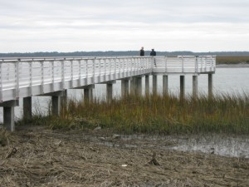

Set to open in just a couple of weeks, a new fishing pier at the Steamboat Landing on Edisto Island replaces a wooden pier that had been closed for a year.
The new fishing pier at Steamboat Landing features sustainable aluminum decking, wood composite railings, concrete pilings, and is now ADA-compliant – allowing for anglers in wheelchairs.
The pier stretches into 22-feet deep waters on Steamboat Creek.
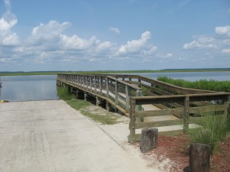
The original Steamboat Landing fishing pier
The pier’s replacement was made possible by the Shore-Based Saltwater Fishing Access Grant from the South Carolina Department of Natural Resources (DNR). Grant funds were made possible through the sale of saltwater fishing licenses.
The Charleston County Park and Recreation Commission (CCPRC) will host a grand-reopening ceremony for the Steamboat Landing fishing pier on Friday, February 8 at 11:00 a.m.
Steamboat Landing is located at Steamboat Landing Road on Edisto Island. Free for public use, is one of 19 landings in the Charleston area managed by the Charleston County Park and Recreation Commission.
PHOTO CREDITS: CCPRC

Tweet

Comments

Ready! Aim! Relocate!
Published Date : January 30, 2013
Author : admin


Embarking on his own economic development mission of sorts, South Carolina Congressman Jeff Duncan (R-SC 3rd District) is encouraging production relocation to the Palmetto State by one of the nation’s oldest continuously operating manufacturers.
In a letter dated January 23 of this year, Congressman Duncan encouraged George Kollitides, the CEO of the parent company for Remington Arms, to consider relocating the company’s New York production facilities to South Carolina in light of New York’s recent decision to adopt increased gun restrictions.
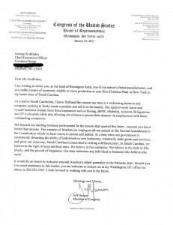In his letter, Congressman Duncan highlights South Carolina’s business climate, pointing out the fact that companies like Boeing, BMW, Michelin, Amazon, Bridgestone, and ZF have all invested heavily and created jobs in the Palmetto State. “But beyond our sterling business environment lie the reasons that sparked this letter – reasons you know better than anyone,” Duncan wrote citing second amendment and free commerce issues.
“We believe in the right to life, liberty, and the pursuit of happiness. Our state welcomes any individual or business who believes the same,” he wrote.
Duncan added, “It would be an honor to welcome you and America’s oldest gunmaker to the Palmetto State.”
In addition to the letter to Mr. Kollitides, Congressman Duncan sent another letter to South Carolina Governor Nikki Haley encouraging her to approach other companies in the firearms industry to relocate their operations to South Carolina.
“In South Carolina, we believe in the right to keep and bear arms,” Duncan wrote the Governor. “We need to encourage other businesses who share those beliefs to relocate to the Palmetto State.”
Read Congressman Duncan’s letter HERE.

Tweet

Comments

Are You Ready for Some BBQ?
Published Date : January 29, 2013
Author : admin


Do you think you’ve got what it takes to win the Commissioners Cup State Championship BBQ Cook Off?
If you’re a backyard barbecue warrior, or a professional that hits the barbecue circuit, then now is the time to sign up for the South Carolina Department of Agriculture’s Smokin’ at the Market Commissioners Cup BBQ Cook Off. The competition is March 22-23 at the State Farmers Market, 3483 Charleston Hwy., West Columbia.
The cook off is sanctioned by the Southern BBQ Network. The categories for the Commissioners Cup include: Anything Butt, Butts, Pork Ribs, Grand Champion, and Reserve Champion. South Carolina Commissioner of Agriculture Hugh Weathers will present the awards on Saturday afternoon of the event.
Barbecue teams can sign up HERE, or email Jackie Moore at jmoore@scda.sc.gov for more information.

Tweet

Comments

Defending Champion Carl Pettersson to Play in RBC HERITAGE
Published Date : January 28, 2013
Author : admin
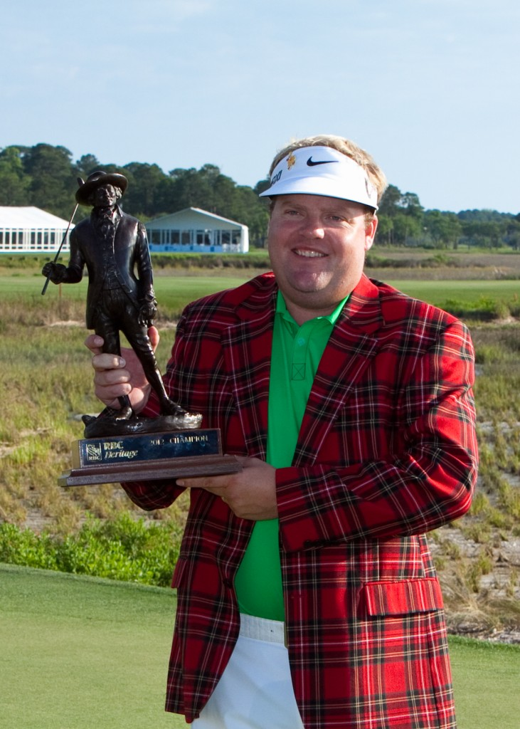

Carl Pettersson will defend his title at the 45th annual RBC Heritage, April 15-21 over the famed Harbour Town Golf Links. The Swedish native is joined by six other past champions who are making early commitments to the only PGA TOUR stop in South Carolina.
The other former RBC Heritage winners slated to compete are two-time champions Stewart Cink and Boo Weekley, plus Brandt Snedeker, Jim Furyk, Glen Day and Justin Leonard.
The entire group will be shooting for the top prize of $1,044,000 from a purse of $5,800,000.
Pettersson has won five times on the PGA TOUR, most recently at the 2012 RBC Heritage. He beat Zach Johnson by 5 strokes after carding 3 birdies on the first five holes. The win tied him with Jesper Parnevik for most wins on the PGA TOUR by a Swedish player. Carl moved to Greensboro, NC with his family in high school and later attended NC State. He now lives in Raleigh and is a US citizen.
Snedeker won twice in 2012, first at the Farmers Insurance Open and then at the TOUR Championship. In 2011, Brandt fired a final round seven-under par 64 at Harbour Town to tie Player of the Year Luke Donald and then went on to defeat him in a playoff.
Furyk, the 2010 victor, as well as 1999 champion Day, both won after playoffs. Cink, former British Open Champion, captured the Heritage in 2000 and 2004. Weekley is the last to win back-to-back titles in 2007 and 2008. Leonard won at Harbour Town in 2002.
Daily tickets and weeklong badges for this year’s tournament are now on sale online at www.rbcheritage.com or by calling the tournament office at (843) 671-2448.
PHOTO CREDIT: Heritage Classic Foundation

Tweet

Comments

SC Venues Rank Among "Top Stadium Experiences"
Published Date : January 25, 2013
Author : admin


Releasing its second annual list, Stadium Journey magazine named two South Carolina venues among “The Top 101 Stadium Experiences of 2012,” with Clemson’s Death Valley at number 46, and Myrtle Beach Pelicans’ Ticket Return.com Field at Pelicans Ballpark edging in to the top 20 at number 19.
According to Stadium Journey, the publication “utilizes its FANFARE scale for ranking the stadiums on its website and for the purposes of creating this list. The scale takes into account the food & beverage at the stadium, overall atmosphere, the neighborhood in which it resides, the fans, access outside and inside the stadium, return on investment, and allows for room for ‘bonus points’ for unique features. Reviews are submitted by Stadium Journey‘s 80+ contributors, and tiebreakers are settled by a stadium’s ‘Crowd Score,’ (the average of ratings submitted by members).”
Myrtle Beach Pelicans officials said the team received its official score from Stadium Journey earlier in the season. With the score based out of 5, the Pelicans earned a 4.6 for FANFARE Score and a Crowd Score of 4.4.
TicketReturn.Com Field at Pelicans Ballpark earned the highest marks in the food and beverage category, neighborhood, access, and the extras categories. The magazine’s regional correspondent mentioned in his review that “the club combines a great product on the field with a beautiful facility in a hard-to-beat location.”
“Seeing the overall experience at Ticket Return.com Field at Pelicans Ballpark ranked ahead of so many world-renowned venues should be a source of pride not just for anyone associated with the Pelicans, but for all residents of the Grand Strand,” said team Vice President and General Manager Andy Milovich. “Certainly, we don’t have 100,000 seats, or host Super Bowls and World Series, but it’s humbling to see the fun, affordable and memory-making experience that the Pelicans provide 70 nights a year recognized like it deserves.”
What’s your favorite sports venue in South Carolina, and why?

Tweet

Comments

SC Senate Passes Bill to Fix Ballot Issue
Published Date : January 24, 2013
Author : admin


With the courts removing over 200 Republicans and 40 Democrats from last June’s South Carolina primary election ballots due to conflicting ethics and election laws, the South Carolina Senate has passed a bill designed to prevent the issue from coming up again.
Named the “Equal Access to the Ballot Act,” bill S.2 sponsored by Senators Chip Campsen, Larry Martin, Ronnie Cromer, and Wes Hayes will equalize filing requirements of both incumbents and challengers.
It also clarifies the law so that candidates seeking Congressional, Statewide, or district offices including more than one county must file a Statement of Intention of Candidacy (SIC) with the State Election Commission, and that General Assembly candidates must file a SIC with the election commission of the county in which they reside.
Candidates must also file a Statement of Economic Interests (SEI) electronically with the State Ethics Commission. Incumbents and challengers will be treated equally, with both being required to file a SEI by noon on March 30 for any year which there is a general election.
Those who fail to file an SEI by the close of the filing period will be subject to a fine and then given a grace period to file the proper paperwork, rather than being immediately removed from the ballot. Candidates who intentionally refuse to comply with the filing requirements after repeated notices and fines will not be allowed to take office until a completed SEI is filed.
“Last year, voters were denied choices because of a small technicality,” said Senate Judiciary Chairman Larry Martin. “This bill will ensure that voters will be given the choices they deserve, and eliminate the potential for an issue like the one we had in 2012.”
Senator Campsen said that the issue needs to be resolved quickly. “An issue which removed more than 250 candidates from the primary ballot is definitely one that needed to be addressed as soon as possible,” Campsen said. “Voters can now be assured that they will have the opportunity to vote for the candidate they choose.”
The bill now moves to the House for debate.

Tweet

Comments

Michelin North America Investing $200 Million in Anderson County
Published Date : January 24, 2013
Author : admin


Tire maker Michelin North America will expand its existing rubber production operations in Anderson County. The $200 million investment is expected to generate 100 new jobs.
“I am proud to say this new expansion at this facility is one of the lynchpins that will allow us to maintain Michelin’s industry leadership in providing customers with the best tires in all categories,” said Pete Selleck, chairman and president of Michelin North America. “Michelin’s continued investment in Anderson County and the state of South Carolina is a testament to our proven, high-quality workforce here.”
Michelin North America will expand its rubber production facility, located at One Bib Way in Starr, in order to keep up with increasing demand that has its factories in North America building more tires of every kind and size. The expansion is expected to be operational in 2014.
“It’s exciting to see a world-class company like Michelin choose to further expand its footprint in our state. We celebrate Michelin’s decision to invest $200 million and create 100 new jobs in Starr. When one of South Carolina’s largest manufacturers chooses to expand here, it helps send the message that the Palmetto State is the right place to do business,” said Governor Nikki Haley.
Today’s announcement is the second expansion announcement in South Carolina for the company in less than a year. Last April, Michelin announced expansion plans and committed to invest $750 million and create 500 new jobs in Anderson and Lexington counties. In the last 21 months, the company has committed to invest a total of $1.15 billion and create at least 870 new jobs in South Carolina.
“South Carolina has really become the national leader in the tire industry and today’s announcement by Michelin just adds to our reputation. Additionally, this provides another boost to the Palmetto State’s manufacturing renaissance. Our automotive-related industries continue to thrive, grow and create new jobs,” said Secretary of Commerce Bobby Hitt.
Since January 2011, South Carolina has recruited more than $5 billion in capital investment and more than 8,000 jobs in the automotive-related sector.
Construction has begun on the Starr plant expansion, which will be adjacent to the current facility. Also nearby is Michelin’s previously announced Earthmover tire plant that is being built and is scheduled to begin producing tires later this year.
“We are delighted that Michelin again has decided to invest in our great state and our wonderful county,” said Anderson County Council Chairman Francis Crowder. “The relationship between Anderson County and Michelin has been long and fruitful. Today Michelin will again add quality jobs and investment to our area. We are truly blessed and we pledge to continue nurturing this very special relationship now and in the future.”
The Starr factory is one of two Michelin semi-finished rubber production plants in Anderson County. The company’s largest rubber-producing plant in the world is only a few miles away in Sandy Springs. Built in 1975, that facility was one of Michelin’s first manufacturing facilities in the U.S.
“There is no better way to kick off 2013 than by announcing an investment of $200 million and 100 jobs,” said Anderson County Councilman District 3 Eddie Moore. “Not only is this great news, but it is a demonstration of Anderson County’s business-friendly environment. Michelin is part of the Anderson County family – they have put down roots in our community and it is extremely gratifying to watch them flourish. Their success is our success.”
Michelin is South Carolina’s largest manufacturing employer. Nearly 9,000 of Michelin’s 22,000 employees in North America will be located in South Carolina when all the construction is complete. Nine of Michelin North America’s 18 production facilities are located in the state.
The company has begun hiring maintenance technicians already, and will begin hiring production workers in the coming months. Anyone interested in job opportunities with the company should visit careers.michelin-us.com/.

Tweet

Comments

$4.5 Million Investment in York County Expected to Create 60 New Jobs
Published Date : January 24, 2013
Author : admin


Lap Tech Industries, a manufacturer of precision components, will expand its existing operations in York County with a $4.5 million investment expected to generate 60 new jobs.
“We are excited to be growing our operations here in York County. This expansion is an important step for our company and will help us to extend our reach and meet the demands of new customers. South Carolina has continued to provide us with the right business environment in which to operate. We appreciate all the support we’ve received from state and local officials,” said Ramon Guzman, president of Lap Tech Industries.
Lap Tech Industries manufactures components for customers in the automotive, electronics, appliance and metal stamping industries. The company provides precision finishing services such as grinding, lapping, polishing and precision cleaning to its customers. The company will be moving into a newer, larger building in order to expand its precision finishing operations and add additional capabilities. Future planned capabilities also involve precision fabrication and metal forming. The new facility will be online by early summer 2013.
“While we work hard every day to bring new companies to South Carolina, it’s always exciting to see one of our existing businesses grow. We celebrate Lap Tech Industries’ decision to invest $4.5 million and create 60 new jobs in York County. Announcements like this show everyone that South Carolina is the ‘it’ place to do business,” said Gov. Nikki Haley.
Since January 2011, South Carolina has recruited more than $7 billion in capital investment and more than 20,000 jobs in the manufacturing sector.
“South Carolina’s manufacturing renaissance continues to gain steam with announcements like this one. Lap Tech Industries’ decision to expand in York County is another indication that our business-friendly climate and skilled workforce are helping companies find success and grow,” said Secretary of Commerce Bobby Hitt.
York County Council Chairman Dr. said, “York County is excited that Lap Tech Industries is expanding their precision finishing operations and workforce into an existing building in the East York Industrial Park in York. This company represents the best of small business in South Carolina and we look forward to growing with them as they continue to lead the path of an emerging optics industry.”
The company will begin hiring for the new operations in March, 2013. Anyone interested in job opportunities with the company should contact the company at 803-831-0761.
Lap Tech Industries, a manufacturer of precision components, will expand its existing operations in York County with a $4.5 million investment expected to generate 60 new jobs.
“We are excited to be growing our operations here in York County. This expansion is an important step for our company and will help us to extend our reach and meet the demands of new customers. South Carolina has continued to provide us with the right business environment in which to operate. We appreciate all the support we’ve received from state and local officials,” said Ramon Guzman, president of Lap Tech Industries.
Lap Tech Industries manufactures components for customers in the automotive, electronics, appliance and metal stamping industries. The company provides precision finishing services such as grinding, lapping, polishing and precision cleaning to its customers. The company will be moving into a newer, larger building in order to expand its precision finishing operations and add additional capabilities. Future planned capabilities also involve precision fabrication and metal forming. The new facility will be online by early summer 2013.
“While we work hard every day to bring new companies to South Carolina, it’s always exciting to see one of our existing businesses grow. We celebrate Lap Tech Industries’ decision to invest $4.5 million and create 60 new jobs in York County. Announcements like this show everyone that South Carolina is the ‘it’ place to do business,” said Gov. Nikki Haley.
Since January 2011, South Carolina has recruited more than $7 billion in capital investment and more than 20,000 jobs in the manufacturing sector.
“South Carolina’s manufacturing renaissance continues to gain steam with announcements like this one. Lap Tech Industries’ decision to expand in York County is another indication that our business-friendly climate and skilled workforce are helping companies find success and grow,” said Secretary of Commerce Bobby Hitt.
York County Council Chairman Dr. Britt Blackwell said, “York County is excited that Lap Tech Industries is expanding their precision finishing operations and workforce into an existing building in the East York Industrial Park in York. This company represents the best of small business in South Carolina and we look forward to growing with them as they continue to lead the path of an emerging optics industry.”
The company will begin hiring for the new operations in March, 2013. Anyone interested in job opportunities with the company should contact the company at 803-831-0761.
Tweet

Comments

The Iceman Cometh...Or Not
Published Date : January 24, 2013
Author : admin


According the state’s meteorological elite, “winter weather” is expected for Upstate SC tomorrow, but we don’t think there’s a real need to worry.
As one of our readers reminded us last night from a conversation she had at the airport:
“Any South Carolinian worth his weight in salt knows that if it’s not coming up 85 from Atlanta, the North Carolina mountains will block most of it.”
Truer words have seldom been spoken.
(BTW, for our friends not “from ’round here,” winter weather in Upstate SC means ice, not snow.)

Tweet

Comments

Google Adds $600 Million Investment to Lowcountry Operations
Published Date : January 18, 2013
Author : admin


Governor Nikki Haley, state Sen. Paul Campbell, Berkeley County Supervisor Dan Davis, Berkeley County Chamber of Commerce President Elaine Morgan, Google’s Berkeley County Data Center Operations Manager Eric Wages and local business and community leaders participated in a groundbreaking ceremony announcing that Google will expand its operations at the Mt. Holly Commerce Park in Berkeley County. The additional $600 million investment at the data center site brings Google’s total investment to over $1.2 billion.
“South Carolina and the Berkeley County community are great places in which to work and grow,” said Data Center Operations Manager Eric Wages. “When Google first announced plans to come to Berkeley County in 2007, we were attracted to not only the energy infrastructure, developable land and available workforce, but also the extraordinary team from the local community that made us feel welcome. Today’s announcement is just a continuation of our investment in the state. Google is proud to call Berkeley County home.”
SC Department of Commerce officials say that the announcement aligns with Google’s goals to provide the best possible user experience.
The data center in Berkeley County houses computer systems and associated components that support services such as Google search, Gmail, Google+, and YouTube. The company is growing capacity to meet demand for Google’s services.
“Today’s announcement is another big win for South Carolina. We celebrate Google’s decision to grow its footprint in Berkeley County with a $600 million investment. When a world-class company like Google decides to expand in the Palmetto State, it shows we are providing the sort of business environment that helps foster success,” said Governor Nikki Haley.
Google first announced plans for a South Carolina data center in 2007 and made an initial investment of $600 million to get the center up and running. In November 2010, Google announced plans to construct a second building at the site, which is now in operation.
“Google has been a part of South Carolina’s business community for several years now and today’s announcement reaffirms the company’s commitment to our state. Investments like this not only create wealth but also help to sustain the surrounding communities,” said Secretary of Commerce Bobby Hitt.
According to officials involved with the announcement, the company’s facilities consume 50 percent less energy than a typical data center. In 2007, Google committed to become “carbon-neutral.” At the Berkeley County site, Google is experimenting with ways to collect stormwater and use it to cool the servers inside the data center as a part of that committment.
“When our community came together to develop this business park, we wanted to attract leading companies that would establish deep roots and grow,” said state Sen. Paul Campbell. “Google’s expansion is an example of how Berkeley County can serve the needs of the world’s most innovative and dynamic companies. I hope Google’s growth here prompts other growing businesses to put down roots here.”
“Google is a world-class corporation impacting life and business in our ever changing technology-based society. The continued growth at the Berkeley Campus is significant not only for Google, but serves as an endorsement of success to other industries that consider choosing to locate in our county and region,” said Berkeley County Supervisor Dan Davis.
Google is also involved in supporting science and mathematics programs in local schools. Since 2008, it has awarded more than $885,000 in grants to local schools and nonprofits. It also has helped implement a free, downtown Wi-Fi network in Goose Creek.
“Google is a vital member of our region’s business community and their significant expansion is a testament to our fast-growing advanced security and IT sectors and knowledge economy,” said Wayne Hall, Charleston Regional Development Alliance Board Chairman.

Tweet

Comments

SC Takes Top Spot for Jobs Linked to Foreign Investment
Published Date : January 17, 2013
Author : admin

South Carolina continues to stand out as a top destination for foreign investment, ranking first in attracting jobs through foreign investment, according to an analysis by IBM-Plant Location International (IBM-PLI). The Palmetto State ranked above Texas and North Carolina, which were ranked second and third, respectively, in the 2012 report.
“It is exciting to see South Carolina once again recognized as the ‘it’ place for business investment. Foreign firms have played and continue to play a key role in our state’s economy. We have worked hard to show companies from around the globe that South Carolina is the place to put down roots and do business, and this ranking is another indication of our success,” said Gov. Nikki Haley.
Each year, IBM-PLI publishes a report titled Global Location Trends looking at foreign investment around the globe. The data are derived from IBM’s Global Investment Locations Database (GILD) which tracks announcements by companies on their location decisions throughout the year. The numbers in the new report were based on data gathered in 2011.
“South Carolina is just right for business, and plenty of international companies know it. Hundreds of foreign firms employ tens of thousands of residents throughout our state, creating wealth and helping make the communities they’re in sustainable. The IBM-PLI report’s ranking is another confirmation that people are sitting up and taking notice of the economic development successes we’ve had here in the Palmetto State,” said Secretary of Commerce Bobby Hitt.
The report also looked at global trends and events that affect investment by companies. The latest edition of the Global Location Trends report can be downloaded from IBM’s website at www.ibm.com/gbs/pli.

Tweet

Comments

2013 South Carolina State of the State
Published Date : January 17, 2013
Author : admin

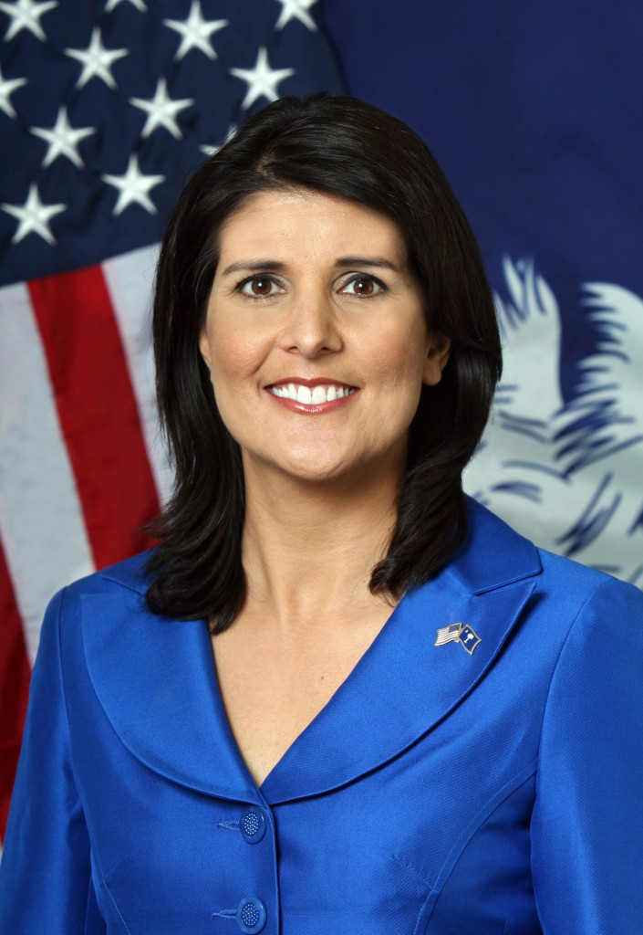Each January, much like the president does at the Federal level, the governor of South Carolina addresses a joint session of the General Assembly to describe the state of our state.
If you missed Wednesday night’s address, you can watch it here or read the text of her speech below.
Mr. Speaker, Mr. President, Ladies and Gentlemen of the General Assembly, Constitutional Officers, and my fellow South Carolinians:
This and every year, we will continue the tradition that recognizes the certain truth that everything we have in this state and this nation we owe, first and foremost, to the men and women in uniform who bravely serve on our behalf.
So now, please join me as we pay tribute to those who gave the last full measure of devotion in the service of their state and country this past year:
- Chief David Lee Crenshaw, Pendleton
- Sergeant Channing B. Hicks, Greer
- Sergeant John D. Meador II, Columbia
- 1st Lieutenant Ryan D. Rawl, Lexington
- Master Cpl. Sandra “Sandy” Rogers, Aiken
- Private First Class Adam C. Ross, Lyman
- Sergeant First Class Matthew B. Thomas, Travelers Rest
On behalf of all South Carolinians, to their families, know we will never forget.
We love and respect our men and women in uniform here in South Carolina – few things make me as proud as the level of patriotism that just radiates off our state and her people.
When I make that call to the families who just lost a loved one, I promise them that the people of South Carolina will wrap their arms around them and never let go.
And the citizens of this state have never let them down.
A wonderful example of that is the 4,150 volunteer members of the South Carolina Patriot Guard Riders.
You’ve all seen these selfless men and women – whether you know it or not.
Their mission is two-fold: to show their sincere respect for our fallen heroes, their families, and their communities, and to shield the mourning family and their friends from interruptions created by any protestors.
They do it magnificently.
Please join me in extending a warm South Carolina thank you to Bruce Ballou, the State Captain of the South Carolina Patriot Guard Riders. You make our state so proud, and may God continue to bless you and your volunteers for their service.
We have another very special guest with us tonight, a hardcore rockstar, Brigadier General Lori Reynolds, the commanding General of one of the greatest military institutions that’s ever existed: the Marine Corps Recruit Depot, Parris Island. If you don’t believe me, tour it yourself – but take my advice, don’t mess with this General.
The Marine Corps has been at Parris Island since 1915 and has trained there for every major conflict of the 20th and 21st centuries. We are so proud of our Marine Corps, so proud that the most impressive Marine training facility in the world is located right here in South Carolina, and so proud that General Lori Reynolds now calls the Palmetto State home.
I’d now ask you to indulge me in a brief moment of personal privilege.
When we as a family started this Administration one of the biggest challenges was moving into a house that was, more than anything, a museum.
A wonderful, beautiful, historic building but a museum nonetheless. And so as a mom my biggest challenge was to make that house into a home for all of us.
We were blessed to have a mansion family that welcomed us and understood the games our kids would play by putting wigs on statues, giving each member of the security team a nickname, and playing jokes on the staff constantly.
We love them all. But there was one person that blessed our lives in a way that no one else could.
He did the same for the Hodges and the Sanford families.
He did the same for many of you.
Chamberlain Branch became a staple of the Residence, not for the job he did but for who he was.
He greeted many of you and other South Carolinians in a way that was Godly and unforgettable.
He made everyone feel special and welcome.
Most importantly, to this mom, he was the person my children couldn’t wait to see when they got home and the one who truly turned that house into home for us.
Our family was blessed by his unselfish kindness to our children and everyone he came in contact with.
By now you all know that Chamberlain was tragically killed in December and our hearts remain broken.
Chamberlain has three young children – Chyann, Little Chamberlain, and Chaniya – who were staples running around that house, and we are blessed to have with us tonight his amazing wife Cherisse.
Please join me and the Hodges and Sanford families in recognizing Cherisse, and saying to Chamberlain Branch, one of the kindest, best men we ever knew, that while you will forever be missed you will never be forgotten.
I also have the pleasure of being humbled by two little ones who remind me how cool it is to be their mom every day.
Whether it’s getting them up and out the door every morning for school – sometimes fighting about what to wear or whether to go to school at all – or them not having a care in the world about me being on TV, they have a way of making me remember what truly is important in this life.
They put up with a lot but never lose the smiles on their faces, so please join me in welcoming Rena, who still loves to dance and Nalin, who still has a passion for the game of basketball.
Of course, our family is clearly missing someone tonight.
Michael is not with us as he has deployed with the South Carolina Army National Guard ADT 49 to Afghanistan.
We miss him terribly but he is doing exactly what he signed up to do – serve his country. He is excited to answer the call, and his only ask to me was to remind our state and country that we are just one of thousands of families that share the bond of knowing military service.
Michael, Rena, Nalin and I thank you for the many prayers and messages of support that have been sent to our family. It has given us strength and inspiration. And we look forward to having him and his entire unit back safely with us next year.
Ladies and gentleman, the state of our state is productive – in spite of the challenges that come our way.
The last half-decade or so has not been an easy one for our nation. Through the financial crisis and the deep recession that followed, we have watched Washington flounder on both sides of the aisle, bouncing from one so-called solution to another.
The result of our federal government’s incompetence has been predictably poor: a stagnant recovery, listless jobs numbers, rising unemployment.
The opposite has been true in South Carolina over the last two years. 31,574 jobs announced. Over $6 billion in new investment. Unemployment at a four-year low.
And two 11-win football teams.
Coming into office, I made a promise to the people of South Carolina, a promise to eat, sleep, and breathe jobs in our state.
We have all the tools to be successful.
A beautiful state, a place where any person would want to live, work and raise a family. A loyal, dedicated workforce with a burning desire to learn and a work ethic to match. And one of the lowest union participation rates in the country.
We needed to let the nation, and the world, know that South Carolina was open for business. Show them the positives of our great state, and the progress that we have made as a state and as a people.
And we have.
In two years, we have announced new jobs in forty-five of South Carolina’s forty-six counties.
We’ve announced more than 6,300 new jobs to rural areas of our state.
We’ve cut taxes on small business – and special thanks to Chairman Brian White and Rep. Tommy Stringer for their fight to make that happen.
We’ve passed tort reform that, for the first time ever, puts a cap on lawsuit damages.
We’ve fought against the unionization of South Carolina, cherishing the direct relationship between our companies – who know how to take care of those that take care of them – and their employees.
We’ve, through Lillian Koller and the Department of Social Services, moved more than 14,000 families from welfare to work.
We’ve created an Agribusiness partnership to showcase the largest industry in our state.
We’ve been awarded, for the second consecutive year, a Gold Shovel in recognition of our economic development successes.
We’ve been ranked as the second best state in the nation as a place to do business. But as Secretary Hitt knows, we aren’t going to stop until we’re first.
We’ve announced $5 billion in foreign investment.
And we’ve seen no less an authority than The Wall Street Journal say that, “Anyone still thinking the U.S. has lost its manufacturing chops hasn’t been to South Carolina.”
South Carolina is truly becoming the “It” state when it comes to economic development and job creation – not just in the United States, but worldwide.
With us tonight are a number of people who are proof positive that what we are doing is working, and I’d like to ask you to help me welcome these wonderful friends of South Carolina.
To those whose names I call, please stand and remain standing. And please hold your applause until the end.
- Representing 500 jobs in Anderson and Lexington Counties, from Michelin North America, Inc., Richard Kornacki
- Representing 126 jobs in Georgetown and Williamsburg Counties, from Agru America Inc., Vicky Thornton
- Representing 124 jobs in Union County, from Belk, Inc., Dave Penrod
- Representing 100 jobs in Colleton County, from SarlaFlex Incorporated, Krishna Jhunjhunwala
- Representing 1,000 jobs in Lancaster County, from Red Ventures, Mark Brodsky
- Representing 200 jobs in Berkeley County, from Nexans, Cam Dowlat
- Representing 80 jobs in Florence County, from McCall Farms, Inc., Henry Swink
- Representing 750 jobs in Richland County, from WNS North America Inc., Reese McCurdy
- Representing 190 jobs in Chesterfield County, from Schaeffler Group USA Inc., Bruce Warmbold
- Representing 50 jobs in Bamberg County, from Tobul Accumulator, Inc., Jim Tobul
- Representing Honda of South Carolina Manufacturing, Inc., Brian Newman, in celebration of the fact that they just produced their 2.5 millionth ATV.
- Representing Fujifilm Manufacturing USA, John Ueno, in celebration of the 25th anniversary of Fujifilm being in Greenwood, South Carolina.
Please join me in showing our support to these great friends, old and new, and thanking them for making South Carolina their home.
And as if we didn’t have enough to celebrate last year when Condé Nast named Charleston the best tourist destination in America, this year we’ve topped ourselves, as our beautiful Lowcountry city was named the number one tourist destination in the world.
Representing the Charleston Area Convention and Visitors Bureau tonight is Helen Hill, who along with the hospitality industry, our own people at PRT, and most importantly the citizens of Charleston deserves a round of applause.
I’m also of the mind that when any South Carolinian succeeds, it’s a great day in South Carolina. And we should all be exceptionally proud of a great friend to this state and a proud Clemson Tiger, Dr. Louis Lynn.
In 1985, Dr. Lynn founded ENVIRO AgScience, Inc., and his successes and contributions have not gone unnoticed. This past year, the United States Department of Commerce gave Dr. Lynn the Ron Brown Award as the nation’s Small Business Person of the Year. Congratulations, Dr. Lynn.
That the companies represented here tonight chose South Carolina to be their home is a tribute to the kind of state we have right now.
But we can absolutely do more.
And we will do more – because none of us should be satisfied until every person in South Carolina has the opportunity to find work.
First, we cannot rest on our laurels when it comes to our tax rates.
You’ve long heard me say that South Carolina needs to reduce our tax burden every single year. Never has that been more important than now, with our citizens opening their paychecks this month and seeing that, low and behold, Washington’s tax hikes on the rich somehow got them too.
This year, I propose that we eliminate the six percent tax bracket.
This reform cuts taxes for the overwhelming majority of people who pay income tax, and not a single South Carolinian will pay more.
Other states have seen the successes we’ve had in South Carolina and are nipping at our heels. Look around the nation and see all the governors, the legislators, the states that are proposing slashing or even eliminating their income taxes. We have to keep up.
Second, we need to take a serious look at our regulatory environment.
If government is costing a business time, then government is costing that business money.
And while the legislature convenes annually to look at new legislation and regulations, I know of no joint legislative and executive effort that comes together to look at removing regulations that stymie the private sector and hold our economy back.
That changes this year.
Tonight I am announcing the formation of a Gubernatorial Task Force, largely to be made up of members of the business community, that will review regulations and recommend those that can be eliminated.
Some changes can and will be made at the agency level – which is why one of the appointments I make will be the Chairman of Commerce’s Small Business Regulatory Committee, Dan Dennis, and why I will be directing by Executive Order all of my agencies to begin this review process.
But some may require legislative action, which is why I am asking you to join me in this effort and inviting Majority Leader Peeler, Minority Leader Setzler, Majority Leader Bannister, and Minority Leader Rutherford to each make an appointment to the task force.
It has always been my belief that the best way to recruit new businesses in our state is to take care of the businesses we already have – and that with the business community as our biggest cheerleaders, there is nothing we can’t accomplish in the great state of South Carolina.
Third, we have to address our crumbling infrastructure.
Our roads, our bridges – they simply aren’t up to standard. More than 1,000 of South Carolina’s bridges are either load-restricted or structurally deficient.
First and foremost, it’s a public safety issue. The citizens of South Carolina deserve to drive on roads that aren’t littered with potholes and on bridges they know won’t fall down.
It’s a core function of government. But it’s also an economic development issue.
South Carolina has announced our self as the new superstar of American manufacturing.
We build things.
We build planes.
We build cars.
We build tires.
We build more ATVs than anywhere else in the world.
We need roads and bridges that match the quality of the companies that manufacture in our great state.
And we will get them.
But I will not – not now, not ever – support raising the gas tax.
The answer to our infrastructure problems is not to tax our people more, it’s to spend their money smarter.
Why would we raise the gas tax to improve infrastructure when all the gas tax dollars we currently collect don’t go to improving our infrastructure?
Millions of dollars each year in gas tax revenue are being diverted away from our bridges and our highways. Let’s change that.
And then let’s invest more of the money we already have into this vital area.
Every year you hear me talk about the “money tree” that falls during session, whereby new dollars appear above and beyond what was available when we balance our budget in December or January.
Let’s prioritize that money differently this year.
We’ve released an Executive Budget that is balanced, funds the core functions of our government, strengthens underfunded needs like mental health and law enforcement AND identifies an estimated $90 million this year for road and bridge improvements.
Let’s follow that blueprint. We can make our state safer – and our business climate even more dynamic.
With us today is Warden Mike McCall, one of the unsung heroes of South Carolina state government. Warden McCall runs Lee Correctional Institution – one of our most dangerous prisons, housing the worst of the worst of our convicts.
As a legislator, it was always my belief that giving money to corrections was giving money to criminals, and that there were better, more noble places our tax dollars should go.
Warden McCall will tell you that’s not true.
Twice in the past year, the Warden has had the prisoners take control of parts of his prison. He has seen one of his guards viciously beaten and left for dead in a janitor’s closet.
Yet Lee Correctional has no towers, no wands, and few cameras. I’ve been there. I’ve seen it.
Warden McCall will tell you that if we give money to his facility it’s not going to the prisoners, it’s going to the guards. And that for them, it’s a matter of life or death.
Join me in thanking Warden Mike McCall – and then join me this budget year in helping to keep him, and all our prison guards, safe and secure.
Of course, we can’t talk about security in South Carolina without talking about the Department of Revenue and the protection of the personal data of the people of our state.
Plenty has been said and written about the international criminal hacking that took place at DOR – I’m not here to rehash that or to look backwards, except to say this: when it comes to data security, the state of South Carolina should have done better in the past and will do better in the future.
That does not mean that we will be 100 percent protected. The toughest lesson I have learned is that in today’s world there is no such thing as absolute security. That is true for conventional terrorism and homeland security threats, and it is true for cyberterrorism and cybersecurity threats. It’s a hard reality, but reality nonetheless.
What it does mean is that we will do everything we can to make sure that no state in the country has better security measures in place than we do.
Already we have taken a number of steps in that direction at the Department of Revenue.
We are encrypting all personal and sensitive data.
This month we will have completed implementation of two-factor identification for DOR employees.
We are segmenting our networks to make sure that our most sensitive information is protected separately and securely.
We have created a Security Council within the Department, a team of professionals that will meet regularly to discuss the state of our security in this changing world and constantly update our processes.
And we have changed the organization of the Department so that the Chief Information Security Officer reports directly to Bill Blume, the director of the agency.
By the end of this process the Department of Revenue’s data will be as secure as any data in the private or public sector.
But it’s not just DOR that requires our attention. In October I asked Inspector General Pat Maley to review the IT standards and practices across state government.
His report made clear the following: while cybersecurity policies were carried out on a near-daily basis in almost every agency, South Carolina lacks a single entity with the authority necessary to better secure our systems.
We must fix that, and fix that this year.
I have also directed every single cabinet agency to work with our state IT department to make sure that twenty-four hours a day, seven days a week, fifty-two weeks a year, our systems will be watched.
These measures are not cost-free, but they are necessary, and I want the thank Chairman Hugh Leatherman and Chairman Brian White for their help in enabling the state to respond forcefully to this attack.
My ask to you tonight is to ensure that it’s not just cabinet agencies, but every agency in state government that is working with our state IT department to provide our citizens the security they deserve.
To date, more than 1.1 million of South Carolina’s citizens and businesses have signed up for credit protection, either through Experian or through Dun and Bradstreet.
They are good, honorable companies who will help keep our information protected and at the same time be respectful to the citizens of South Carolina who have turned to them in our time of need.
So to every South Carolinian watching tonight, let me say this: if you have not signed up yet for protection, if your parents have not signed up for protection, if your friends or your coworkers or your neighbors or your siblings have not signed up for protection, please, please urge them to do so.
It is so important. Please visit: www.protectmyid.com/scdor and use the activation code SCDOR123.
There is no question that what happened at the Department of Revenue was a jolt to all of us. My pledge to the people of our state is that as with all crises, all challenges, we will do everything in our power to come out the other side stronger than before.
We’ve come now to the portion of the evening that may feel to some like déjà vu. Restructuring.
Few of us would deny that our government structure is outdated, broken, and does not well serve the citizens of South Carolina.
Every year governors as far back as Dick Riley have stood before you and pleaded to bring our government into the modern era.
And every year it feels like we end up in the same place, preaching the same changes, facing the same obstacles.
This year I want to keep it simple – two critical changes to the way South Carolina is structured.
First, our Department of Education.
Last year, for the first time ever, the House passed a bill that would allow governors to appoint the Superintendent of Education.
I cannot overstate how important this change is.
And all we are asking is that we give the voters the opportunity at the ballot box to make this constitutional change.
General Zais supports it.
The South Carolina House of Representatives supports it.
And I believe that if given the opportunity the people of South Carolina will support it at the ballot box.
Let’s give them that opportunity. They deserve it.
And now to the Department of Administration.
Each of the last two years, I have made the argument as to why ridding our state of the unaccountable “Big Green Monster” that is the Budget and Control Board would move South Carolina forward.
Some of you, like Senators Larry Martin and Shane Massey, have made that argument with me.
For me to do so again tonight would be redundant.
I believe most of you know it is the right thing to do.
Instead, I will make this observation: if one came to South Carolina from another state or country and saw the way the Department of Administration bill was handled last year, he or she would surely be confused.
The Senate unanimously voted in favor of it. A large majority in the House voted for it. And still, it didn’t pass.
How is that possible, one might wonder. How did the Senate not even take a vote on the final day? That’s not the way our system is supposed to work.
One might conclude that some of the votes in favor of restructuring were contrived. One might even think that some wanted to be on the record in favor of it while at the same time trying desperately to stop it from happening.
Well, to that, I will say this.
I wish a warm welcome to all the newly elected members of the House and Senate, but I want to extend a special welcome to the new senator from Lexington County, Katrina Shealy. Senator Shealy represents one less excuse for those who don’t want to change the wasteful and inefficient way state government operates.
There are no more excuses left. Let’s pass the Department of Administration this year.
Unfortunately, our structure of government isn’t the only place South Carolina lags behind the rest of the country.
In recent years, there has become a palpable sense among the people of our state that something is fundamentally wrong with the way many elected officials have conducted themselves.
In some ways that sense is unfounded. The vast majority of our elected officials are honest and honorable people. But in other ways, the public’s unease is fully justified.
For too long, votes weren’t being recorded.
Hundreds of would-be challengers were thrown off the electoral ballot while incumbents skated by untouched.
The people, by and large, believe that South Carolina government is set up in a way that serves the public officials of our state rather than the other way around.
We have made some progress over the last years, starting with the passage of a bill that for the first time ever requires that every single vote on the floor of the General Assembly be on-the-record – and I thank you for making that a reality.
But we still haven’t done nearly enough.
The State Integrity Investigation took a look at every state’s risk for corruption and gave South Carolina an “F”.
We got an “F” for our ethics enforcement agencies.
We got an “F” for our legislative, executive, and judicial accountability.
We got an “F” for our public’s access to information.
We got an “F” for our state budget processes.
We got an “F” in nine of the fourteen categories they considered.
Every single one of us knows that is not good enough, that the people of South Carolina deserve better, and that it is our responsibility – our obligation – to give it to them.
I think we each also know that if the public is going to trust the changes we make to a system that almost exclusively governs us then we should not be deciding alone what those changes look like.
Instead our ethical standards should be determined NOT by those inside this Capitol but by those who have no stake in our rules.
That’s why, in October, I created a panel of individuals of unimpeachable personal and professional credentials to help us navigate this reform process.
The panel includes former prosecutors.
It includes former members of our Ethics Commission.
It includes former legislators.
It includes members of the press.
It includes appointees made from each of your bodies.
It includes Democrats and Republicans.
Most importantly it is made up of people who have nothing to gain from their participation other than the satisfaction of moving South Carolina forward.
Rarely has such a talented and diverse group of people gotten together and worked so quickly, so meticulously, and so diligently toward the task at hand.
While every member of the South Carolina Ethics Reform Commission deserves our thanks and praise, the co-chairs of the Commission are here with us this evening, and I ask you to join me in recognizing two wonderful statesmen, two former Attorneys General, Travis Medlock and Henry McMaster.
They have thrown themselves into this process with an intensity and sense of purpose that gives me great hope for the recommendations they will deliver to us within the next two weeks.
They have been thorough and thoughtful, taking testimony and gathering research from those within the system as well as those outside it.
And I have every faith that their recommendations will make South Carolina stronger.
Our citizens must have confidence in how we do our jobs. That confidence will come from adopting the recommendations of this bipartisan, professional, and unbiased group of experts. Our citizens deserve no less, and we should accept no less.
Now let’s talk about health.
For all the debate we will have over health care in the coming legislative session I believe we all agree that we want and need a healthier South Carolina.
And no one can deny that this administration – working with legislators like Rep. Murrell Smith and Sen. Thomas Alexander – has made health a priority.
We started 2011 with a Medicaid budget out of balance and we brought it under control.
We started with one of the lowest rates of insured children in the country and now South Carolina is recognized for adopting leading edge strategies to reach more kids.
We started with mental health and addictive disorder programs hobbled by cuts and together we have reinvested in both.
We started with a Medicaid program that required little accountability for quality or cost and we’ve demanded better value.
These are successes we should celebrate.
But let us ask a simple question. “Are taxpayers getting the most health for the money they spend on health care?” My answer is no – not by a long shot.
We spend more money for health services per person than any nation on earth. Year after year we devote a larger and larger portion of our paychecks, our payrolls and our state and federal budgets to health care services.
Maybe we wouldn’t worry about all of this spending if our outcomes were better, but they aren’t.
The United States is falling behind the rest of the world in infant mortality and life expectancy – and here in South Carolina we have one of the lowest life expectancies and highest infant mortality rates in the U.S.
With such high costs and such poor outcomes, why would we throw more money at the system without first demanding improved efficiency, quality, and accessibility?
The Affordable Care Act, known as ObamaCare, says expand first and worry about the rest later.
Connecticut expanded early under ObamaCare and just reported a $190 million Medicaid deficit – in spite of subjecting their citizens to a massive tax increase.
California just raised taxes in part to cover their Medicaid deficit and yet needs $350 million more to pay for ObamaCare next year.
That’s not us. That’s not South Carolina.
The federal government likes to wave around a nine dollar match like it is some silver bullet, some extraordinary benefit that we cannot pass up.
But what good do the nine dollars do us when we can’t come up with the one?
And what good are any dollars when they come through a program that doesn’t allow us the flexibility to make the decisions that are in the best interest of the people of South Carolina?
In the end, I cannot support this expansion for a very simple reason: it avoids addressing our health system’s high costs and poor outcomes.
As long as I am governor, South Carolina will not implement the public policy disaster that is ObamaCare’s Medicaid expansion.
Instead, we need to improve health care value. And we will.
We are taking a lead in payment reform. This year alone over $40 million of payments are tied to performance – which means better outcomes for Medicaid patients and for South Carolina taxpayers.
We are asking Medicaid beneficiaries to be more engaged in their health. If a patient doesn’t follow a doctor’s advice to stop smoking or doesn’t take their medication as prescribed we end up spending more money than necessary, and more importantly, they’ll never get healthy.
We have to improve patient engagement – and stop rewarding bad behavior.
And we are working on hotspots of poor health.
We’ve already reduced harmful early elective deliveries by half, and we are one of the first states in the nation to no longer pay for this poor practice.
We are investing in rural health, because if you have Medicaid and live in Marlboro or Bamberg it is likely you aren’t as healthy as if you have Medicaid and live in Greenville or Lexington.
This is true for reasons that go far beyond health care, but that doesn’t mean we can’t implement changes that make a difference.
We’ve long known that rural hospitals face challenges that larger hospitals don’t, and now, for the first time ever, the State of South Carolina is going to treat them that way. Health and
Human Services now pays rural hospitals differently from urban hospitals, and starting next year we plan to fully reimburse rural hospitals for their uncompensated care.
This isn’t new money – but money shifted from areas where we need it less to where we need it more, and we will continue to get creative as we work to improve health in the parts of South Carolina that for too long have been pushed aside.
As we go forward together through this debate on health, I ask that we keep the following in mind.
First – health and well-being is ultimately driven most by income, education, personal choices, genetics and support from family and community.
Second – when South Carolina says we are going to do something we have to do it well and we have to pay for it.
We can’t promise expanded Medicaid but cut reimbursements so low that doctors won’t see Medicaid patients. We can’t promise expanded Medicaid while we continue to underfund mental health. And we can’t promise expanded Medicaid while maintaining waiting lists for long-term care services. We need to meet our current commitments before promising more.
Third – there is enough money in our public and private health care system today to make the system work. We can’t spend our way out of this problem – that’s too easy in the short term and too painful in the long term.
The next three years is an extremely risky time for our state budget and for our health system, and while it may be easier to take the federal money and figure out how to pay for it later, I am not willing to commit us to a short-sighted decision we will not be able to back away from.
Instead of expanding a broken program we will continue working together to implement real health solutions for South Carolinians – because a health system that delivers the highest value will be able to thrive regardless of what the future throws at us.
Finally, tonight, let us talk about education.
First, it would be wrong to have a discussion about education without first taking time to remember the victims of the tragedy at Sandy Hook Elementary School. Please join me in a moment of silence.
Thank you.
In South Carolina, we have done some useful things on education in the last couple of years.
We’ve reaffirmed our commitment to charter schools.
We’ve invested in innovation with a focus on both rural and urban areas through programs like Teach For America.
General Zais has pushed the federal government for more flexibility to manage and evaluate our schools and educators – and he won.
So we’ve seen some progress. But our state still has a long, long way to go.
There is no surer path out of poverty and toward a quality life than having a good education.
But it’s not only that. Having a well-educated workforce is a real factor in attracting more businesses and jobs to our state. There’s a real economic element to improving education as well.
I know there are some strong school choice bills that are making their way through the General Assembly, and as I’ve always said I support school choice. It will be good for the parents and children of our state to be able to make their own family decisions, and it should have happened a long time ago.
But I have never been one who believes that choice is the only way to improve education. It is one way, a truly important way, but we have to do other things as well.
Tonight, I want to start a conversation about the way we fund K-12 schools in South Carolina.
I say “I want to start a conversation,” for two reasons.
Number one, I am not by nature a patient person but I know from painful experience that the General Assembly is a body that does not often move quickly. So I figure let’s start with a constructive conversation rather than a controversial piece of legislation and let’s see where that takes us.
Number two, I know that when we start to talk about how we fund our schools, a lot of people can get really nervous really quickly. So let’s take this calmly, and just start with a conversation.
As we all know, sometimes conservations lead to more.
My starting point for this conversation is personal.
Michael and I are the proud parents of two children in Lexington County public schools.
I am grateful every day that my children attend public schools where the teachers are exceptional, the facilities are first-class, and the sense of opportunity and hope for the future pulsate through the classrooms and hallways.
But let’s be honest in this conversation. What I’m describing is not what schools are like in all parts of our state.
I grew up in Bamberg, going to school in a brick box. My education was wonderful because of very special teachers, but when it came to resources, we didn’t know what we didn’t have. I know what it’s like in Bamberg and in many other rural and poorer areas of our state.
I am NOT one who believes that more money is the answer to our education problems. There are other bigger factors, including poverty and broken families.
But the amount of money that actually touches a teacher and student in the classroom is without a doubt a factor in the differences between those schools – and between the education that those children receive.
Now, here’s the tricky part.
We must not do anything that undermines the quality of our schools in Lexington or Greenville or in any of the economically vibrant parts of our state. The parents of those students pay the taxes that fund their education, and I will play no part in diminishing the return they receive.
But we do have to figure out a better way to bring up the schools in the poorer parts of our state, and history shows that we cannot count on their own depressed local tax bases and restrictive federal dollars to do it.
We need to spend our dollars smarter. We need to be more accountable. And we need to better serve all the children in South Carolina.
So, I want to start a conversation.
And I want to start it with three distinguished members of this General Assembly.
The first two are Senator John Courson and Representative Phil Owens, respectively the Chairmen of the Senate and House Education Committees.
The third person I want to reach out to for that conversation is Senator Nikki Setzler.
Now Senator Setzler and I have had some differences. That’s OK. That’s politics.
But I respect his commitment to public education. I know he shares my interest in keeping our Lexington County schools as great as they are. And as the newly elected Senate Democratic leader, I know he and his caucus have at heart the areas of our state that are in most need of attention on education.
So Senators Courson and Setzler, Representative Owens, I invite you to join me in this conversation.
I’m convinced that we can change our policies in ways that improve educational quality for all our children. But I’m also convinced that we can’t do that without touching some sensitive topics, and without bipartisan support and consensus from all parts of our state.
Let us begin that conversation.
This new year, I have found myself reflecting on the last two.
I came into office wanting to make changes that move us forward in a way the people could feel it in their homes and businesses.
We’ve had some great successes together whether they be job announcements, taking our pensions system from the red to the black, reducing taxes, fighting to protect Boeing from the federal government, or creating an Office of Inspector General.
In the same vein we have had some challenges, watching a two year restructuring effort fall in the Senate on the last hour, learning firsthand what businesses have been fighting for years as criminal hackers targeted our state, or watching with frustration as both parties in Washington are unable to find resolutions that help states but instead place further burdens on them.
I come away from these reflections very optimistic because I know what we in South Carolina are capable of when we work together.
I know that we have added over 31,000 new jobs in South Carolina because we have acted as a team, from the county level to the economic development alliances to the state.
The success we’ve had in the jobs arena shows what can happen when there is a willingness to work together.
The challenges come in when we lose focus on the issue and the finger pointing begins.
My goal is to continue to strive for a positive environment that produces results.
I ask that you join me in proving to the people of South Carolina that we are and will be more productive in the new year.
We won’t always agree but we should always be willing to respectfully work towards a resolution for the good of the state.
The people of our state have enough challenges, and they deserve the satisfaction of knowing that Columbia is working for them.
We have a choice this year. We can spend our time playing politics. We can snipe at each other. We can use the pulpits we all have access to – the wells of these distinguished bodies, the microphones on top of a podium – to score political points.
But I believe our state deserves better.
I believe this is the year we can make the people of South Carolina proud by giving them successes on restructuring, on tax relief, on regulatory reform, on strengthening protections in cybersecurity, on healthcare, on education and by raising the bar on the ethics of public officials.
It is a great day in South Carolina, but it will only continue if we make it so.
I for one look forward to the fingers going down and the handshakes of celebration beginning.
Thank you, God bless you, and may He continue to bless the great State of South Carolina.
Shortly after the governor’s speech, SC Department of Transportation Commission Chairman Eddie Adams of Oconee County contacted CRESCENT with a statement regarding the gas tax.
Governor Haley’s remarks addressing raising the South Carolina Fuel User Fee represents the fact that politics is about elections and not what’s best for South Carolina. Tell the people what they want to hear! South Carolina remains the 3rd lowest fuel user fee in the US. The SCDOT has the responsibility in maintaining more miles than 46 other states. As Chairman of the SCDOT Commission and owner of a petroleum wholesale and retail business, even I, without bias, understand that our substandard highway system is at a critical point. Governor Haley states, “Why would we raise the gas tax to improve infrastructure when all the gas tax we currently collect goes to improving our infrastructure. Millions of dollars each year are being diverted away from our bridges and highways.” The diverted money the Governor refers to are by some of her own agencies, DOR, DHEC and DNR for more than $25 million. In fact, fifty percent of the current revenues of the SCDOT goes to just maintaining only a small part of our outdated system.
At the current time, SCDOT estimates that in order to bring the current outdated system up to a good status, it would take more than an additional $1billion dollars per year to meet the highway transportation needs over the next 20 years. Without transportation infrastructure, there will be no Economic Development.
Governor Haley and the Legislature have an opportunity to invest in the Economic Future of South Carolina. It is time for our elected officials to make hard decisions that will make South Carolina a place that our children will want to call home!
PHOTO CREDIT: Office of Governor Nikki Haley

Tweet

Comments

BMW Manufacturing Reports Record Production Volume
Published Date : January 14, 2013
Author : admin

BMW Manufacturing reported record production volume of 301,519 vehicles in 2012. The BMW X3 accounted for nearly half of all vehicles produced (150,143).

BMW Manufacturing achieved another record production year. Annual production of 301,519 vehicles marks 2012 as the highest production volume in the South Carolina plant’s 19-year history. This represents a 9% increase over the production volume for 2011 (276,065). Since 2010, the plant’s production output has increased by 90% (159,284).
“Our Associates are very committed to building quality products for the world. Our customers recognize that and are responding positively,” said Josef Kerscher, President of BMW Manufacturing Co. “In order to sustain our success, we must continue to be flexible and competitive.”
In January 2012, the company announced a $900 million investment to expand the plant’s manufacturing footprint by 1.6 million square feet, add another vehicle model and increase the plant’s overall annual volume to 350,000 units.
Construction projects related to the plant expansion include:
- A 170,000 square foot body shop expansion
- A new 300,000 square foot body shop
- A 650,000 square foot paint shop
- Approximately 400,000 square feet of new logistics and warehouse space
- Several on-site modifications to existing facilities

BMW’s expansion continues at the South Carolina plant. A 650,000 square foot new paint shop is planned.
All construction projects are underway. In addition to the X3 and X5 Sports Activity Vehicle and the X6 Sports Activity Coupe, the factory is preparing to add the new BMW X4 to its current vehicle lineup. The plant produces more than 1,000 vehicles per day and exports 70% of its production to over 130 global markets.
“The expansion and improvements being made to the plant site represent nearly 500 construction jobs,” said Kerscher. “The work being done today ensures the continued success of this plant well into the future.”
Through 2012, BMW Group has invested nearly $5.8 Billion in the Spartanburg plant. Earlier this month, BMW of North America reported the best sales year ever with 347,583 vehicles (BMW and MINI combined) sold in 2012. The BMW vehicle models produced in South Carolina contributed significantly to the company’s U.S. sales success, accounting for 30.7% of all BMW brand U.S. sales (281,460). The X5 led with 44,445 units followed by the X3 (35,173) and the X6 (6,749).
PHOTO CREDITS: BMW Manufacturing

Tweet

Comments

Why Take Advantage of Restaurant Week? Look to Stella's Southern Bistro
Published Date : January 14, 2013
Author : admin


By: John Malik
Jason Scholz pays about $8.00 for a whole chicken and in order for his restaurant to be successful as a business, that $8 needs to come back to him at least three times.
“I can make a whole lot of wonderful with a whole chicken,” grins Jason, the Chef/Owner of Stella’s Southern Bistro in Simpsonville, and in the restaurant business such wonderfulness isn’t going to come from a restaurant that advertises on network television during a professional football game but rather on your kid’s high school calendar.
“The restaurant business isn’t for the faint of heart. The margins are very tight, so you’ve got to treat everything that comes in your back door as if it were priceless. I’ve been in other kitchens and watched cooks throw away stuff such potato peels, parsley stems, or bacon fat. At Stella’s we’ll use those parsley stems in stock or an herb flavored oil, the potato peelings can become potato chips for staff meal and bacon fat has a ridiculous amount of uses.”
It’s that sort of coupon clipping mentality that has allowed Stella’s to thrive and Restaurant Week offers an opportunity for places such as Stella’s to cut through the national marketing of the big chains, find new customers, and delight them. It’s also the diner’s chance to try something new — a bistro in their neighborhood that may have much higher aspirations than dropping whole onions in a deep-fat fryer.
“There’s a lot of chicken being sold on Fairview Road and most of it is just fried chicken breast between a bun, so if I bought and sold plain chicken breast, I’d end up competing with the fast food guys. We use whole chickens, they costs less and it gives you a lot of flexibility and options. We’ll butcher the birds ourselves first by removing the leg quarters, and we may use those for confit (kahn-feet), or maybe we’ll make smoked sausage or a stuffing. The breast will get used for a dinner special, the winglets are staff meal, the giblets will go into our country style pate, the livers become chicken liver mousse and we’ll take the chicken carcass and scrape every bit of meat from it then we’ll make stock with the carcass and wingtips.”
I’ve spent more than a few hours working in Jason’s kitchen, and when he says he wants that chicken carcass scraped, he means it. With the tip of a paring knife every available ounce of meat and fat is scraped from the carcass. The bones are cleaned, and with the help of a few humble vegetables such as carrots, celery, parsley, and onion, they become chicken stock which later becomes the backbone for his sublime soups or sauces. The trimmings are weighed then frozen, and when he has the right quantity, they become something wonderful such as smoked chicken Andouille sausage. The fat gets rendered down by simmering it in a small amount of water until the water cooks off and the fat resembles liquid gold. Liquid chicken or duck fat make the most amazing potatoes simply by covering the potatoes with the fat and roasting them in an oven. The leg quarter will often get deboned, cleaned of any tendons, tenderized then filled with a stuffing — cornbread and vegetables this week, perhaps ground chicken and roasted peppers next week. Or the leg quarter may get cured by packing in salt, pepper and herbs. Two days later the chicken gets rinsed then slowly simmered in plenty of garlic, onion, and the aforementioned liquid fat. The end result is what the French would call confit, or preserved. The salt pulls the moisture away thereby concentrating the chicken flavor, it’s chicken flavor squared.
“We’ll never be able to spend the kind of money on advertising that some of our neighbors do. Within walking distance of Stella’s I’ve got at least a dozen fast food outlets, a few fast-casual places and some mid-price casual chains. They bombard the airwaves nightly, stuff your mailbox with coupons, and have dancing farm animals waving signs. Stella’s certainly can’t compete with that, but they sure as heck can’t compete with my kitchen crew either. And by utilizing my groceries properly we can offer an amazing meal at affordable prices. Our first time customers are always nicely surprised that for another dollar or two over what they might spend at a chain restaurant, they can come here and have an exceptional meal,” Scholz added.
Restaurant Week runs from January 10th through January 20th.
Stella’s Bistro is located at 684-C Fairview Road in Simpsonville. www.stellasbistro.com
John Malik is an award winning chef in Greenville, SC. Along with his wife Amy, they owned and operated 33 Liberty Restaurant from 2001 until 2008. Following that he was Excecutive Chef at two upscale retirement communities in the Greenville area. John has a BA in English from Southeastern Louisiana University and has written for Smithsonian Air & Space, Saveur, The Greenville News, Greenville Journal, e-Gullet and has been featured in Southern Living, Bon Appetit and Chile Pepper magazines. John holds the whimsical title of Kingsford Charcoal Flame Master and was named Who’s Who in America Barbecue for his sophisticated take on traditional smoking. While 33 Liberty was open John hosted the entire team of Michelin’s “Red Guide” inspectors for a private meal and lived to talk about it.
John has made numerous guest chef appearances including the Food Network, Fox & Friends, the International Food & Wine festival at Disney World, Great Chefs of the South (Beaufort, SC) “Fixin to Eat” a Salute to Southern Chefs (Paso Robles, CA), the Epicurean Evening (Los Angeles, CA) Charlotte Shout! (Charlotte, NC), Drager’s (San Mateo, CA) and Greenville’s own Euphoria.
While important to remember that he IS a serious chef, most recently, after undergoing major knee surgery, John let the best of his cabin fever get to him and imagined himself as the mayor of his Upstate city…and he was kind enough to drag our editor on his fictional written journey before pondering who has the state’s BEST pimento cheese.
PHOTO CREDIT: Stella’s Southern Bistro

Tweet

Comments

YOUR TURN: “All-Star Bowl Showing SC Football Talent” By: David Wyatt
Published Date : January 14, 2013
Author : admin
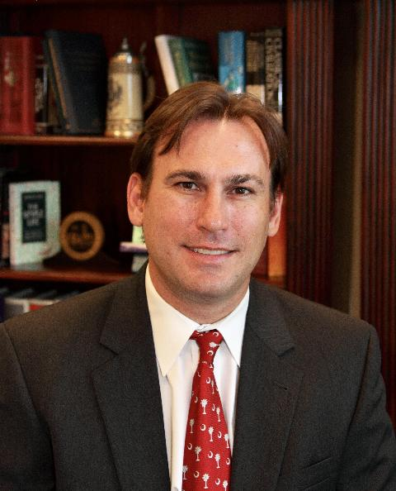

It was a banner year for the University of South Carolina and Clemson University football programs as both won bowl games and ended the year ranked in the top 10.
However, football in the Palmetto State is about more than just the two biggest universities. Over the years, South Carolina colleges and high schools have produced All-Americans, two Heisman Trophy winners, first-round draft picks, NFL Pro Bowlers, All-Pros, Super Bowl winners, College Football Hall of Famers, and Pro Football Hall of Famers.
South Carolina is one of the top five states in the country yearly for putting football players into the NFL. That number becomes the first or second state in the country ever year if you look at it on a per capita basis.
Everyone agrees that talent is here. The disagreement begins over the question of whether that talent is best cultivated in the Upstate, the half of the state above Interstate 20, or is it best cultivated in the Lowcountry, the area below I-20.
That is where the South Carolina College All Star Bowl (SCCASB) comes in. This game is designed to highlight the talent from the state to professional scouts and coaches as well as settle the Upstate vs. Lowcountry debate by establishing an annual regional champion. In addition, the game will help feed and care for South Carolina senior residents as a portion of the proceeds go to Meals on Wheels, and SCCASB viewers and fans will have the opportunity to donate as part of the event.
The inaugural SCCASB is scheduled for March 23 at North Greenville University and will be aired live to a statewide television audience. The game will feature the 48 best college football players from the Upstate against the 48 best college football players from the Lowcountry. Eligible players include all seniors that just finished playing football in one of the 12 collegiate football programs in South Carolina as well as those out-of-state college seniors that grew up playing football in South Carolina.
Sam Wyche, former NFL Coach of the Year, is the commissioner of the SCCASB. Hall of Famer and South Carolina State legend Coach Willie Jeffries is coaching the Lowcountry team against the Upstate team coached by the 1981 National Champion and Clemson coaching legend coach Danny Ford.
This game has something for everyone, and players and fans benefit on multiple levels.
The SCCASB is a perfect opportunity for players to get time with team personnel and showcase their talents on and off the field just one month before the NFL Draft. The timing of this game is ideal because it gives players time to heal and train to reach maximum conditioning as well as perform and interview right before the draft where teams are making their talent purchases.
Another benefit of the SCCASB is bringing these players home to South Carolina to play again and a chance for all players to play one last college football game. Many of the players on each team will be reunited from high school, while others will be playing together for the first time.
Fans will get the opportunity to see talent across multiple conferences compete in a unique competition.
Whether players are trying to get a shot at the NFL or simply playing in a historic final chapter of their football career, the match-up to take place in the beautiful foothills of Greenville County is one no true football fan will want to miss.
David Wyatt is a partner in the Gleaton Wyatt Hewitt Law Firm and president of Wyatt Sports. Learn more about the South Carolina College All Star Bowl at www.sccollegeallstarbowl.com.
DISCLAIMER: The opinions, beliefs, and viewpoints expressed by the author are those of the author and do not necessarily reflect those of CRESCENT: The Magazine.
To submit an op-ed for CRESCENT’s “Your Turn” section, please email it to input@crescentmag.com.

Tweet

Comments

Speaker Bobby Harrell Stops in Greenville to Highlight 2013 Legislative Agenda
Published Date : January 7, 2013
Author : admin
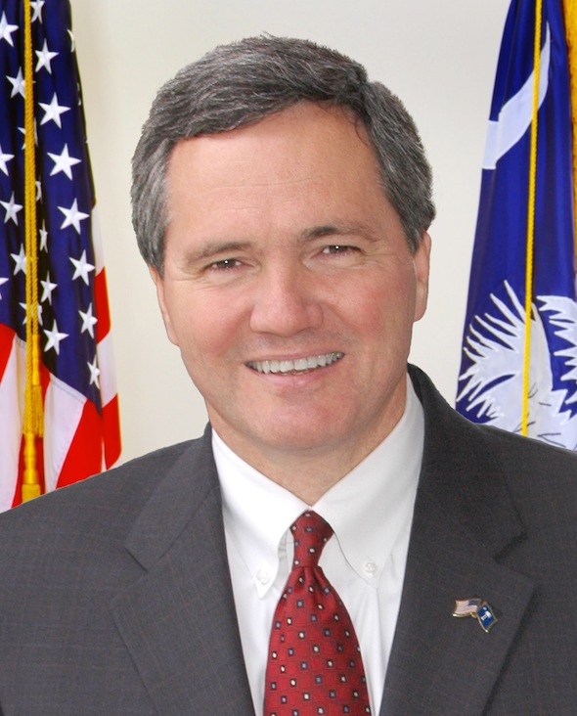

With less than 24 hours before the start of the new session of the South Carolina General Assembly, House Speaker Bobby Harrell (R-Charleston) stopped in Greenville to present the 2013 House GOP legislative agenda to a packed audience downtown.
Speaker Harrell’s address is available exclusively from www.CrescentMag.com.

Tweet

Comments

Psychological Thriller by South Carolina Author Hits Bookshelves
Published Date : January 7, 2013
Author : admin
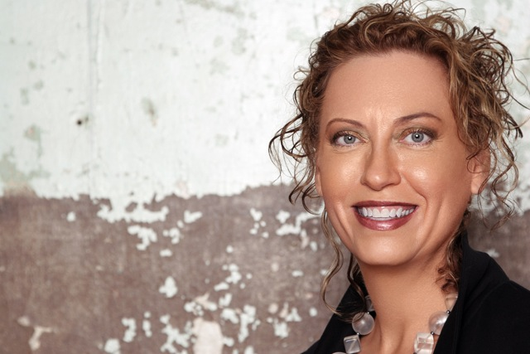
As major cities begin their homeless counts, a new psychological thriller will illustrate the reality of millions of young people with no place to call home. Anonymity, by national bestselling author Janna McMahan, is a hard-hitting account of the daily life of one girl alone on the streets. This is the fourth novel for McMahan who lives in Columbia, South Carolina.
McMahan was influenced to write Anonymity by a girl she saw whose face was a mask of intricate tattoos. “It was shocking and I carried her image in my mind for years. I kept asking myself why she would do that to herself,” McMahan said. “As a writer, I was even more troubled by the question of who would do that to a child. It was a mystery to me, so removed from my own life that I had to write about it.”
An idea for a story that would do the girl justice finally came to her and McMahan started research. “Gutter punks, street rats, worms are all terms used to describe the young homeless, but I found these kids to be capable and clever. They have to exist in an adult world with no resources and still keep their humanity,” McMahan said. “Readers tell me that they look at homeless people differently after Anonymity, how off their preconceived notions were. I know I came away from writing the story with a different perspective. It was a challenge, a dark story in many ways, but just like life, there are light moments too. There has to be levity for people to enjoy a book and for me to stay sane was an author.”
Anonymity is an action-packed drama about families—those we are born into and those we piece together out of need. Lorelei is a young runaway who works her way down the California coast and across the Southwest with a band of Travelers like herself. She lands in Austin, a hip city known to Travelers for a lively music scene, artsy alternative lifestyle and welcoming youth services. Lorelei meets Emily, a bartender who befriends her. Being anonymous is how Lorelei hides from her past, but Emily’s attention exposes her young friend and ends up calling forth the very danger from which Lorelei was trying to escape.
“Lorelei’s problems are very adult. She not only has to meet basic needs like food and shelter, but she has to deal with issues like sex, drugs and people who want to take advantage of her,” McMahan said. “She has serious trust issues and even well-meaning people have a hard time breaking through her tough exterior. The facial tats are to warn people away. Her survival instincts are good, but she let’s her guard down to Emily and that’s when things go bad fast.”
During her research McMahan turned to LifeWorks, a youth homeless shelter in Austin. “The folks at LifeWorks were amazingly helpful. They showed me where the kids hang out, explained how services worked, shared studies and experiences. These kids are not just runaways. The majority of them simply aged out of the foster care system,” McMahan explained. “These kids truly have no place to call home.”
Koehler Books will donate a portion of the proceeds from the sale of Anonymity to LifeWorks. “We are pleased to contribute to LifeWorks,” said publisher John Koehler. “They do vital outreach and help America’s young homeless transition to a better, self-sufficient life.”
McMahan’s upcoming South Carolina appearances will be at Books on Broad in Camden on January 26, at Books-A-Million in Trenholm Plaza in Columbia on February 2 and at Litchfield Books at Pawleys Island on February 22. She will also be at the South Carolina Book Festival in May. Check the appearances tab at www.JannaMcMahan.com for more information. Follow her book tour through www.facebook.com/jannamcmahan and Twitter at @JannaMc.
PHOTO CREDITS: Koehler Books

Tweet

Comments

Restaurant Week 2013 is January 10 –
Published Date : January 7, 2013
Author : admin


For the fourth year, food lovers won’t have to open their wallets quite as wide at many of South Carolina’s best restaurants during Restaurant Week South Carolina 2013.
This year’s event will be January 10 – 20.
January is traditionally a slow restaurant month, so Restaurant Week South Carolina allows consumers to try new places at a substantial savings while helping the state’s dining establishments fill their seats.
Participating restaurants range from casual to fine dining and will feature special menu items, promotions, and discounts. As Restaurant Week South Carolina showcases the state’s culinary scene from the Upstate to the Midlands to the Pee Dee to the Lowcountry, it reminds people that the state is a destination with top chefs, farm-to-table dining, and more.
The South Carolina Restaurant and Lodging Association (formerly the South Carolina Hospitality Association) in partnership with its local chapters and partners have come together to create this event, which will showcase South Carolina as a premiere dining destination for local, regional, and national food lovers.
Since seatings fill quickly, restaurants suggest making reservations in advance.
To learn more about Restaurant Week South Carolina visit www.restaurantweeksouthcarolina.com and also search for participating restaurants by region, city, or cuisine.
NOTE: To see which restaurants use locally grown or raised ingredients, visit the South Carolina Department of Agriculture’s “Fresh on the Menu” program.

Tweet

Comments

